PHOTOGRAPHS –
80 HIGH STREET
SWINDERBY
LINCOLN
LN6 9LU

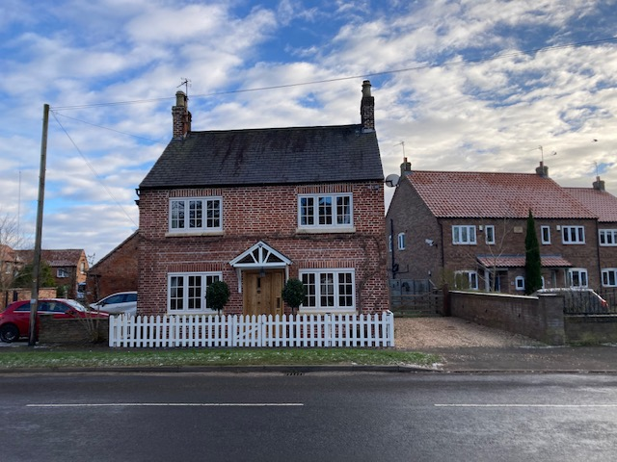
1. The front west facing elevation of the cottage with south side gravel drive, viewed from across High Street.

January-2024

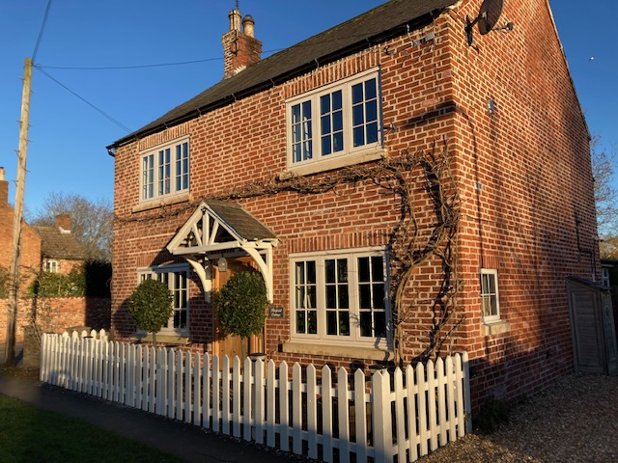
2. The front south west corner of the cottage from the front of the drive.

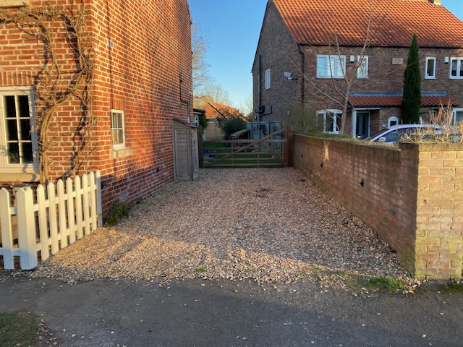
3. Looking east into the south side gravel drive.

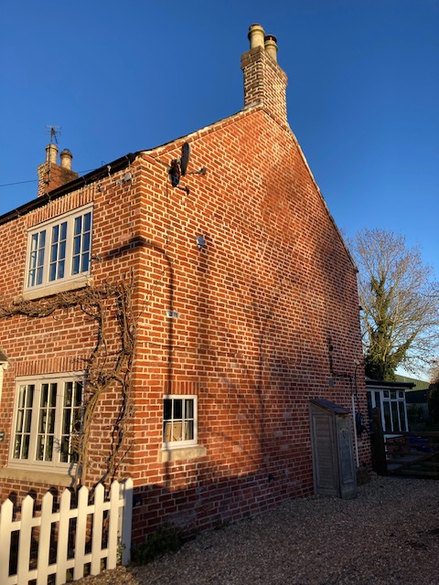
4. The south gable wall of the cottage and drive.

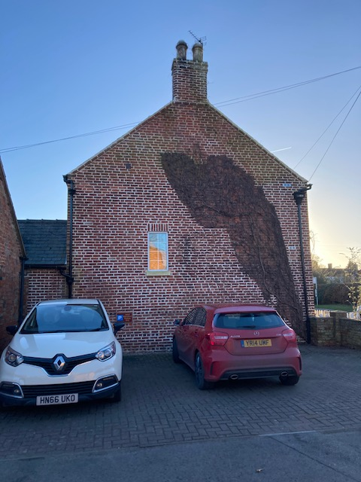
5. The north gable end wall of the cottage viewed from the neighbouring school carpark.

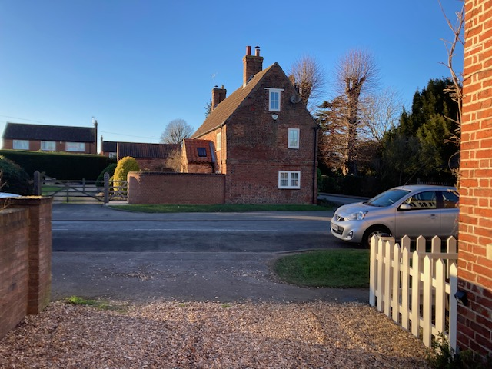
6. The view west from the south side gravel drive across High Street.

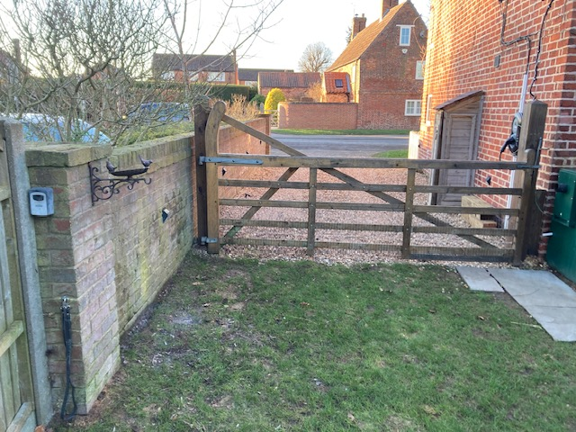
7. The gate into the garden from the end of the gravel drive.

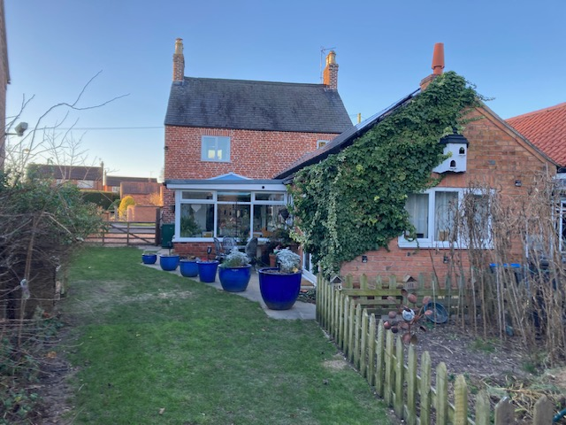
8. The rear east facing elevations of the cottage and garden.
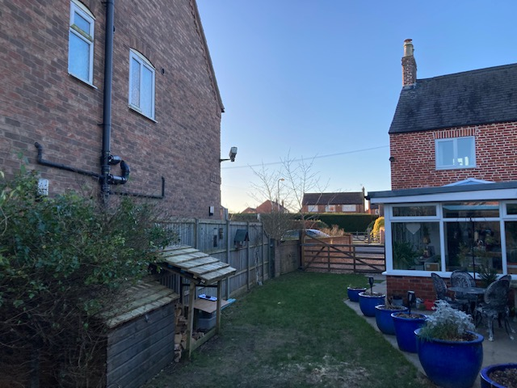
9. The garden gate, garden and neighbouring south side house.

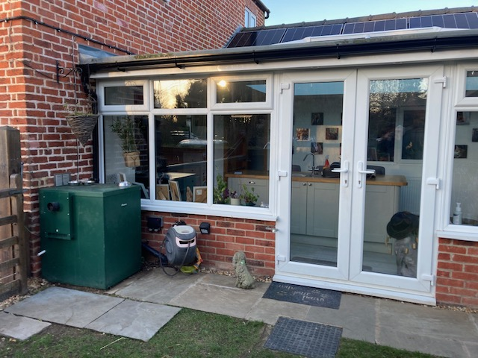
10. The external boiler and south elevation of the kitchen garden room, rear of the cottage.

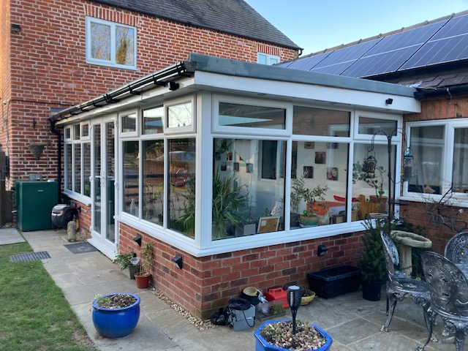
11. The rear flat roofed kitchen garden room.

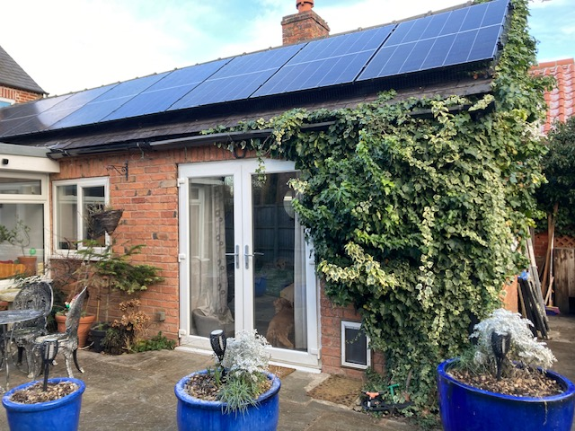
12. The cottage rear north wing, south elevation, with solar panels.

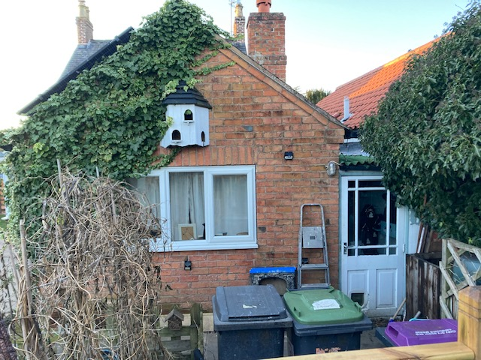
13. The rear east gable end wall of the north wing.

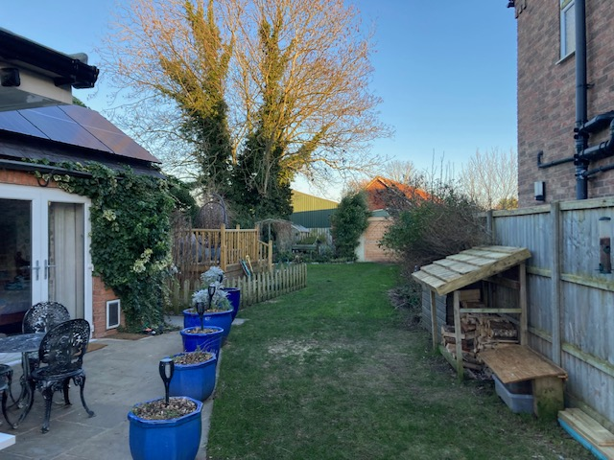
14. Looking east down the rear garden

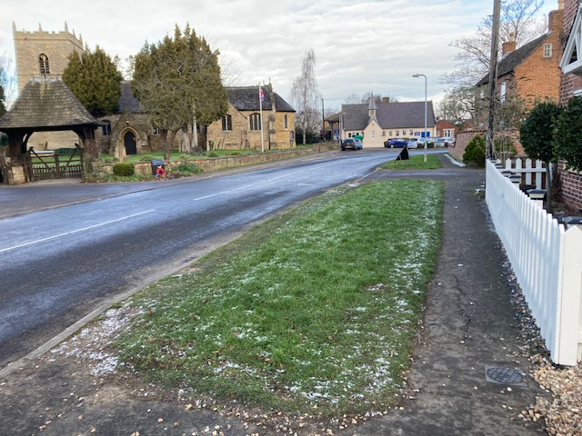
15. The view onto High Street, looking north from the vehicular entrance.

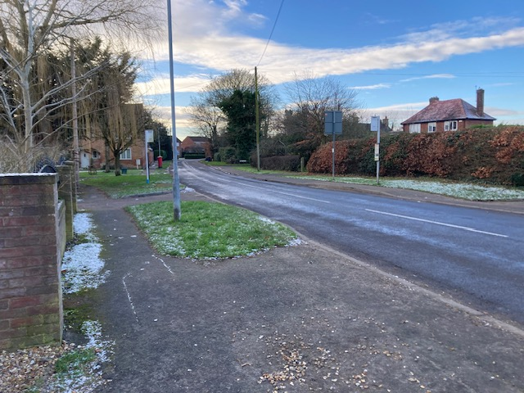
16. The view looking south along High Street from the vehicular entrance.

END.

