THE BOLITHO ESTATES
The Estate Office  Chyandour  Penzance  Cornwall TR18 3LW | Tel: 01736 363021  01736 365306  Fax: 01736 368142  e-mail: mail@bolithoestates.co.uk

Design and Access Statement

Application: Listed Building Consent for the replacement of the roof covering at Kerris Manor Farmhouse

Address: Kerris Manor Farmhouse, Paul, TR19 6UY

- Introduction

Kerris Manor Farmhouse is a Grade II* listed farmhouse with the following listing description:

PAUL KERRIS SW 42 NW 5/12 Kerris Manor Farmhouse including front garden walls and rear courtyard walls. C17, possibly incorporating earlier walls. Remodelled at the front in 1721 for RP (Richard Pearce) (datestone over doorway) and extended in the C18. Granite ashlar front, otherwise moor stone rubble with granite dressings. Scantle slate roof with gable ends. Granite coped, gable ends to rear range. Original gable axial and lateral dressed granite stacks with moulded tops. Circa late-C19 or early-C20 pierced crested clay ridge tiles.

The roof covering is in need of replacement.

- Scope of Works

The Bolitho Estates is seeking permission as they wish to replace the existing wet-laid slate roof covering with a new wet-laid slate roof covering thus retaining the character of the building.

- Use

The farmhouse has been let by way of a Farm Business Tenancy for a number of years and is occupied by the Tenant Farmer.

- Appearance

It is anticipated that the only change in appearance will be an improvement from the current to restore it to its previous condition as shown in the following photographs:

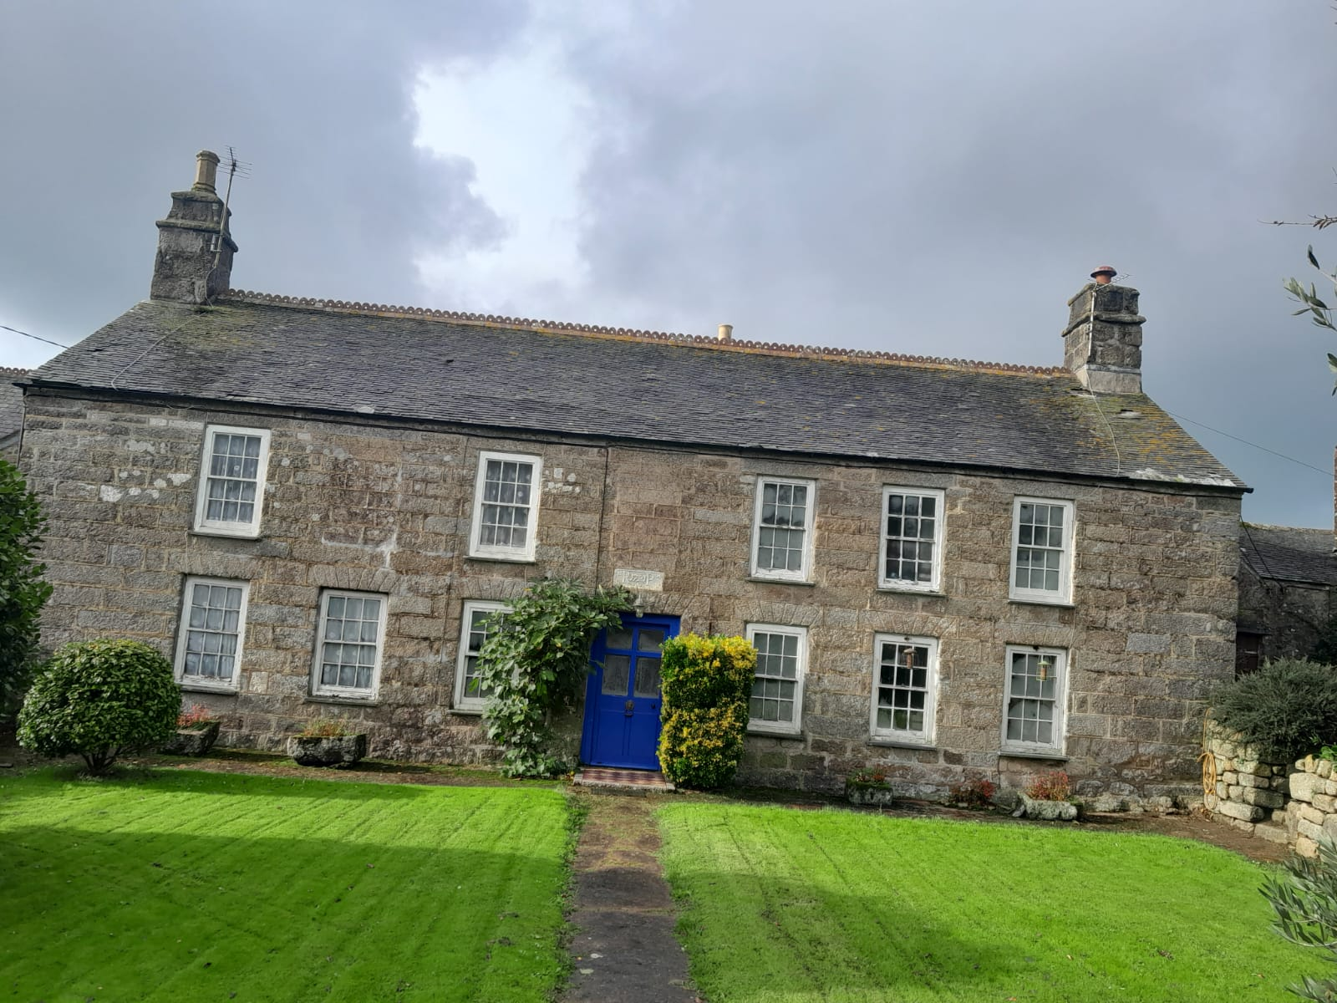
Front elevation of Kerris Manor Farmhouse November 2023

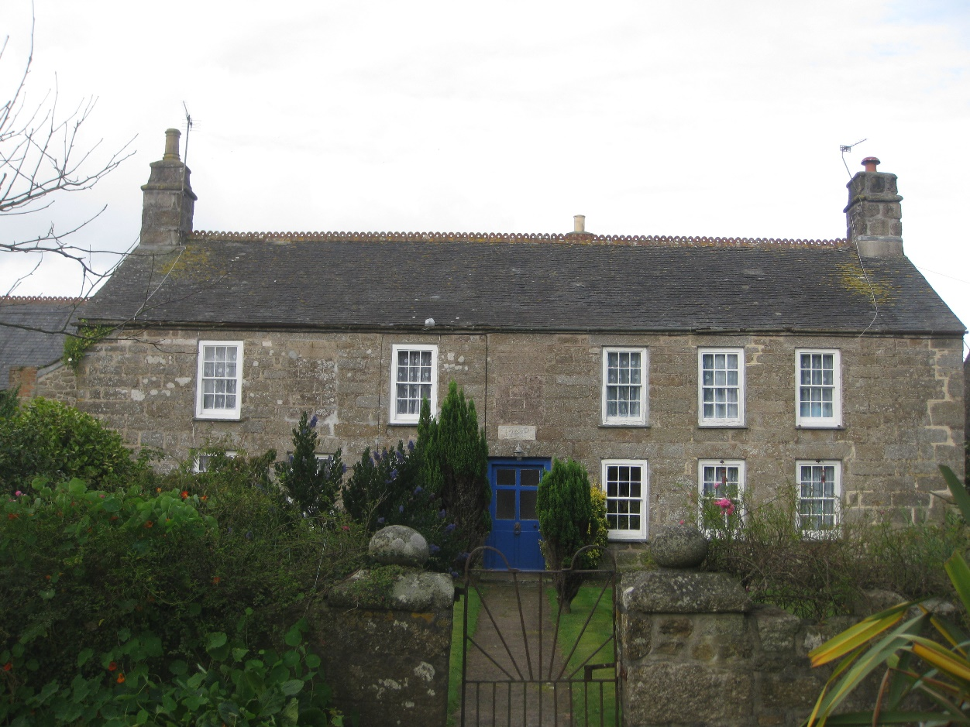
Front elevation of Kerris Manor Farmhouse 2012

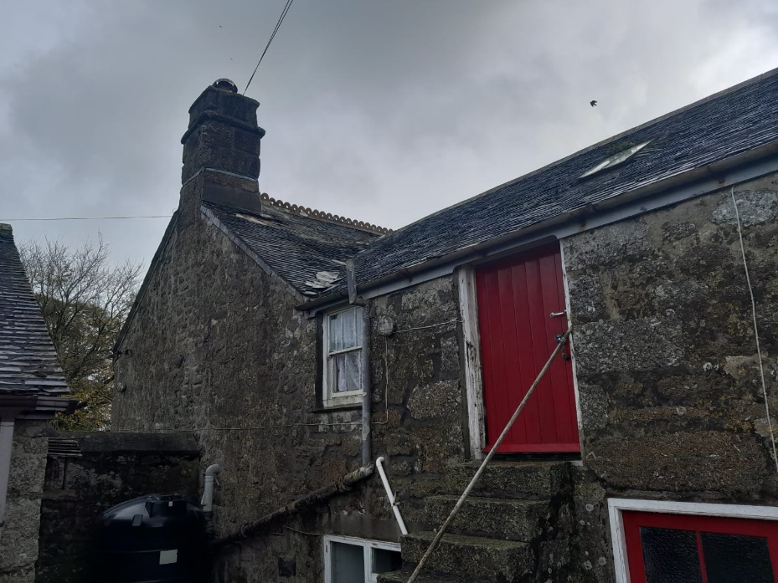
Side elevation of Kerris Manor Farmhouse November 2023

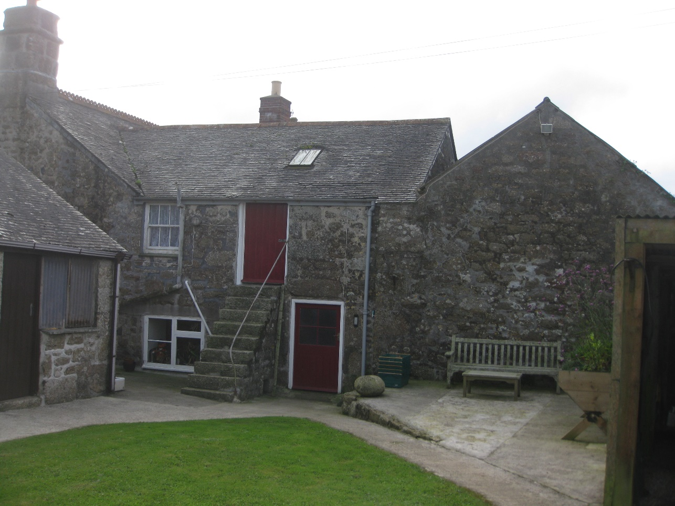
Side elevation of Kerris Manor Farmhouse 2012

- Access Statement

Due to the remoteness, the primary access to the site is by vehicle using the present public lane from the B3315 Newlyn to Land’s End Road. A local bus service exists within 1 mile to Paul and Sheffield, and the site is accessible via a series of rural roads all suitable for cyclists.

- Conclusion
The overall conclusion to be drawn is that the proposed re-covering of the wet-slaid roof will restore the property to its original state and prevent any further damage to the Grade II* listed property.

Additional pictures showing the scale of damage to the roof covering:

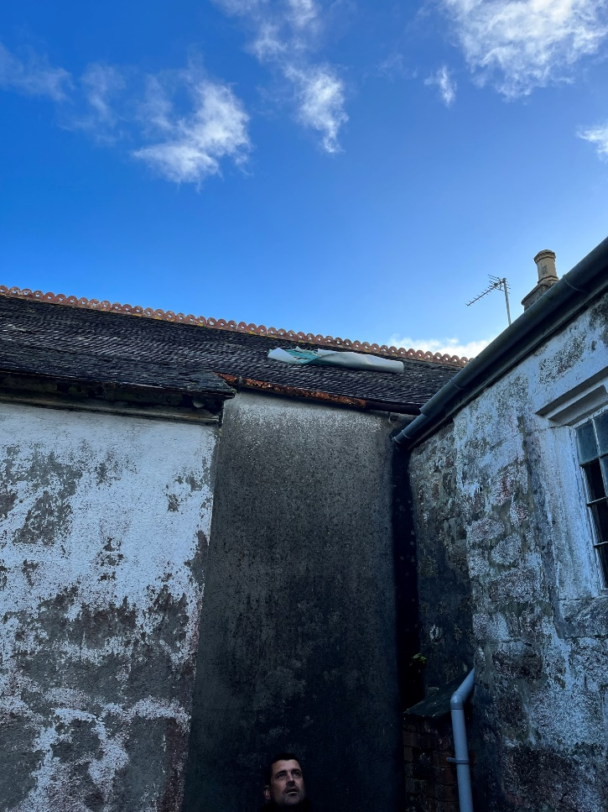 | 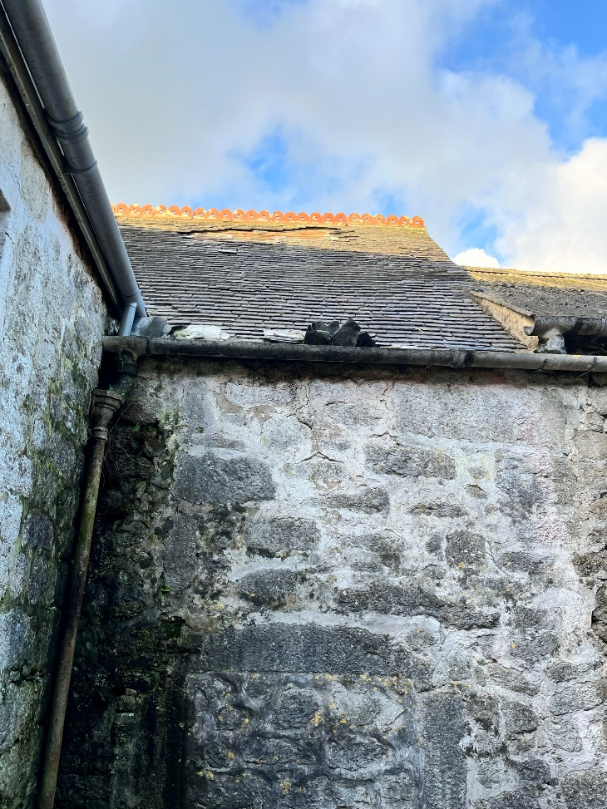
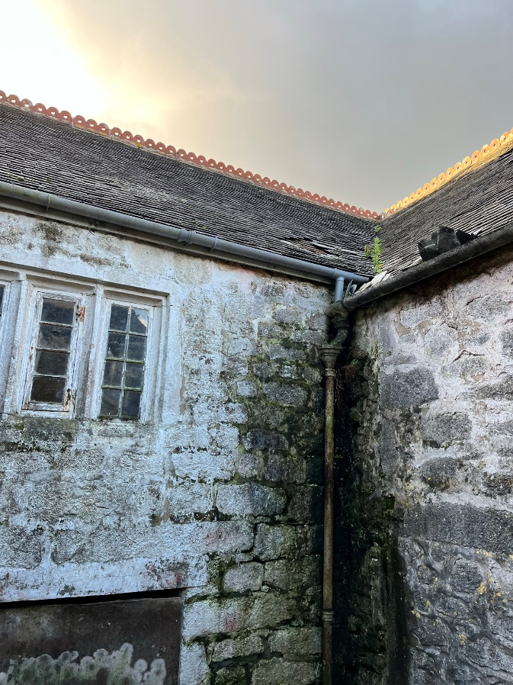 | 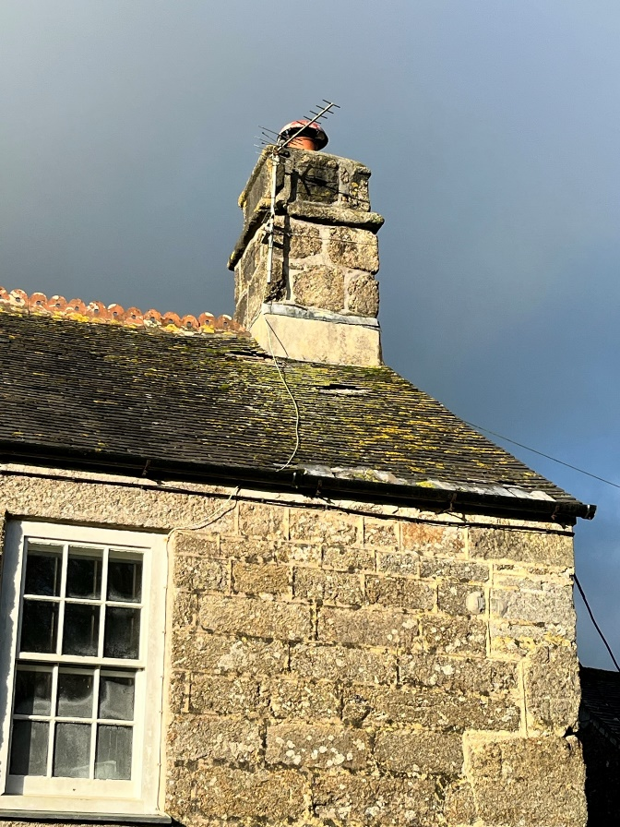
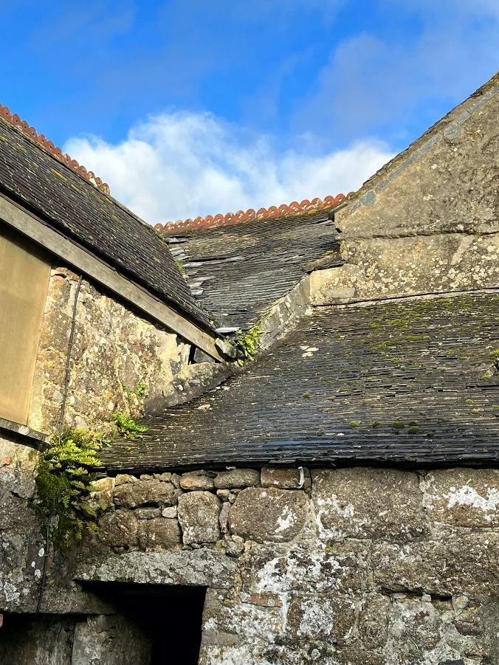 | 