Application for works to Trees protected by Tree Preservation Orders
Applicant name: Gina Rivett
Address: 5 Brinkworth Place, Burfield Road, Old Windsor. SL4 2LH
Proposed works:
Reduce limb of (Sycamore or Beech) Tree (T1) at front of property (overhanging road) by approx 6m
Reduce lowest branch on Sycamore by approx. 2m to allow 3m clearance from building

Reason for works:
T1 to rebalance Tree, reduce wind stress and reduce risk of limb failure
T2 to allow 3m clearance from building
Photos:
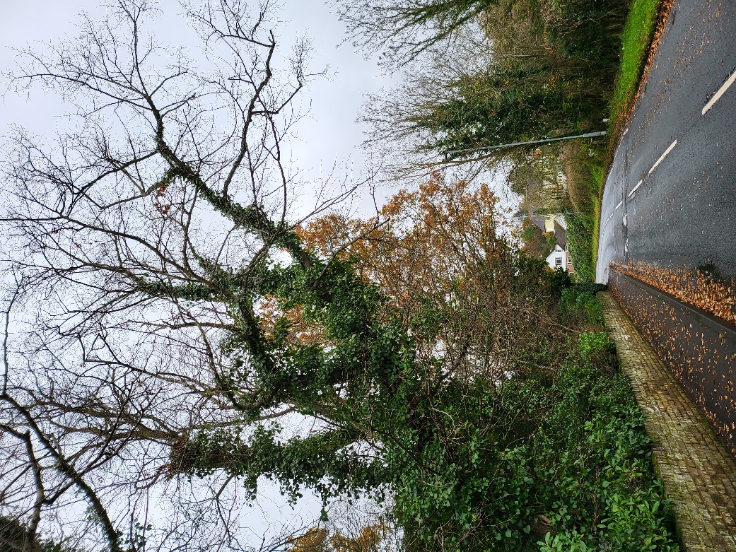
T1
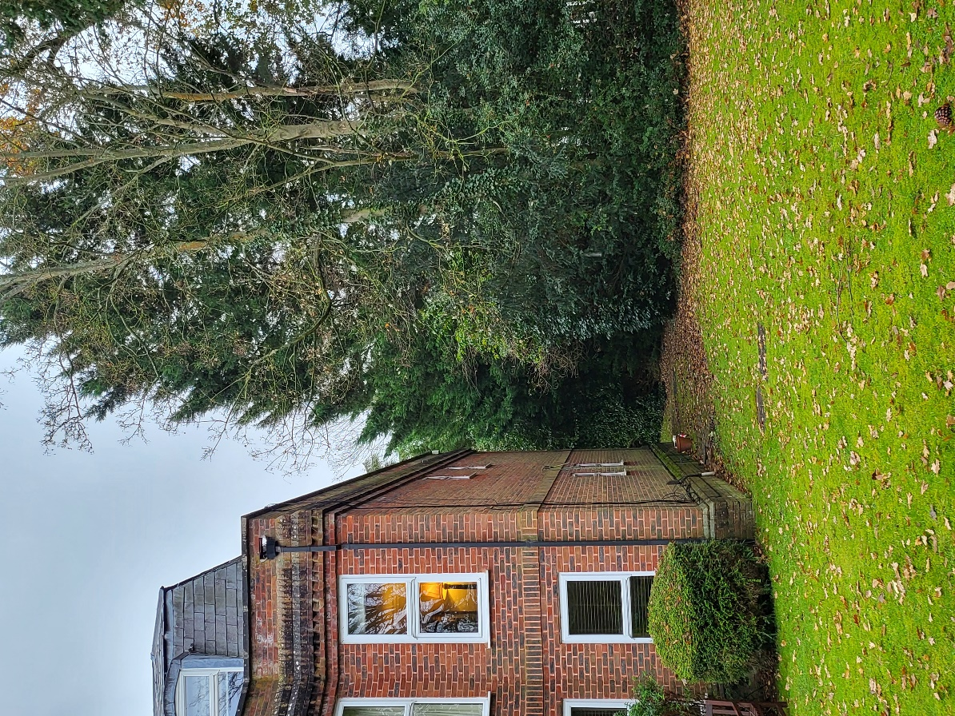
T2

