Heritage Statement
Site description: 2 Priory Terracce,Cheltenham,GL526DS
Ariel View.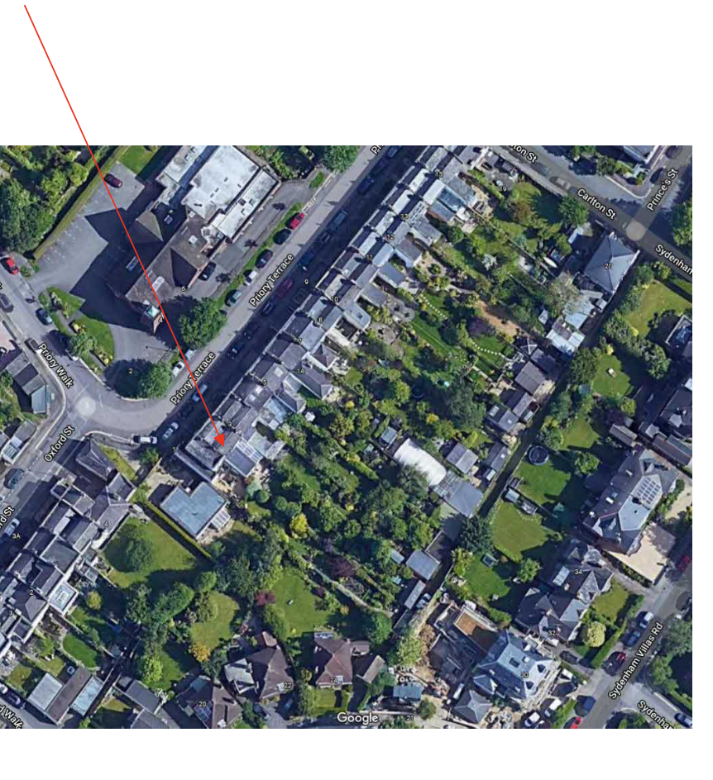

Block Plan: 2 Priory Terrace,Cheltenham,GL526DS
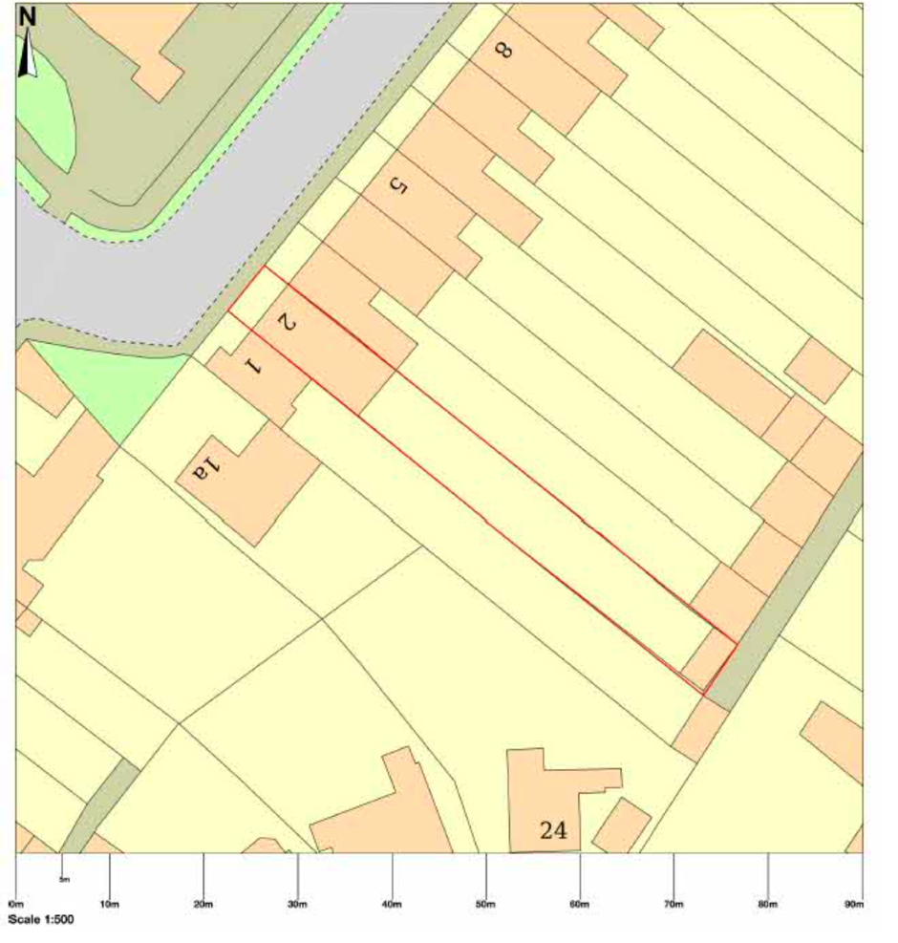

Location Plan. 2 Priory Terrace,Cheltenham,GL526DS

Proposed location plan.

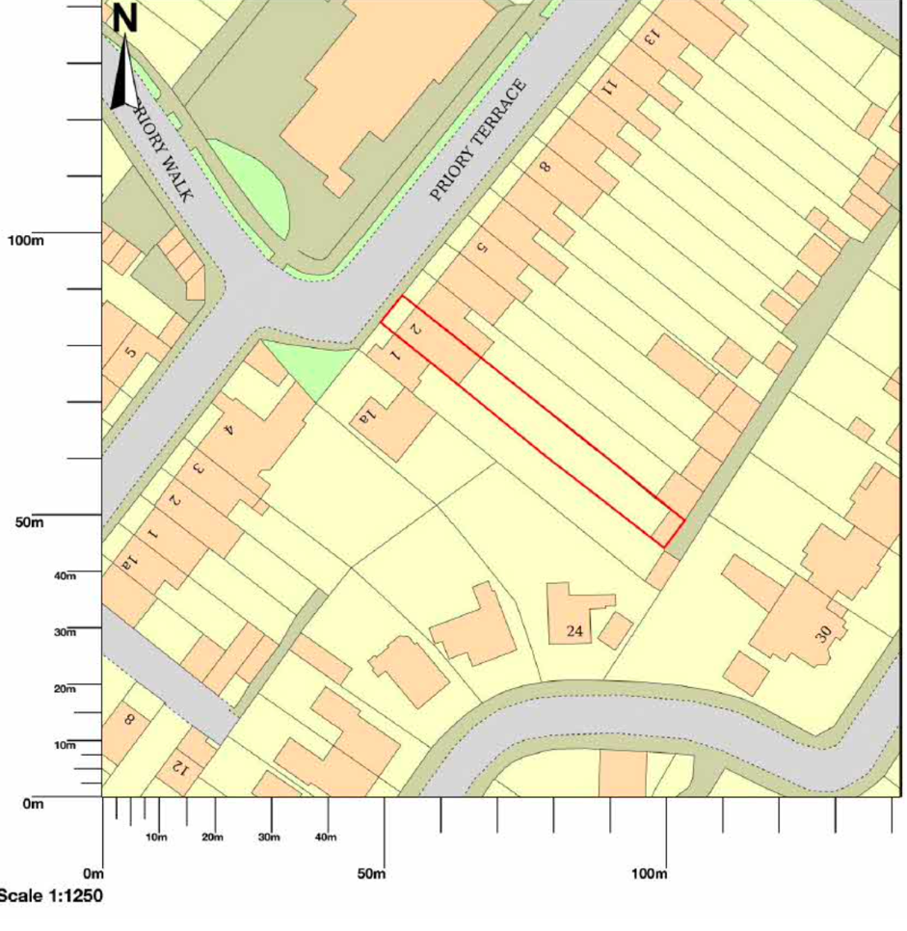

Heritage Asset

Official list entry
Heritage Category: Listed Building Grade: II
List Entry Number: 1387619 Date first listed: 14-Dec-1983
Date of most recent amendment: 26-Nov-1998 Statutory Address 1: 19, SYDENHAM ROAD
Statutory Address 2 NUMBERS 1 TO 15, CRICKLEWOOD AND ATTACHED RAILINGS, 1 TO 15, PRIORY TERRACE
The scope of legal protection for listed buildings
This List entry helps identify the building designated at this address for its special architectural or historic interest.
Unless the List entry states otherwise, it includes both the structure itself and any object or structure fixed to it (whether inside or outside) as well as any object or structure within the curtilage of the building.
For these purposes, to be included within the curtilage of the building, the object or structure must have formed part of the land since before 1st July 1948.
Location Statutory Address:19, SYDENHAM ROAD
Statutory Address:
NUMBERS 1 TO 15, CRICKLEWOOD AND ATTACHED RAILINGS, 1 TO 15, PRIORY TERRACE
The building or site itself may lie within the boundary of more than one authority.
County: Gloucestershire
District:
Cheltenham (District Authority)
Parish:
Non Civil Parish National Grid Reference: SO 95630 22049
Details
This list entry was subject to a minor amendment on 13/03/2012
SO 522 SE 630/15/727
CHELTENHAM PRIORY TERRACE (East side) 14.12.83 Nos.1-15 (Consecutive) and
Attached railings (formerly listed as Priory Terrace No 4)
(Formerly listed as Nos 5-15(Consecutive) and attached railings II
Includes: Cricklewood Sydenham Road

Terrace of 16 houses with attached forecourt railings to Nos 3 and 16 and area railings to Nos 4, 6, 7, 8, 9, 10, 11 and 12. c1840-50. Stucco over brick with slate roofs and brick party-wall stacks; iron railings and porches. Double depth plan several with service ranges to rear. EXTERIOR: 2 storeys on basement, 2 first-floor windows each. First-floor band; crowning frieze and cornice where original; low parapet and copings throughout. Rustication to ground floor at left. First floor has 6/6 sashes where original, with one 8/8 sash at right. Ground floor has 6/6 sashes with margin-lights where original and some 8/8 and 1/1 horned sashes. Basement has 6/6 sashes. All windows in plain reveals and with sills. Entrances mainly at right: 4-panel doors with lower flush panels and overlights, some with margin-lights. Similar entrance at right is in projecting 2-storey bay. Left return: 2 storeys, 3 first-floor windows, those to left and centre have 6/6 sashes, otherwise blind. First-floor band with incised anthemion motif; crowning frieze and cornice. Central entrance: steps to 6-panel door with overlight with glazing bars in Doric architrave. INTERIORS: retain original joinery and plasterwork including dogleg staircases with stick balusters and wreathed handrail. No.4 retains very good interior decoration, the ground floor has ceilings decorated with mid-C19 Crace-style stencil work in different colours and some gilt, particularly highlighting cornice work; the doors and other fittings are in keeping. SUBSIDIARY FEATURES: tent-roofed porches to Nos 2, 9 and 10 have scrolled lozenge motif to uprights and openwork friezes. Arrowhead railings with urn finials to stanchions to sides of steps throughout, also to forecourts of Nos 3 and 16. X-motif area railings. Some window boxes with embellished road and scroll motif (No.7, ground floor and No.10); scroll motif (No.9). No. 4 Priory Terrace was included in the 23rd list for the Borough of Cheltenham on 14th December 1983.
Listing NGRSO9563822049
Legacy
The contents of this record have been generated from a legacy data system.
Legacy System number:
475605
Legacy System
LBS
Property History
The application site is a grade II listed building situated within the central conservation area. It is part of a terrace of 16 houses. All houses have lengthy gardens and rear access from a gated private no through driveway.
The property planning history shows a two-storey extension and a conservatory granted in 1999. The relevant application number for the alterations is 99/50024/FUL.
In 2022 permission was granted for Solar panels to the rear roof of the property . The relevant application number for the alterations is 22/00743/FUL.

Assessment of Significance
The applicant is proposing to install two additional solar panels to the central roof valley. Consideration of this planning application has included reference to:
Planning Policy Statement 1: Delivering Sustainable Development Planning Policy Guidance 15:
Planning and the Historic Environment; Policies CP1, CP3, CP4 and CP7 of the Cheltenham Borough Local Plan (Adopted 2006)
The proposed location for the solar panels is on the roof within the central valley on the rear facing slope. The panels will not be visible from the front or rear of the property. The distance between the extension rear wall and the end of the garden is 45m. The middle butterfly section of the roof is the chosen location for these two additional panels.
The application building is the second of the terrace, and therefore it is at the end of the private drive. There are no public footpaths near the property with views to the rear of the listed terrace.
The central valley of the roof is not visible from the rear access road or the rear garden.
The installation of solar panels will involve limited interference with the roof and will be reversible. The finish of the panels is sympathetic to the colour and finish of the current roof.
The use of renewable energy is encouraged within PPS1 and policy CP1 of the local plan, and the proposed installation is not considered to have a detrimental impact on the listed building. This is evident by the use and installation of solar panels to other listed buildings within the neighbouring streets of Oxford Street, Priory Street, Sydenham Villas Road and at number 13 Priory Terrace.
The proposal will not affect the setting and the heritage asset in a negative way as the solar system will not be visible from any road or public footbath.
Installation Tiles.
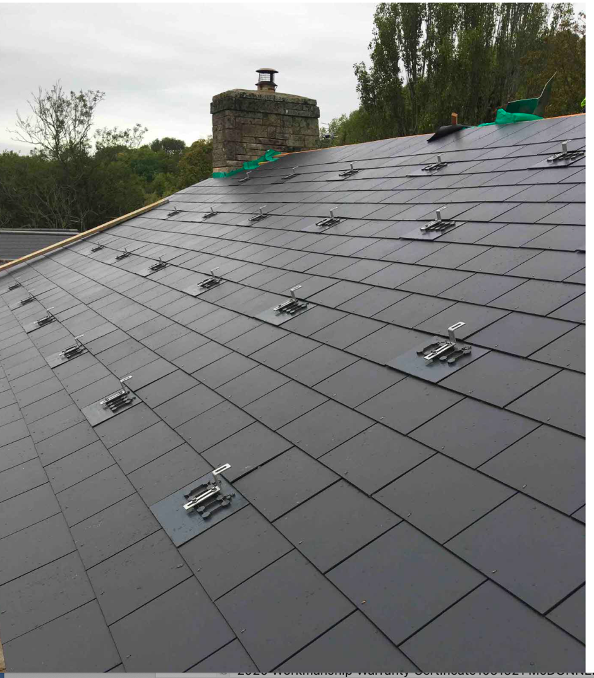
Installation Rail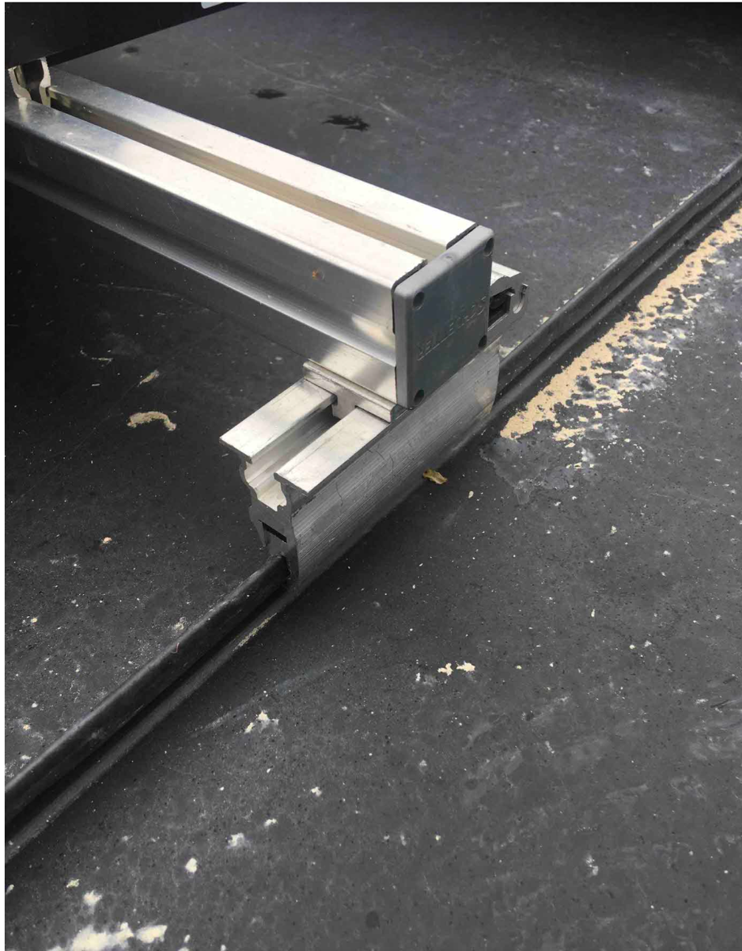
Installation Rail

Front
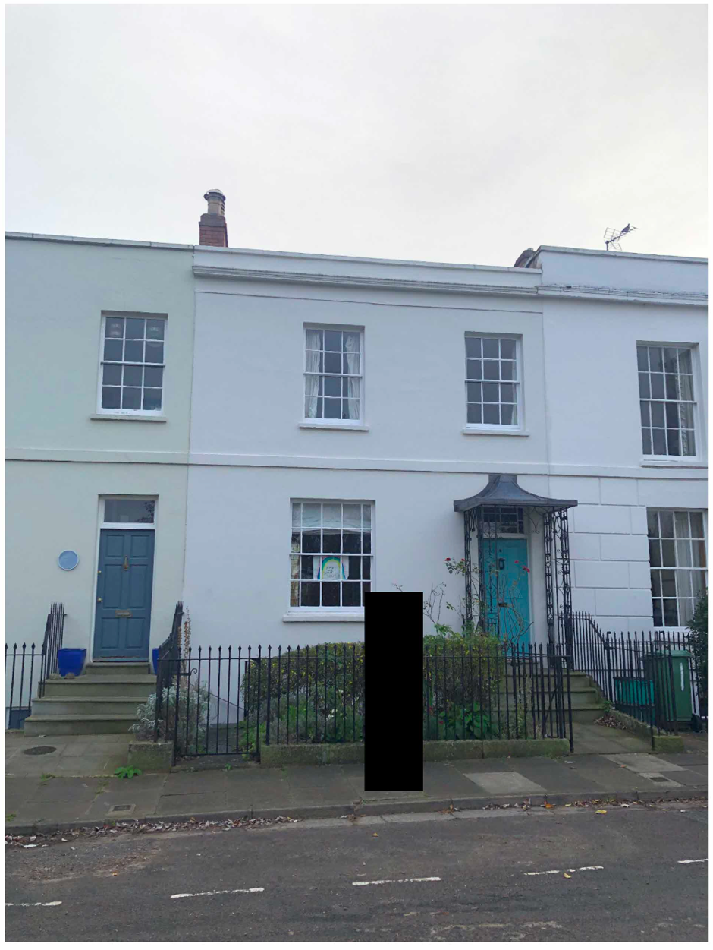

Rear

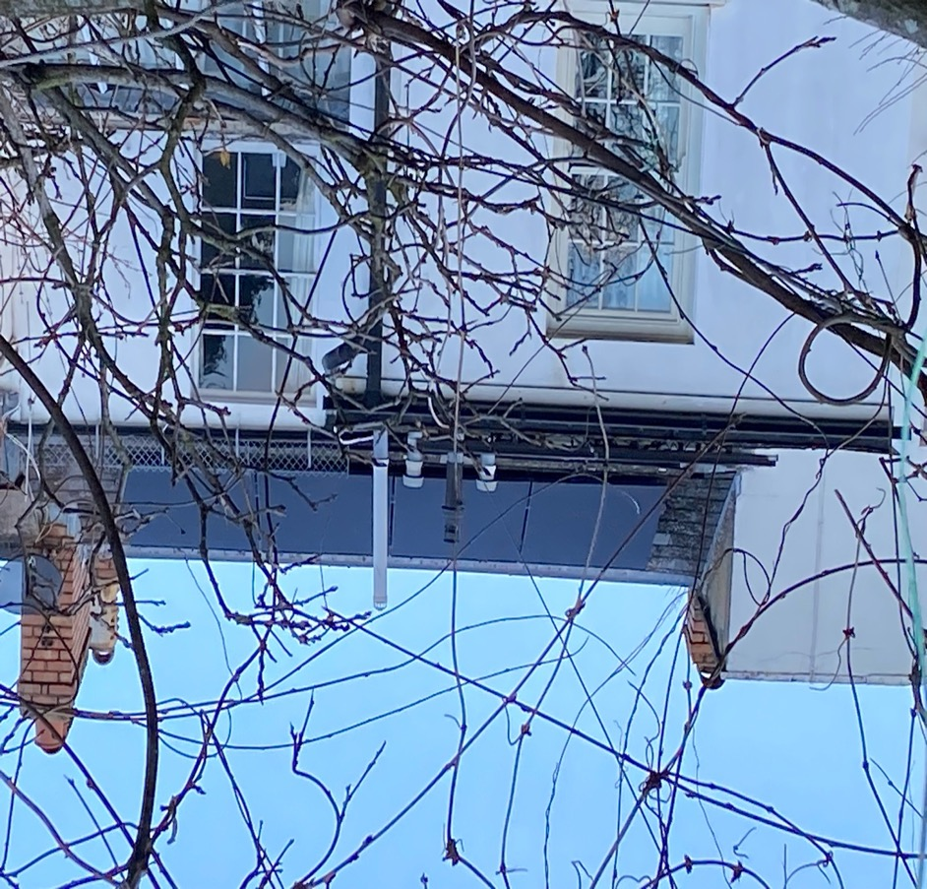

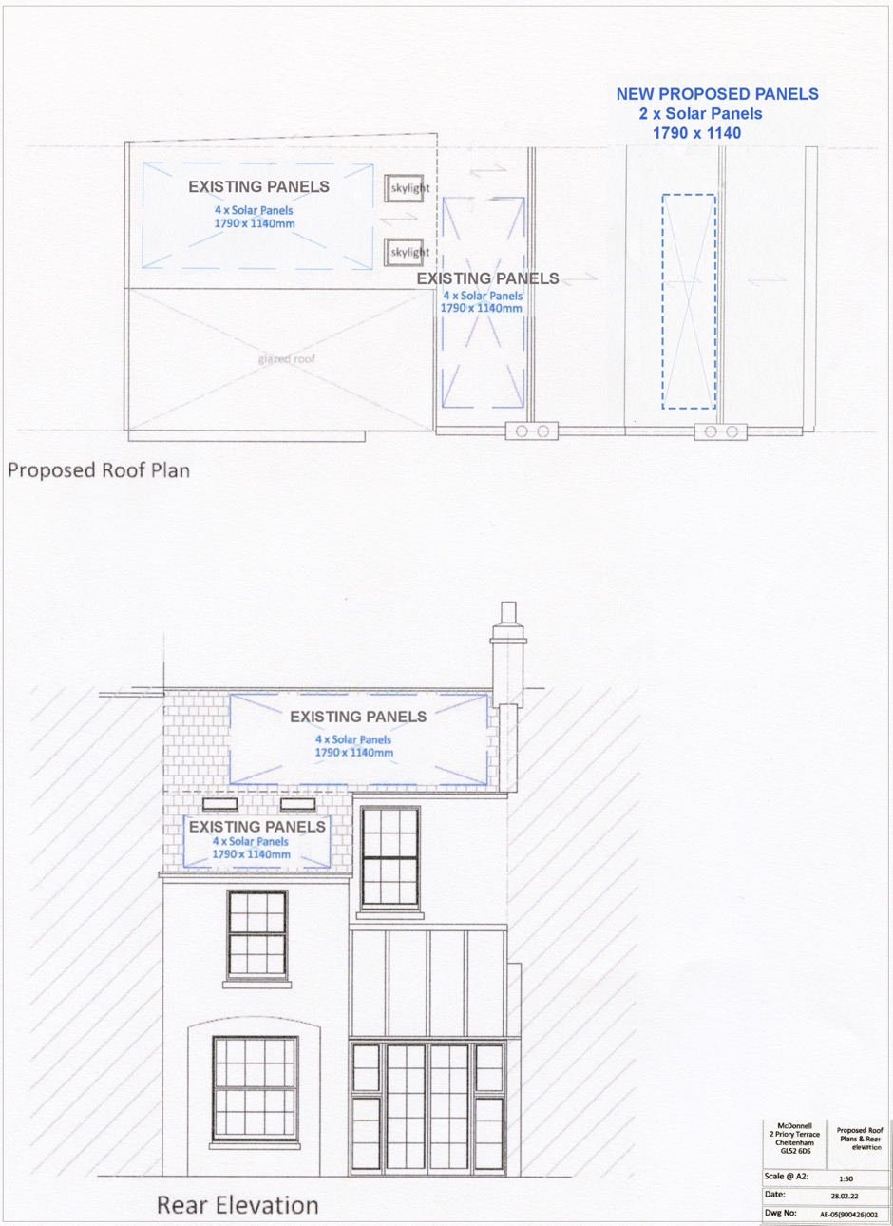

Proposed roof plan and rear elevation
Rear view from patio showing existing panels.
