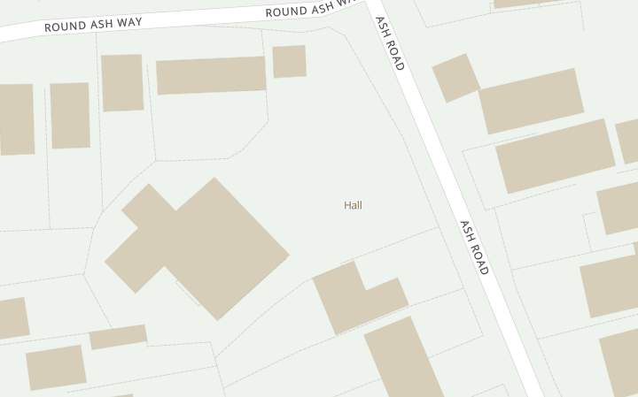
T1

Map of location of TPO Tree (T1)

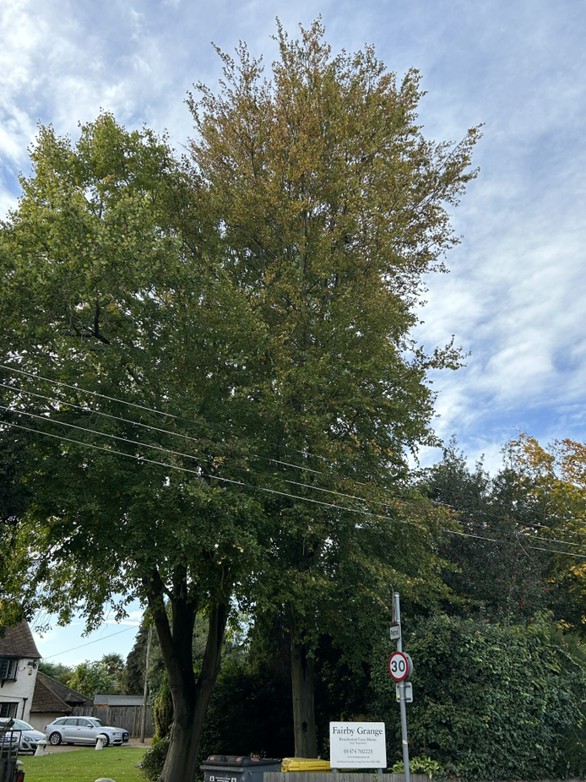

Photo of Tree (T1) under TPO – Beech 85/003/TPO

