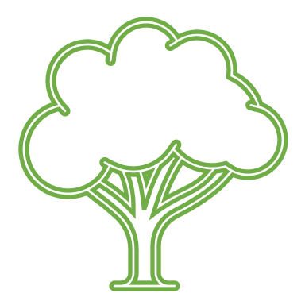LIME TREE
No 34
Blake Close

Blake Close

