STAINTON QUARRY Ltd

Noise Management Scheme
Ref. NMS 1.0 Rev. 1.0 Jan 2024

CONTENTS
- Introduction
- Site Location
- Noise Conditions
- Noise Sources
- Noise Control Measures
- Noise Monitoring
- Noise Complaints
- Exceeding Noise Criteria

APPENDICES
Site Plan – Noise monitoring points
Near Miss/Near Hit Reporting Form Ref. NMNHRF3.000 Rev. 3.000 MAY 2021

- Introduction
Current activiites at Stainton Quarry have been operational since 2009 and include working of existing spoil heaps by crushing and screening, removal of loose block and drilling/splitting of larger blocks in preparartion for cutting.
The site also benefits from a stone processing facility housed in two substantial fully enclosed buildings. Activites within the buildings include three automated stone cutting lines, forming, shaping and preparation of stone for masonry and walling and general mechanical maintenance of machinery and plant.
1.1 The following noise management scheme is submitted in accordance with Conditions 25 and 26 of Planning Permission CE/14/00140/MIN.
1.2 This noise management scheme takes into consideration the updated planning conditions which came into effect March 2015 and explains precisely what measures shall be used to monitor and control noise emissions.
1.3 The site is divided into four phases. Phase 1A and 1B, Phase 2 and Phase 3 with current activities taking place in Phase 3.
1.4 Minerals activities taking place within this phase include the working of existing spoil heaps by crushing and screening, removal of loose block and drilling/splitting of large blocks in preparation for cutting.
1.5 This noise management scheme outlines methods by which Stainton Quarry Limited will assess and minimise the potential impacts of noise generated by the activities taking place onsite with a specific aim to:
Reduce noise disurbance to minimise nuisence to nearby residents
Ensure compliance with environmental noise legislation
Develop noise control strategies to implement alongside daily site activities
Ensure site activities are within specified noise levels and do not cause noise related nuisence
1.6 The aim of this scheme is to adresss the impact of noise and the control measures employed to mitigate that risk. These are supported through monitoring procedures to identify both exceedances over specified noise limits and review, investigate, manage and fully address any possible complaints from nearby residents.
1.7 This noise management scheme will be reviewed annually unless any equipment or process changes have taken place within the meantime. Further reviews will take place in the event of a complaint or identified non-compliance.
2.0 Site Location
2.1 Stainton Quarry is located immediately north of the village of Stainton which lies 1.6km from the town of Barnard Castle, County Durham. The southern boundaries of the site are within 20m of residential properties at certain points and the eastern boundary is within 50m of Staintion Hill Farm buildings. Grid Ref NZ 06990 18917. The site is 0.6km from the main A688 Barnard Castle trunk road and is accessed in a southerly direction only through the village of Stainton.

3.0 Noise Conditions
3.1 Condition 25 of the planning permission states:
Noise emitted from operations taking plaxe on site shall not result in ambient noise levels greater than 60dB(A)L (Max) 50dB(A)Leq (1 hour) (free field) Daytime 0700-2200 hours and 53dB(A)L(Max) 42dB(A) Leq (1 hour) (free field) Night time 2200-0700 hours, as measured at noise sensitive properties.
3.2 Condition 26 of the planning permission states:
Monitoring of noise levels shall be carried out by the operator at the noise sensitive properties for a minimum of 1 hour every 3 months (both day time and night time) for a period of 12 months from the date of this certificate and the results submitted to the Mineral Planning Authority. A proposed future noise monitoring regime shall be submitted and agreed in writing by the Mineral Planning Authority within 3 months of the expiry of this 12 month period and thereafter implemented.
4.0 Noise Sources
Contributing factors to noise in the surrounding area are aggricultural activites and traffic including HGV traffic heading to or from other quarries in the Teesdale area. Noise related incidents have been minimal during this period of operations at the site but there have been incidents that have led to complaints however, these incidents have been isolated
4.1 Sources of noise generated at the site are limited to the following sources:
Crushing and screening plant
Mobile plant
Fork lift trucks
Drilling rig
Cutting plant
HGV movements
4.2 The above noise sources are not continuous and therefore noise levels will vary at different points day to day. For example, aggregates are produced according to market demand and finished product is also stockpiled so the crushing and screening plant does not operate daily. This pattern of activity also determines the frequency and volume of HGV movements.
4.3 The working hours for the site are variable and depending on production demand.
Crushing and screening plant, mobile plant, drilling rig
Monday – Friday 0800 – 1800hrs Saturday – Does not operate
Fork lift trucks, cutting plant
Monday – Friday 0800 – 1700hrs Saturday – 0800 – 1300hrs (Occasional)
HGV Movements
Monday – Friday 0800 – 1700hrs Saturday – 0800 – 1300hrs (Occasional)
NOTE: All of the above hours are variable. Since October 2020, the quarry has been closed on Saturdays however, there be occasions when the site is open and this is mainly to carry out plant maintenance. The site does not operate on Sundays or Bank Holidays.

Equipment with potential to cause noise excess noise
DOOSAN 13.0 EXCAVATOR AND DRILLING RIG
JCB200 EXCAVATOR
VOLVO460 EXCAVATOR
HYUNDAI LOADING SHOVEL A
HYUNDAI LOADING SHOVEL B
CATERPILLAR980C LOADING SHOVEL
MANITOU TELEHANDLER
FINLEY 883 POWERSCREEN
METSO 105 MOBILE CRUSHER
FINTEC 542 POWERSCREEN
Mobile plant and machinery is covered in the Stainton Quarry Planned Maintenance System Ref. PMS1.000 Rev.1.000 June 2019. (Document available upon request).

5.0 Noise Control Measures
5.1 Site Management are responsible for ensuring that nuisences and hazards arising from noise are minimised. Management will identify a noise that has the potential to cause nuisence or harm and will ensure that all staff are also trained accordingly.
Mitigation and operational controls will ensure the effective management of noise.
5.2 The following control measures will be implemented and managed to minimise potential noise impact:

Working the quarry in phases, graduating outwards to create bunds as works progress.

Activities will be scheduled to minimise the effects on nearby noise receptors.

Material handling, in particular loading of aggregates, will take place in screened/bunded areas of the site. If phases are in transition, temporary bunding will be contructed to screen loading noise.

Drop heights when loading aggregates will be kept to a minimum.

Haul roads will be contructed and graded to ensure smooth travel of mobile plant/HGVs. Haul roads, temporary haul roads and non-permiable areas of the site will be maintained to a high standard, regularly inspected for damage or wear and repaired immediately when required.

Plant and equipment procurement policy will ensure that equipment with the lowest sound output levels are used wherever possible.

All plant, machinery and equipment will be serviced and maintained according to the Planned Maintenance System Ref. PMS1.200 Rev. 1.200 Aug 2020. (Document available upon request).

Mobile plant, machinery and equipment will be switched off when not in use.

All mobile plant and FLTs will be fitted with broadband/white sound reversing alarms.

Haul roads, temporary haul roads and loading areas will be constructed in a way that minimises uneccesary reversing.

Regular noise monitoring in accordance wirth Condition 26.

All staff will be trained and regular updates provided through toolbox talks to raise awareness of these control measures, noise hazards, how to identify noise hazards, how to identify something, (perhaps an item of faulty equipment) that has the potential to caused a noise hazard and the importance of reporting to management.

6.0 Noise Monitoring
6.1 Noise Monitoring Locations
The three agreed positions for noise monitoring are as follows:
Stainton Hill Farm
Rear of No. 2 Hesley Rise
Rear of No. 42 Stainton Village
These positions are identified on Site Plan (See APPENDIX).
If access cannot be gained at the proposed monitoring time, a suitable position nearby, of similar characteristics will be selected for the monitoring. In the event of a temporary change, all details must be noted on the subsequent noise report.
6.2 The noise levels in the specified monitoring positions must not exceed 55dBLAeq, 1hr (free field).
6.3 Noise measurements will be made with a Type 1 intergrating sound level meter, complient with BS EN 61672-1:2003 “Electroacoustics. Sound level meters. Specifications BS EN 60804:1994 and will be supervised throughout the monotoring period.
An effective windshield will be engaged to minimise turbulence.
A acoustic calibrator or pintonphone will be applied to the microphone before and after readings to check the sensitivity of the equipment. In addition, instrument calibration should be carried out by an independent body to ensure that all equipment meets national standards.
6.4 Noise monitoring will be carried out at each of the agreed positions and frequency of monitoring will be determined by the Minerals Planning Authority.
In the event of a noise related complaint, an internal investigation will be carried out to determine the source of the noise. The form Near Miss/Near Hit Reporting Form Ref. NMNHRF3.000 Rev. 3.000 MAY 2021 should be used to document the investigation, subsequent findings and action taken. (See Section 7.0 of this document).

6.5 Noise monitoring and reporting shall be undertaken by a competent person/organisation.
Martin Tunstall
NEMS Northern Environmental Monitoring Services
83 Victoria Rd
Darlington
DL1 5JQ
01325 255187
info@nems.co.uk

6.6 Noise monitoring will be carried out at the locations identified as noise sensitive receptors (See 7.1) in accordance with the procedures set out in BS4142: 1997 “Method of Rating Industrial Noise Affecting Mixed Residential and Industrial Areas”.
6.7 Monitoring will be carried out over a period of one hour at each of the locations when suitable weather conditions prevail. Monitoring shall not be undertaken in conditions when wind speeds are higher than 5 m/second and when heavy rain is falling to minimise the risk of noise interference.
6.8 Monitoring will only be undertaken when the site is fully operational and during normal working hours. Break times or periods when regularly used plant is down for maintenance should be avoided.
6.9 All monitoring will take place in a ‘free field’ location with the microphone positioned at least 3.5m from any reflecting façade and at a height of 1.2 – 1.5m above ground level.
6.10 The monitoring equipment will be supervised continuously during the monitoring period and notes will be made of the date, time, prevailing weather conditions and any significant noise sources that are unrelated to the quarry site.
6.11 The pause facility on the equipment will be used to exclude extraneous noise as far as possible so that the recorded results are representative of noise produced from the quarry site.
Where it is not possible to to utilise the pause button to exclude extraneous noise, an allowance shall be made in accordance with the methodology detailed in BS4142.
6.12 The noise monitoring report will include an inventory of plant activity and operations being undertaken on the site during the time of the survey and shall include the following:
Average Wind speed
Climatic conditions including % cloud cover
Identified noise sources during monitoring periods
Noise monitoring location
Details of monitoring equipment including serial numbers and calibration dates
Details of free field noise measurements LAeq, LA90, Lamax
Assessment against planning permitted noise limit criterion
6.13 The noise monitoring results and corresponding report shall be made available to the Minerals Planning Authority upon request. 6.14 Records of noise monitoring results and reports shall be maintained in hard copy and digital format for a minimum period of 3 years.

7.0 Noise Complaints
The following system is in place and shall be utilised if a noise generated from the site causes nuisence to nearby receptors resulting in complaints.
7.1 In the event of a noise related complaint, an internal investigation will be carried out to determine the source of the noise. Use the Near Miss/Near Hit Reporting Form Ref. NMNHRF3.000 Rev. 3.000 MAY 2021 to document the investigation, subsequent findings and action taken. (See Appendix)
7.2 The noise complaint investigation will include the following:
Investigate the complaint to determine the source of the noise.
Additional noise monitoring will be organised, taking into account similar weather conditions and carried out whilst the complaint related activity is taking place.
If it is found that noise levels relating to the activity are higher than specified, activities in relation to the noise complaint will be reviewed suitable improvements implemented.
In certain circumstances, works may be suspended until a full review is complete.
Once the necessary improvements have been made, further noise monitoring will be organised to ensure that the activity is now operating within the specified noise levels.
All results and documentation relating to the investigation should be made available to the Mineral Planning Authority.

8.0 Exceeding specified noise levels
If noise levels are found to be higher than specified during routine noise monitoring, the following mitigation measures will be untilised:
Investigate the complaint to determine the source of the noise.
All activities (with potential to create elevated noise levels) taking place at the time of monitoring, will be reviewed to determine the source of the high noise reading.
The identified source activity will be suspended until necessary improvements are made. If the improvement requires new equipment or substantial equipment repairs, the activity will remain suspended until this course of action is complete.
Once the necessary improvements have been made, further noise monitoring will be organised to ensure that the activity is now operating within the specified noise levels.
If the improvement requires new equipment or a change of process within the source activity, staff training will be carried out to the required standard.
All results, documentation relating to the investigation and details of improvements should be made available to the Mineral Planning Authority.

APPENDIX
Noise Monitoring Points
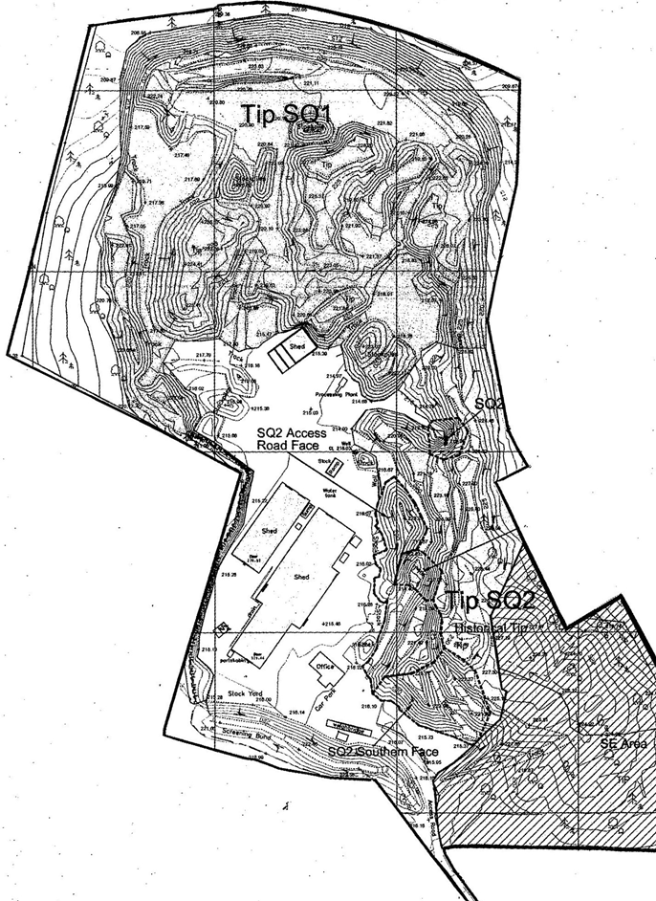

= Noise Monitoring Point

NEAR MISS/NEAR HIT REPORTING FORM
WHAT IS A NEAR MISS/HIT AND WHY SHOULD I USE THIS FORM?
A near miss/hit is something in the workplace that does not result in injury, illness or damage but has the potential to do so.
Reporting a near miss/hit will help us to take actions and make improvements that will contribute to avoiding possible accidents or incidents which may have the potential to cause injury, harm or loss.
Example: An external roof above a walkway is damaged and could leak. Personnel passing through this area are at risk of slipping, causing injury to themselves or others.
Action: Roof repaired before any accidents/incidents occur.
Complete this form if you have any concerns about the safety or wellbeing of yourself or your colleagues and post it in the HS Suggestion Box at reception.

DATE………/………../………… NAME (Leave blank if preferred)……………………………………………………….
LOCATION OF NEAR MISS/HIT…………………………………………………………………………………………………………….
DESCRIPTION OF NEAR MISS/HIT …………………………………………………………………………………………………………………………………………………………………………………………………………………………………………………………………………………………………………………………………………………………………………………………………………………………………………………………………………………………………………………………………………………………………………………………………………………………………………………………………………………………………………………………………………………………………………………………………………………………………………………………………………………………………………………………………………………………………………………………………………………………………………………………………………………………………………………………………………………………………………………………………………………………………………………………………………………………………………
Office use only
NEAR MISS/NEAR HIT ASSESSED BY………………………………………………………
DATE OF ASSESSMENT………./………./……….
ACTION TAKEN
………………………………………………………………………………………………………………………………………………………………………………………………………………………………………………………………………………………………………………………………………………………………………………………………………………………………………………………………………………………………………………………………………………………………………………………………………………………………………………………………………………………………………………………………………………………………………………………………………………………………………………………………………………………………………………………………………………………………………………
I confirm that the near miss has been assessed and relevant corrective action/s taken.

SIGNED……………………………………………………………………DATE………./…………/…………
PRINT………………………………………………………………………POSITION……………………………………………………………

(DOCUMENT ENDS)

