31176 : Proposed ventilation system, 35 Nicolson Street, Greenock.

Air Change
The proposed catering layout would require canopy measuring approximately 3m x 1m to be positioned in the kitchen over cooking equipment.
The possibility of cooking odours migrating upwards and through the fabric of the building should be negated by providing a canopy uplift rate of 0.5 metres per second. This would equate to an overall extract rate of 2.2 m³/s per canopy, which is in excess of 50 air changes per hour in the servery area.
In order to prevent the system from stalling, due to static pressure loss, or to cause unacceptable draughts being created throughout the premises, it would be necessary to produce a supply of filtered replacement air. This would provide approximately 80% of the extract rate in the servery area.

Canopy
The canopy above the cooking suites overhang the cooking equipment by the latest guidelines as laid down in DW 172 by B&ES. They are to be constructed from 304 stainless steel a minimum of 1.2 mm thick.
Filtration of the atomised fats and steam is effected by stainless steel baffle type filters, fitted within a retaining bank to the rear of the canopy. This bank would be set at an angle between 30° and 60°, to allow effective condensation on contact and unimpeded drainage of the fats to a containment gutter and removable drip cup.

Extract Flue
Galvanised steel flue to run below ceiling & out through rear wall, rising up rear wall to terminal above roof finish, secured to external masonry by anti vibration brackets with terminal a minimum of one metre above roof finish level.
Flue ducting will be 500mm diameter and will be bracketed to the existing ceiling then pass through wall rising up rear wall with appropriate steel angle brackets and fixings with anti vibration mountings.
There will be a Vertical Discharge Unit (VDU) fitted to the top of flue duct.
There is a rain catchment and drain off point fitted within the VDU which stops any rain from running down the inside of the ducting and back to the building. These units are designed so that it effectively throws the extract air higher above the building and does not deflect it back down. This greatly dilutes the products of odour within the atmosphere. The terminal velocity at the outlet will be no more than 12 m/s thus minimising breakout noise and within B&ES guidelines.

Fan and Discharge
Vent-Axia “Lo-Carbon” kitchen box fan to be installed. The fan is specifically designed for commercial kitchens, can be fitted close to the cooking hoods, are rated for air streams up to 120⁰C, have variable speed drives, and incorporate backward facing aluminium impellors to reduce noise at source. EKF400E1 model (max flow rate 1ms-1 at 80% speed setting) produces of a sound pressure level of 49dB(A) at 3m. The impact from fan will be less than NR25 at the closest residential property windows at rear of property.
Fan to be fitted to ductwork internally within unit with flexible connectors. Standard bullet / pod type silencer to be fitted to reduce noise levels by >5dB. For silencer to be effective it shall be located adjacent to the fan unit at least one duct diamenter away from fan inlet.
Fan speed should be kept to the minimum level required to adequately ventilate the cooking. Not exceeding target ventilation rates will both save energy and reduce noise emissions. Noise emissions are closely linked to fan rotational speed.

Proposed ducting & vertical discharge unit, 35 Nicolson Street, Greenock.
Discharge unit suitable for 500mm diameter spiral flue

Spiral tubes, 3m length
Galvanised spiral tube. 0.6mm -1.0mm mild steel depending on duct diameter. Available in 3 metre lengths.  Note that metal spiral ducting tube is 'female' i.e. spiral duct fittings such as bends and reducers generally slip inside the tube. Lengths of spiral tube can be joined together using male couplers. | 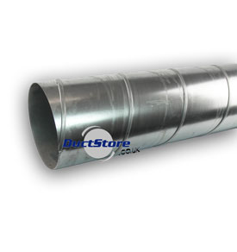
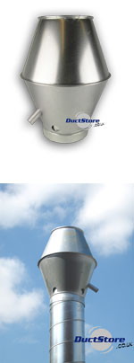
Zinc-plated mild steel.
Jet cowls offer an advantage over standard round cowls in that expelled air is directed vertically rather than laterally - as is common with most roof terminations. This decreases the possibility that exhaust fumes present a nuisance to neighbouring buildings. Using a jet cowl often means a vertical duct can be shorter than it would otherwise need to be with a standard cowl.
Rainwater is caught in a dish within the cowl and is fed out through a drainage tube.
Jet cowls are designed to connect directly to spiral duct tube.

