39 Castle Road Newport – PO30 1DT: GRID REFERENCE: SZ 49297 88590

Description of Property
Circa 1810, Grade II listed dwelling. 1445 CASTLE ROAD (South East Side) Nos 39 to 43 (odd) SZ 4988 NW 5/19. II GV. C18/C19. 2 storeys purple, grey headers with red brick dressings. Gable end slate roof. 2 windows to Nos 39 and 41, No 43 has one window without glazing bars, its doorway is on the south west side. Recessed doors, wood doorcases with thin pilaster strips, bracketed hood. Nos 35 to 43 (odd) form a group. Both properties either side have had UPVC extensions. Part of a conservation area. At some point in the property’s lifespan (dates unknown) a single skin extension has been added to this property.
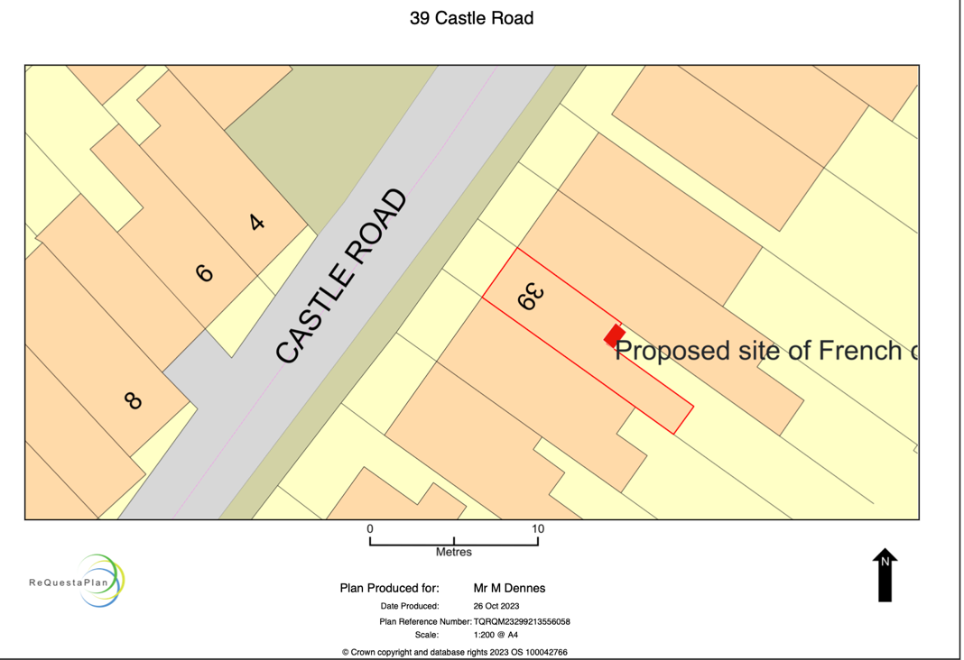

Access statement

Rear access is currently through the single skin extension (wooden door) as seen in the appendix. This would be removed and blocked up. Then, proposed access would be through the new wooden timber French doors leading from the dining room onto the patio in the garden.

Design description of Proposed Work

I plan to remove a timber window and extend the window frame to the floor to include French doors. The current access to the rear of the property, a wooden door from the single skin extension, would be removed and blocked up. The floor would then be raised a step added internally. All materials used will not be seen from the outside and will increase the liveability of the property by making access easier for my family and disability access to the garden. No disturbance to the historical fabric, I agree this is taking place in a single skin extension and it is attached to the original building, but it will have no change on the historical building fabric.
Impact of Proposed Work
There would be no impact to the front of the building from the roadside or the rear. When viewed from outside, there would be no visible change to the appearance of the building and the materials used would be timber and the single skin extension would be the same as before. Given that the doors cannot be seen, it would not be possible to see that the new timber framed double glazed doors are there. Given the fact that either side have had UPVC extensions, it would not look out of place and I am using original timber.

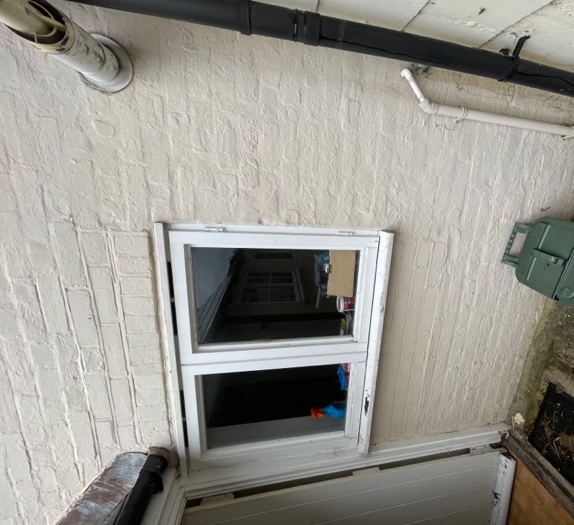
Image shows the area where I propose to replace the windows with a set of French doors to lead to the external space. These windows are located off the dining room.

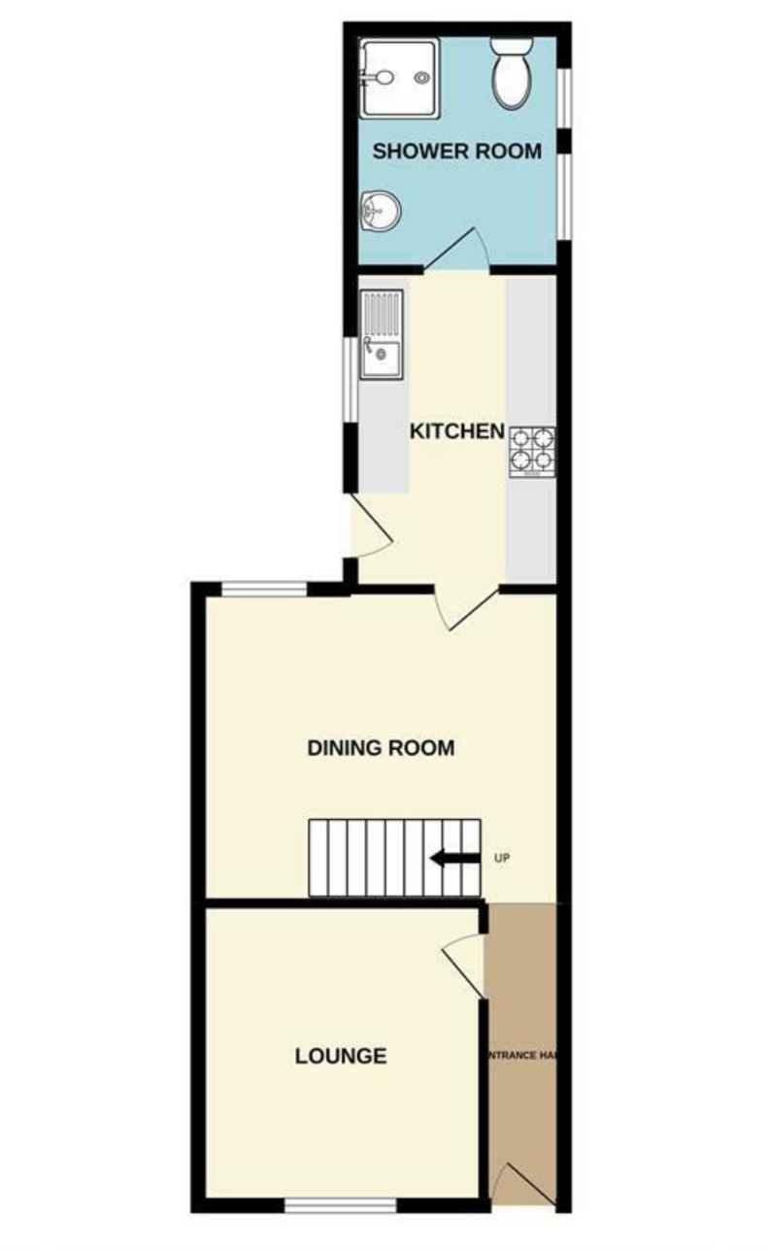

From this image you can see that previously the window has been reduced in size.

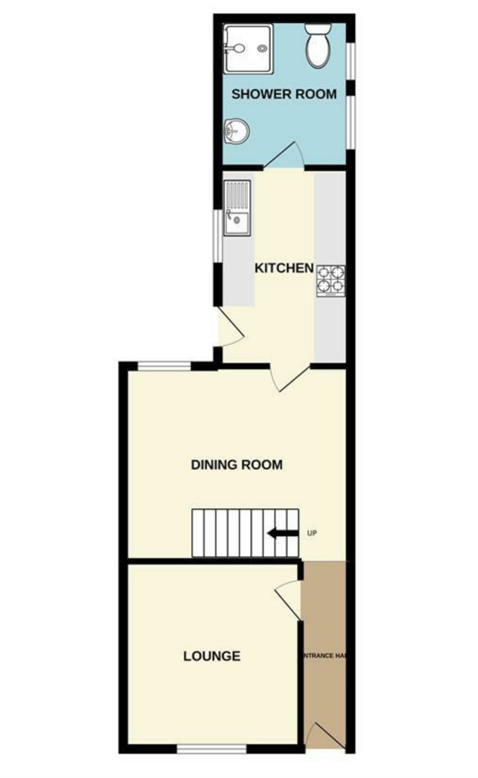
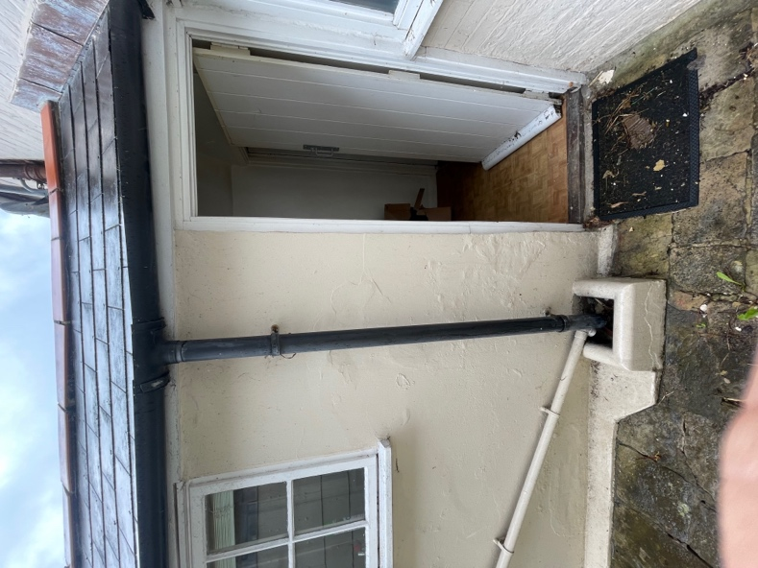
Image shows the current exit to the outside space and is part of the single skin extension to the property.
