Design & Access Statement for the installation of Solar PV system

Crooks Hall, Way Bank Lane, Boyton End, Stoke by Clare, Sudbury, Suffolk

David and Lesley Metcalfe, December 2023
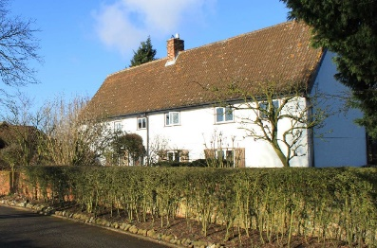
Crooks Hall is grade 2 listed and occupies approximately one acre of rural Suffolk in the watershed area of the river Stour. It is an elevated site at the end of a no-through single-lane road, approximately one half a mile from its nearest neighbour. It is surrounded by agricultural land actively farmed by the neighbour, Mr Kiddy, and his associates.

We believe there has been a residence on this site for at least three hundred years with elements of the property dated to c1700. Once thatched and partly cladded, the buildings were extensively renovated and extended in the 1970s. They now comprise the original Crooks Hall, Crooks Hall Cottage (converted from an original detached flint stone fronted stable block) and Crooks Hall Studio (converted from a detached garage built new in the 1980s). All three buildings have light and power connected and are in constant use by Metcalfe family members.

We respond to the global necessity to consider human impact on the environment and the national call to use renewable sources of power as alternatives to fossil fuels. We consider this investment in solar electricity production to be an integral part of the preservation of the site as a viable residence for the longer term and feel we should take this opportunity as and where we are permitted and able.

The company we have chosen, Cambridge Solar, has a long and reputable history of this type of installation. They have provided us with a clear and considered proposal (still relevant although ostensibly outdated) which comprises a neat and modest installation of 10 panels on the west facing pitch of the studio building. *¹

West-facing panels are known to receive less solar power than south-facing panels, but this compromise means that the installation will not be visible from any public land. The primary view of the property and its context is of the front, southern elevation*² and this will not change in any way. The only view of the installation will be from the western field which has no public access. The panels seen from here will be in the context of the tennis court. *¹ The panels themselves will be matt black in further consideration of visual discretion.

Access to the site will be unchanged by the installation. Access to the work site is already sufficient for the size of lorries needed to deliver the panels and scaffolding. We anticipate no impact on the local environment or road networks. The installation and works will be fully on site and need no cooperation from the surrounding landowners.

The solar PV system will not cause any changes to the use of the site, other than the normal increase in the use of electricity predicted nationally for the near future. Such as that due to the increased use of electricity for heating and in electric cars. We hope that this installation may help mitigate our personal energy costs and preserve the value and viability of the property for future owners.

*¹ [Cambridge Solar PV Proposal.pdf]

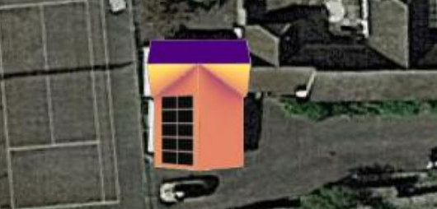

*² [Location.pdf]

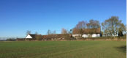

*¹ [Cambridge Solar PV Proposal.pdf]

