21/01418/FUL - 11 Cumberland Place

Discharge of 07 Refuse & Recycling (Pre-Occupation)
Please see below the information regarding which bins will be supplied at 11 Cumberland Place. These have been requested from New Waste Provisions in order for the discharge of the pre-occupation condition 07 of p
Following the guidance from Southampton Waste Management literature for new developments. We have requested 2 x 360L Euro Bins, one for General & one for Recycling. This falls in line with the requirement for Six 1-person apartments.
This is in line with Southampton waste management resources to which I have linked below.
We have attached the location plan and site layout, which shows the approved location of the bins under the planning application 21/01418/FUL.
https://www.southampton.gov.uk/media/odcmnuur/9-_waste_management_tcm63-366608.pdf
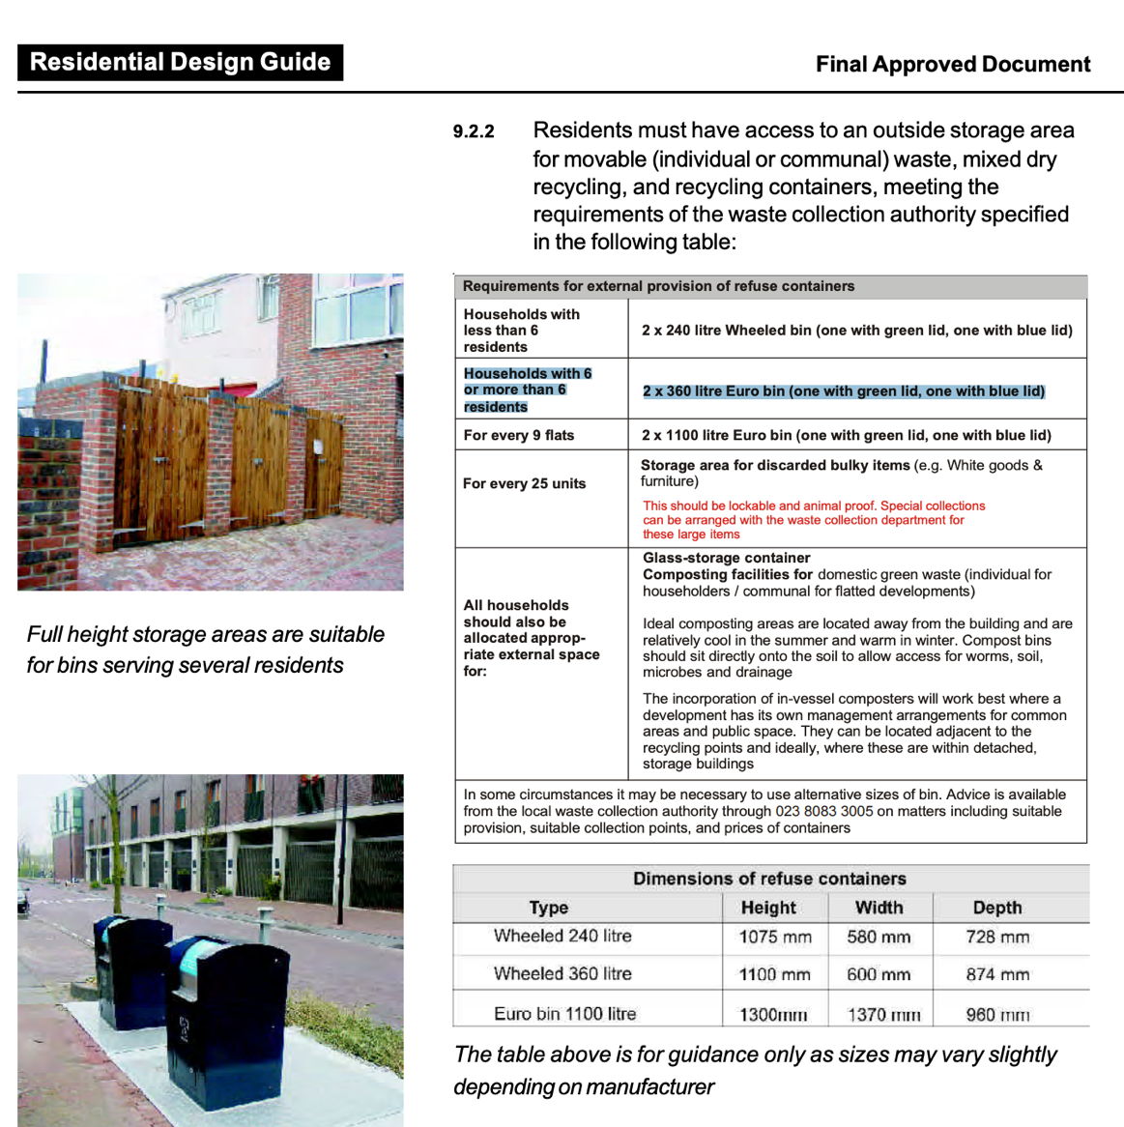

We plan to store the Bin into a housing unit similar to the one below so that visually they do not look an eyesore to the surrounding area.
