Heritage, Design and Access Statement

17 Alfred Mews
Deal
Kent
CT14 6LR

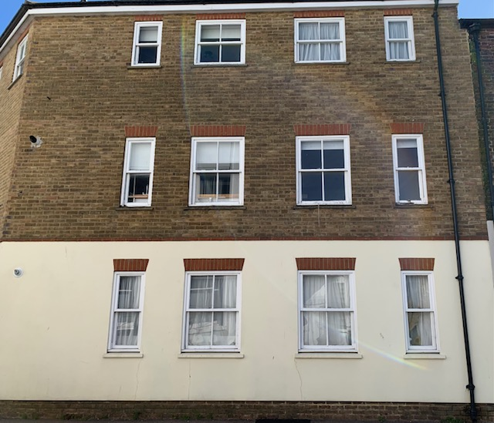

Background

The property compromises of 6 flats built over three storey’s in the conservation area of Deal. The building is a modern building, built in approximately 1990 with rendered and brick elevations, with sliding sash windows under a slated roof. When constructed, the conservation area was given due consideration and so the design is sympathetic towards this. It is noted however, that the brick bonding is modern, being in stretcher bond and the window heads do not have sprung arches, like many of the properties, they are brick on edge.

On the 27th November 2019 permission was granted to replace the windows to the front elevation with new timber windows and sash looking UPVC windows to the rear of the building. Since this date, planning permission has now expired and only a few of the windows to the rear have been replaced with new UPVC ones.

Due to the terms set out in our lease, every four years we are required to have the whole building painted inside and out, including the windows. The ground floor bonding can be painted without any problems however it requires scaffolding to be erected at the front and rear to paint the windows, even thought the money would be best spend on replacing them at this point.

Unfortunately the costs for this have been unsustainable over the years, even more so now. As a result the building is falling into disrepair, with the main reason being the cost for scaffolding and decoration clauses set out in our lease. We feel the current look of the building is detrimental to the surrounding area in which it lies.

We would like to replace the windows for double glazing, so to be more energy efficient, whilst eliminating the condensation which has contributed to the rotten timber frames throughout the building. However once again all the money set aside to help pay for the new windows now has to be spent on meeting the terms within our lease, requiring us, no matter how counter productive, to paint the rotten timber windows, which at best last about two weeks.

Proposal

What we are proposing is to replace the rotting rear windows in UPVC (as previously granted) and the front with the same virtually identical sliding sash windows in UPVC, within the opening apertures. We are sympathetic to the conservation area and its surroundings and understand that this is a lot to ask.

However, if not possible, we would be grateful if careful consideration would be given to help solve this problem of ours. We think that having the front ground floor kept in timber frames and having the 1st and second floor windows done in UPVC would not only be a compromise but a solution to this, negating the need for scaffolding every four years, whilst looking indistinguishable to public view.

We feel that this would help considerably with the buildings upkeep and also the overall look within the surrounding area, as money can then be spent on jobs that need doing rather than mandatory jobs just to meet the clauses set out within our lease.

We would be extremely grateful if this could be taken into consideration.

Design

The new windows are not the same material as the existing, being replacement of the softwood timber in UPVC.

As mentioned previously, when constructed, it was considered acceptable for modern construction detail i.e. brick bond and arches, to be adopted. Thermal loss, at the time of construction, was not considered particularly important, unlike today. The properties do have condensation issues, due to the poor thermal performance of the existing windows, the residents would all like to improve this situation with a high thermally rated replica sliding sash window in UPVC. Any differences in the windows will be difficult to notice, once the installation is complete.

Access Statement

There are no implications for means of access by replacing the existing windows.

Conclusion

The residents wish to maintain the attractiveness of the existing building and we do not consider that replacing the windows would be detrimental to the overall look of the building. Global warming and energy conservation are of paramount importance now, which was obviously not the case when the surrounding buildings were constructed.

We respectfully request, therefore, that these matters are taken into consideration when determining this application. The look of the building will not be adversely affected by the proposals, nor will the conservation area. Modern living, heating, draught proofing and the insulation of the walls of Alfred Mews create major problems with single glazing. Due to the concentration of the heat loss through the windows, condensation is the result and single glazing is not appropriate in modern buildings.

We therefore request your sympathetic consideration of the plight of the residents of Alfred Mews with our proposals for the replacement of the rotten single glazed timber windows.

