Rationale for tree removal.
I asked a tree service to provide a tree survey but they indicated this would not be necessary for a single tree in good condition so I enclose a rationale for removal.
The Old Meeting House, Ditchling and surrounding graveyard is held in trust and I have been appointed one of the trustees in 2022. Part of our responsibilities for upkeep is the grounds of the meeting house and to preserve the fabric of the building. There is no TPO on the tree but it is within the conservation area. Lewes DC advised me to apply to SDNPA. The trustees are in full agreement for the removal of the Field Maple. See below extract of minutes of last meeting:
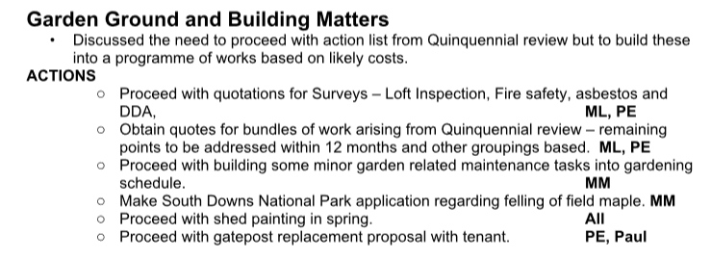
This Field Maple was not deliberately planted in the graveyard and has grown from a sapling to a full established tree. It has quickly (within 20 years) out grown its surroundings and is already as tall as the house and the edge of the crown is within a few feet of the property.
In addition the roots are now affecting several gravestones which are tilting at precarious angles and the short wall behind the tree which marks the boundary of the original graveyard and the new memorial garden is now also at risk from damage from the roots.
It is the trustees full intention to replace this tree with a slower growing less extensive tree in a similar position but further from the graves.

Three images
1 Photo taken this month of tree to show lean of gravestones.
2 Image from Google Maps to show position of tree.
3 Plan to indicate tree marked T 1 and highlighted.
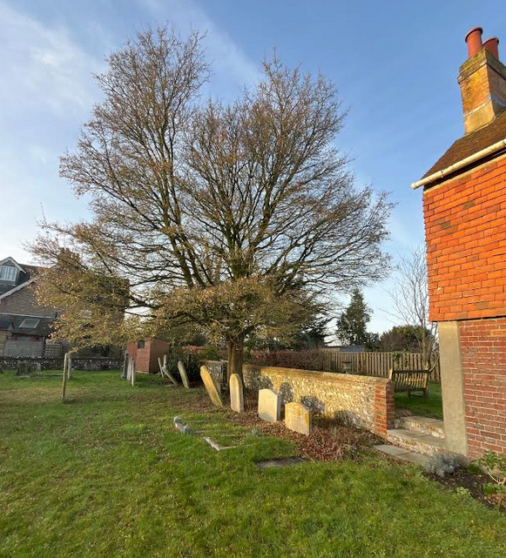
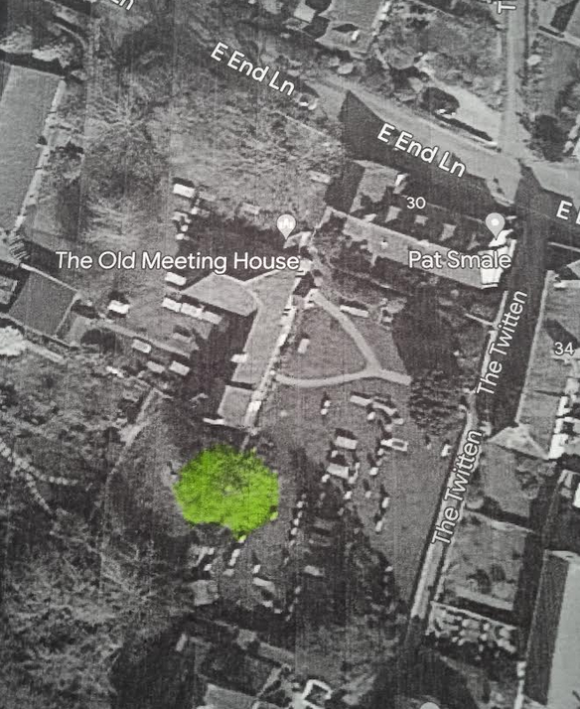
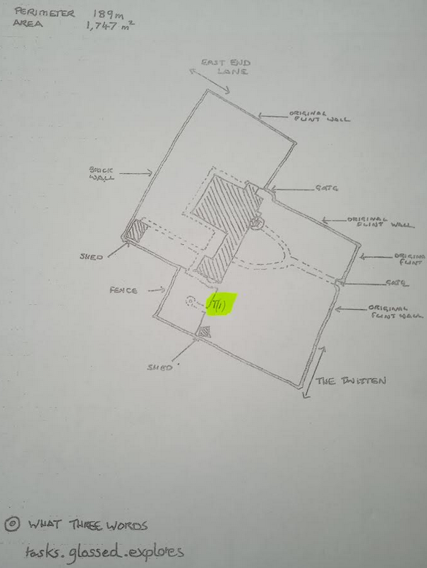

Melissa Mathur

