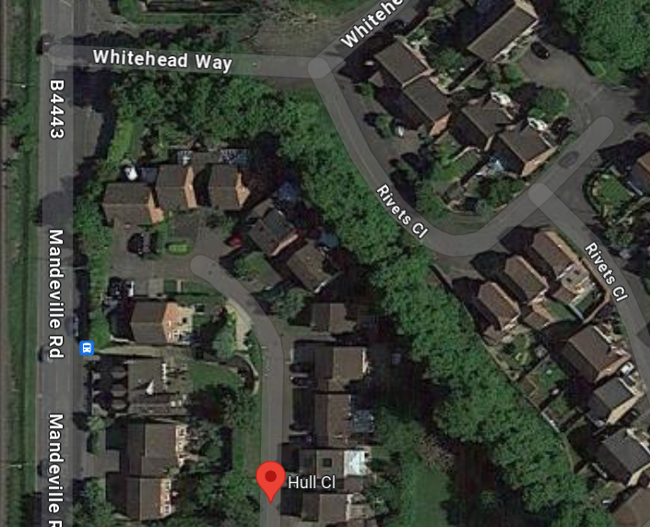
G1

Work location – 14 Hull close, Aylesbury, HP21 8RX
Works to be done – G1 – x2 Lime trees to be reduced by 4m to leave the trees at height of 15m and a spread of 8m.

