Customer |  |  | Madeira Drive | CIWS WO Number |  | 35297
 |  |  |  | MD ID Number |  | BS2 - Trial
 |  |  |  | Component Type |  | Balustrade Stanchion
Inspection Criteria |  |  |  | Results |  |  | Notes
 |  | Check tag attached to component
1 |  | MPI |  | Yes – identify findings below |  |  | Insert Date of Inspection:  1/06/2023
2 |  | Measurements taken |  | Yes– insert measurements as shown.  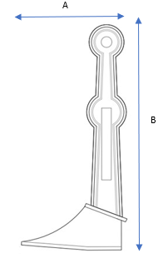 |  |  | A = 29cm  B = 131.5cm
3 |  | Identify any cracks mark on casting with yellow pen and mark on drawing |  | 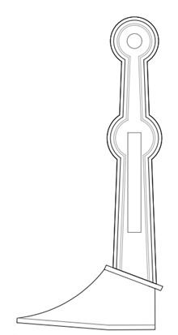 |  |  | Cuts and cracks support frame and on the base frame.
4 |  | Check for pitting corrosion >5mm in depth and >5mm in diameter mark on casting with yellow pen and mark on drawing |  |  |  |  | Eroded base frame & eroded decorative sides.
5 |  | Check for decorative repair mark with yellow pen on casting and mark on drawing |  |  |  |  | Eroded decorative sides.
6 |  | Identify any damaged threads if any mark on casting and on drawing.  Also need measure thread diameters  Identify any damaged bolt holes.  Detail any other defective area to include cracks propagating to surface lamination. |  |  |  |  | Thread Diameters :  N/A
7 |  | Photo taken once inspection complete, and all areas marked take multiple photos of defect areas |  | Yes  Min 2  Max 4
 | Pre-Repair Photographs:
 | 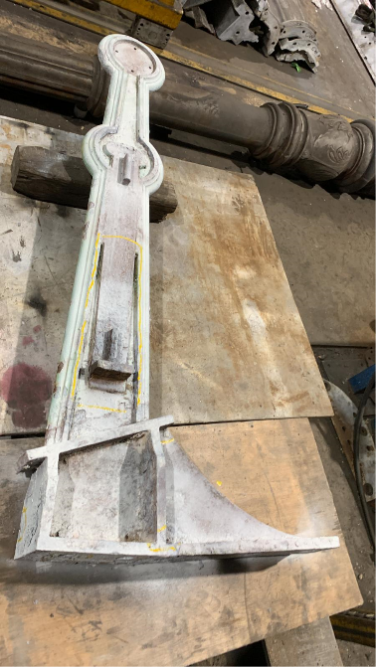 |  |  |  | 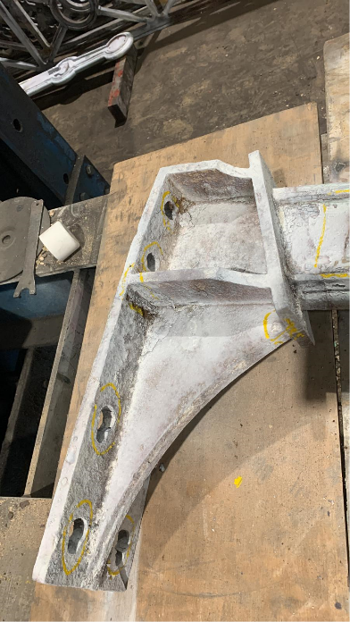
 | Photo 1: |  |  |  | Photo 2:
 | Photo 3: |  |  |  | Photo 4:
 | Post Repair Photographs:

MPI Date:

Weld Date:

Welder:

DPI Date:
 | Photo 1: |  |  |  | Photo 2:
 | Photo 3: |  |  |  | Photo 4:

