Customer |  |  | Madeira Drive | CIWS WO Number |  | 35295
 |  |  |  | MD ID Number |  | SP1 - TRIAL
 |  |  |  | Component Type |  | Spandrel Panel
Inspection Criteria |  |  |  | Results |  |  | Notes
 |  | Check tag attached to component
1 |  | MPI |  | Yes – identify findings below |  |  | Insert Date of Inspection 31/05/23
2 |  | Measurements taken |  | Yes– insert measurements as shown.  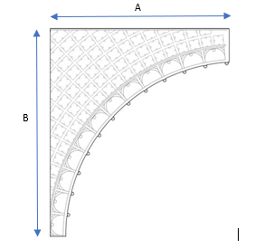 |  |  | A = 2515 mm  B = 2230mm
3 |  | Identify any cracks mark on casting with yellow pen and mark on drawing |  | 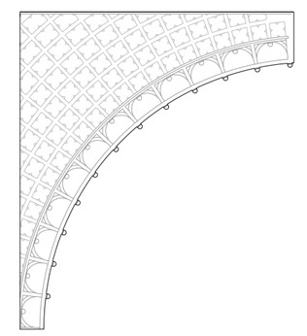 |  |  | Cracks found two locations on lefthand side and missing section on righthand side of section
4 |  | Check for pitting corrosion >5mm in depth and >5mm in diameter mark on casting with yellow pen and mark on drawing |  |  |  |  | Corrosion on decorative side  Eroded bolt hole
5 |  | Check for decorative repair mark with yellow pen on casting and mark on drawing |  |  |  |  | Small corrosion
6 |  | Identify any damaged bolt holes mark on casting and on drawing.  Detail any other defective area to include cracks propagating to surface lamination.  Ensure screw bolts are removed and retained. |  |  |  |  | Thread Diameters :  Screw bolt stuck – once pre-heated for repairs bolt expected to become loose
7 |  | Photo taken once inspection complete, and all areas marked take multiple photos of defect areas |  | Yes  Min 2  Max 4
 | Pre-Repair Photographs: Photo 1 :
 | 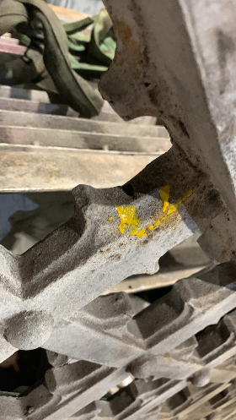 |  |  |  | 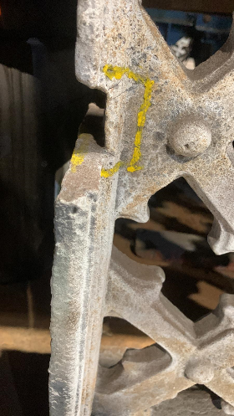
 | Photo 2: |  |  |  | Photo 3:
 | 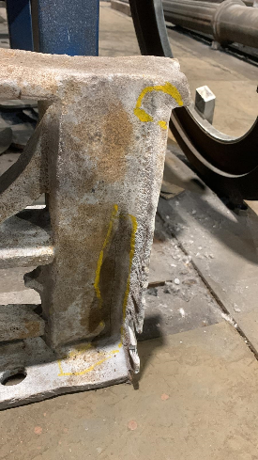 |  |  |  | 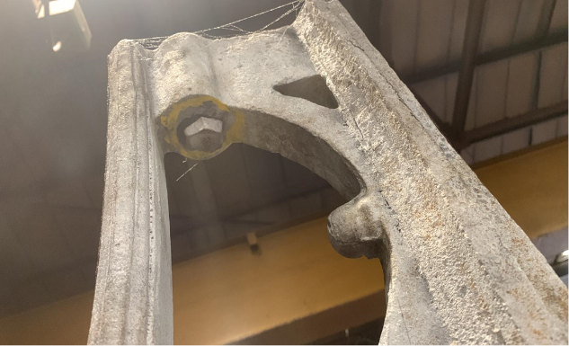
 | 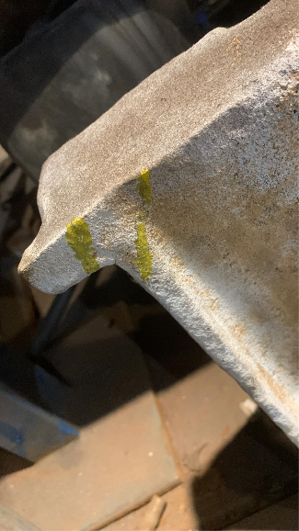  Photo 4: |  |  |  | Photo 5:
 | Post Repair Photographs:

MPI Date:

Weld Date:

Welder:

DPI Date:
 | Photo 1: |  |  |  | Photo 2:
 | Photo 3: |  |  |  | Photo 4:

