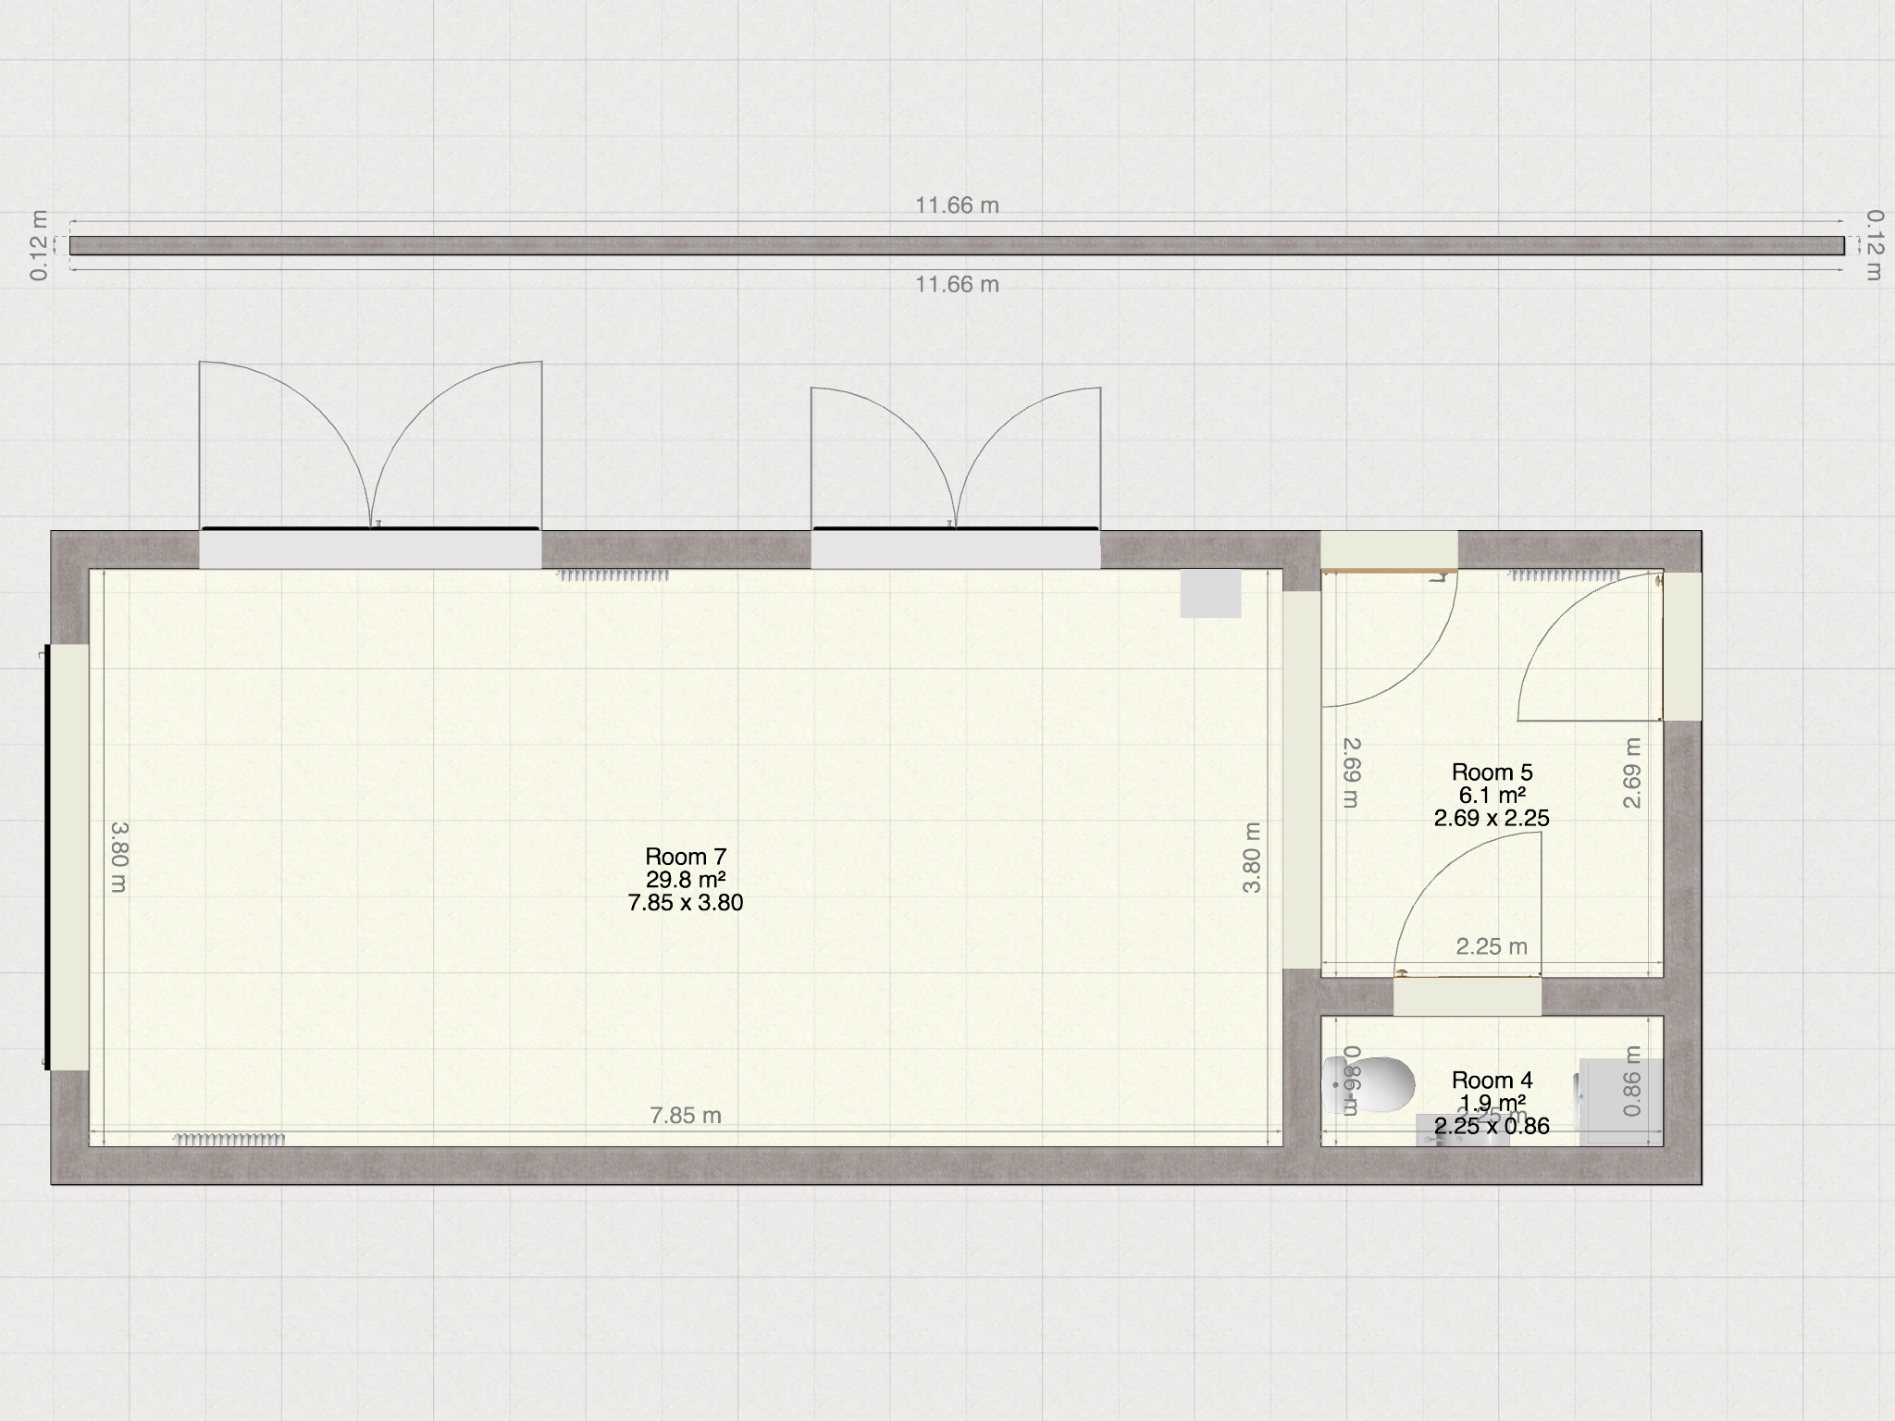

Toilet /

utility

Existing hall

New kitchen

5 m

8.00 m

End of main house

Neighbour’s wall