The Old George, Nailsworth, GL6 0BL
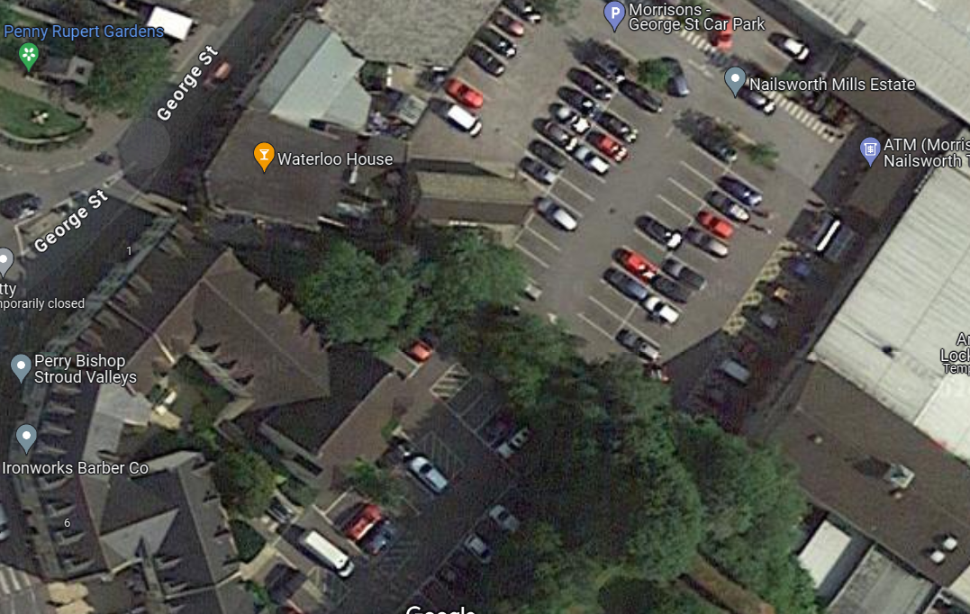
T3
T2
T1
Image 1: Approximate tree locations (GoogleMaps)
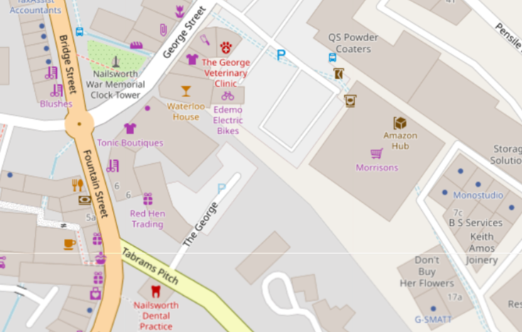
Image 2: Approximate site location

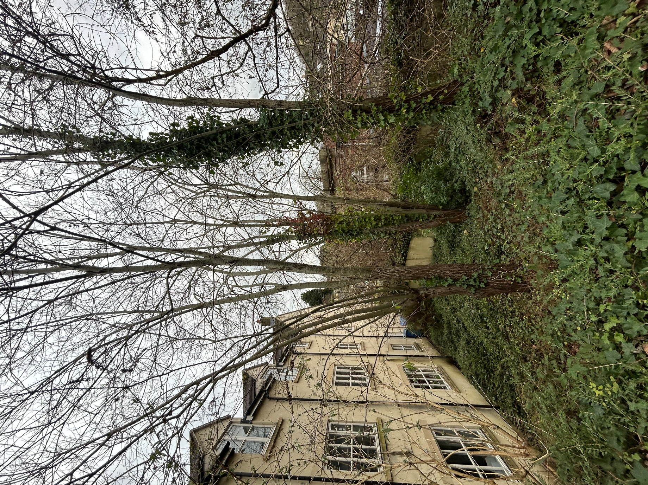
T1
T2
T3
Image 3: Willow trees in proximity to building

