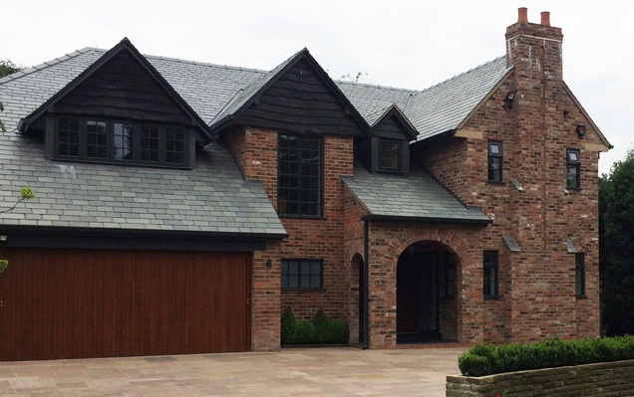
Hi Ian

Please see below email regarding the roof slates

Kind regards
Mike

From: Neil Purcell [mailto:neil@ukslate.com]
Sent: 09 February 2024 15:10
To: Michael Pears
Subject: 21 North Park - Green Slate

HI Michael,

Looking at the photos you sent over for 21 North Park. The slates look to be very small (peggies). I would say it will be very difficult (near impossible) to source the difference from the wastage you will probably get from stripping them.

I would recommend using our Elterdale Grey Green in diminishing course x random width. Elterdale has been accepted as an alternative to Westmorland Green on various projects in the Lake District national park. We have also supplied various projects around the Fylde area.

We can offer the Elterdale in a 500-300mm diminishing course x random width so it wouldn’t look to dissimilar to what you are trying to achieve.

If you have any questions please let me know.

Many Thanks

Yours faithfully
Neil Purcell
Sales Manager

Tel : 015395 59289
Mob : 07843 469475
Web : www.ukslate.com

