Design and Access statement

17 HOWARD CLOSE
W3 0JY

Front porch extension

Proposal:
- The proposal is for a front porch extension to the dwellinghouse located to the East of the Cul-de-sac. No 17 is neither locally nor nationally listed and is not sited in a Conservation Area.

- The proposal is for 1 metre deep by 5 metre wide front porch extension. There has been many similar applications approved within the street and vicinity of the site with identical properties and bay window features which is presented within this statement.

- The site already has lawful consent for demolition of front bay window and front porch extension and this application is for extending the depth only and changing the flat roof design to a more matching tiled slope roof to the house . The lawful certificate applications are reference 240050CPL and 240049CPL.

- Similar proposal was refused due to impact on the character of the house, however under permitted development as granted, the bay window can be demolished and a 5 metre wide porch can be erected in its place lawfully and as such the previous refused reason does not stand anymore.

- This application has reduced the width and depth since the previous refused application.

- Should be noted that the street is comprised of various type of dwellings with different width and front features. Even within the Cul-de-Sac Numbers 19 and 20 do not have bay window features and the door location is to the front of the houses rather than to the side. No. 19 has recently been under development with large front porch as well.

- Whilst the officer has taken examples of porch designs from No.15 and 18, there are numerous examples of porch extensions of varied designs and scales in the immediate vicinity of the site. No.1 Howard close was used as an example as part of this application which was approved recently. The officers only mentions No.1 Howard Close in their report justifying it’s approval, however has disregarded other examples that was put forward on The Link with identical house types with the front bay window and side door of which exact front porch extensions were granted.

- However it is believed that in this instance the location of No.1 Howard Close does not justify the argument on ‘dominating appearance’ mentioned by officers as both properties are identical in terms of façade and building features. If one is deemed ‘dominant’, the other property should also have been deemed dominant in the context of the façade design and proportions to the host buildings regardless of the location. No.1 Howard Close is also a semi-detached property with No.2 Howard Close having a bay window feature which could have been deemed unacceptable unbalancing the elevations.

- The delegated officer report for No. 1 Howard Close has clearly taken into account similar front porch extensions on The Link and as such it states ‘there is no objection to the proposed front extension which would not detract from the character and appearance of the host property when viewed from Howard Close and would not have a detrimental impact on the streetscape.’

1 Howard Close Reference 216320HH granted 2021 with an approved 1.2 metre front porch
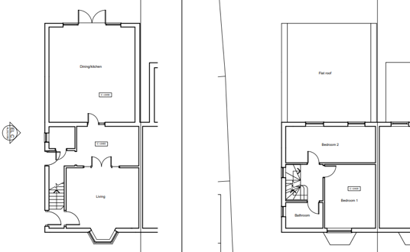
Existing plans

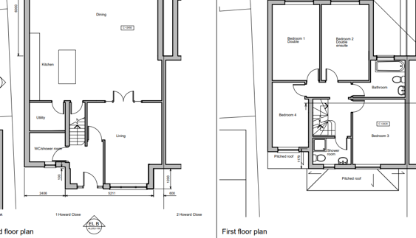Proposed plans
Appeal examples:

- Similar porch design for No.17 The Link was also refused (Ealing Reference = PP/2015/5441) Appeal reference APP/A5270/D/16/3141751) and allowed under appeal. The sole matter with this appeal was the impact of the installation of the front porch. This was also to extend across around three-quarters of the front elevation, including changes to an existing bay window, and would have a pitched roof above.

- Policies 7B and 7.4 of the Council’s adopted Development Management Development Plans Document (DPD) set criteria for the form and design of new development. Emphasis is placed on reflecting the existing street scene and building pattern in terms of scale, materials and detailing. 7. The inspectorate concluded that whatever the context of the Council’s policies, the character and appearance of identical houses on The Link and Howard Close are changing or changed substantially from the conformity that no doubt existed when these properties were first built. The inspectorate under paragraph 7 states that the porch and pitch roof designed would not be substantially different in scale, appearance or materials from what has occurred within the vicinity of the site. The Council had expressed concerns that the new pitched roof over the extended porch would clash with the existing appearance of No 17. The inspectorate was not convinced, however, that the outcome would not give material harm given the changes that have already taken place within the vicinity of the site and identical properties.

- No. 17 Howard Close is identical to these properties on The Link leading to Howard Close and the street has various types of housing with different porch designs . As such there is no uniformity within the street in terms of porch design and the applied porch now is smaller than No.1 HC already granted applications within the street and vicinity of the site. The front porch was also not considered dominating or incongruous to the host dwelling and not detrimentally impacting the character of the dwellinghouse.

- In conclusion, similar designs can be carried out without planning permission such as No.4 Howard Close and the argument of officer about the bay window removal and dominating façade due to the width of the porch should be disregarded as this can still be achieved via permitted development rights for householders.

Conclusion:

- The proposal is designed similar to all the granted applications and identical properties on The Link leading to Howard Close and streets behind which are listed below. The extension would be built in similar brick and roof materials as the original house. For these reason, combined with the design and proportions of the porch, the scheme would be in keeping with the local character and it is believed not to erode the sense of so called uniformity within the Cul-de-Sac taking into account the different porch designs and permitted development rights for householders already granted. Moreover, the site is not within a conservation area and the existing front bay window features are simple unobtrusive features which make little contribution to the character of the area to justify their preservation.

- Despite the location of the site at a Cul-de-Sac in the road, the dwelling is not more prominent than No.1 Howard Close on the same road. The front porch is carefully designed with simple and traditional design similar to examples provided. No. 4 Howard Close can also be viewed as a precedent to realise that the property’s appearance would not be eroded, but rather be improved and updated following the host building fenestration. Should also be noted that No.17 Howard Close has high front hedges that would partially obscure any front porch or extension when compared to the other granted properties with open front forecourts.

4 Howard close as built below:
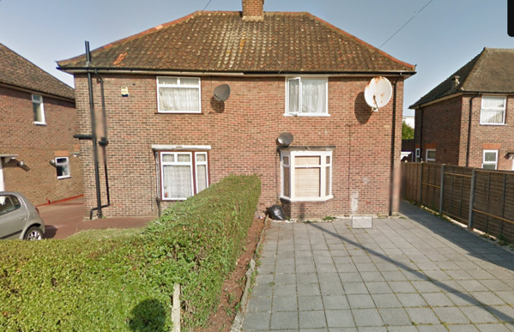
Before porch
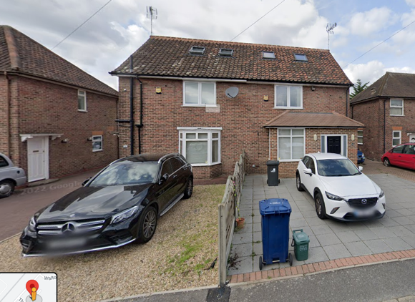
After Porch
- For these reasons, the applicant believes that the scheme complies with policies D3 and D4 of the London Plan, adopted 2021 and policies 7B and 7.4 of the Ealing Development Management DPD, adopted 2013, as well as the National Planning Policy Framework. These policies seek, amongst other things, a design led approach to high quality design; having regard to contextual form, layout, pattern, scale, materials and detailing which complements the existing building and character of the area. The porch is designed in simple design language matching the materiality of the host dwelling whilst removing the bay window feature which does not have an immense contribution to the character of the building and the area. The front forecourts of the dwelling is also around 7 metres deep comfortably accommodating the designed porch depth.

- Apart from above examples, No.4 and 2 Norman Way Approved ref 220364FUL/ 223142FUL have no side garage to take as reference and were granted for identical designs to this application which should have also be deemed as ‘dominating to the character’ of the building as it would remove the bay window with similar proposed depth and widths. The front porches were considered acceptable within the delegated reports suitable for the buildings.

- I believe the examples should be taken into account to determine the decision for this application for matters of consistency. This is because main concern has been the domination of the development to the building and identical extensions were approved . Based on the research no front porch of exact design was refused within the vicinity of the site . The porch herby is carefully designed proportioned to the house and front forecourt of the house with modern simple architectural features matching the main house materials whilst updating the rather out of date front bay window enhancing the existing dwelling whilst maintaining the overall integrity of the building.

SOME OTHER EXAMPLES:

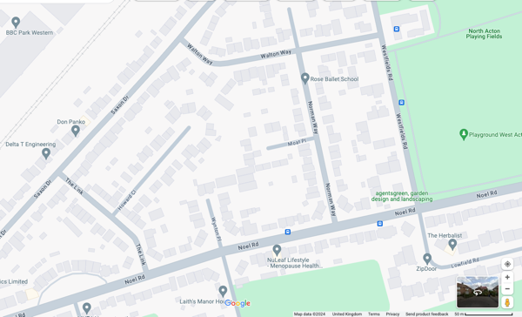

- The examples granted of similar design with identical building characters. Should be noted that this area was built by Great Western Rail as part of the Housing Association and as such there many identical modest buildings of such character within the vicinity of the site and these are just few examples which more can be found.

13 The Link, Reference 202892FUL granted July 2020
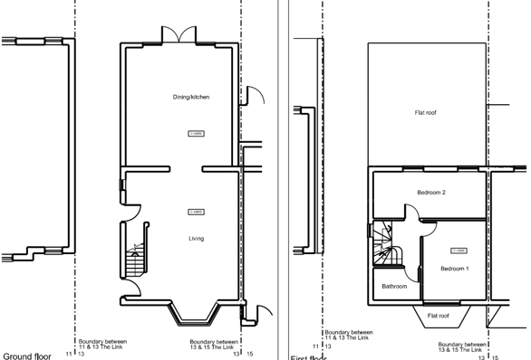
Existing plan
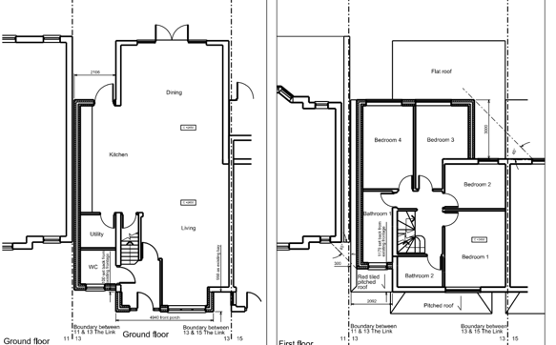
Proposed plans
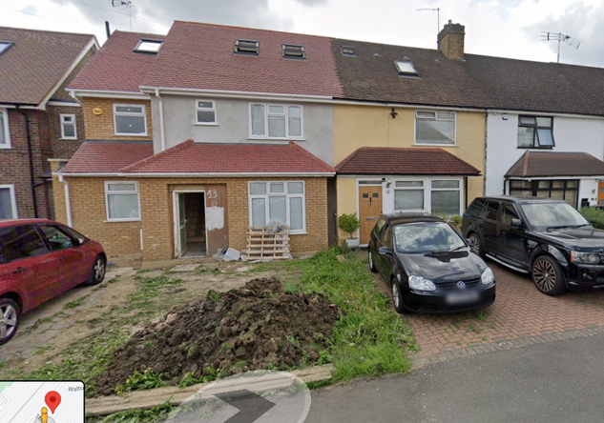
The Link After porch and front extension:
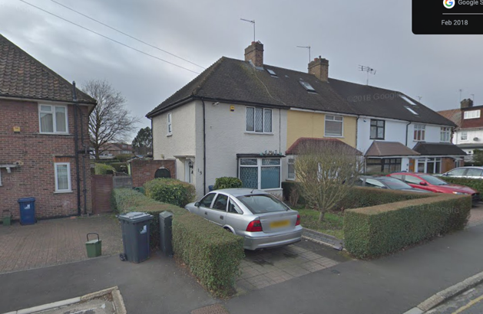
The Link Before porch extension:

2 and 4 Norman Way reference 223142FUL granted for identical front porch extensions:

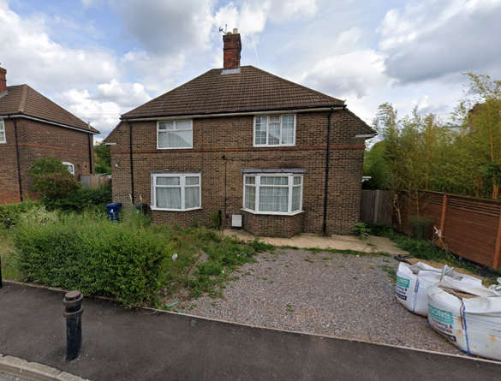
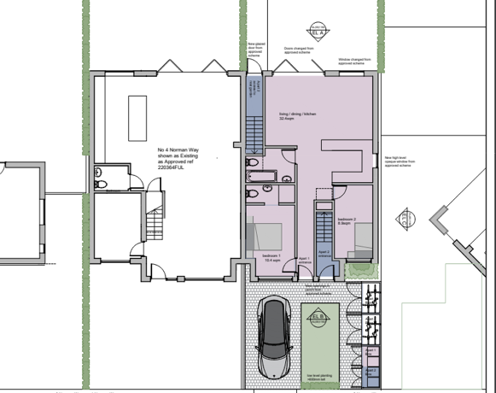
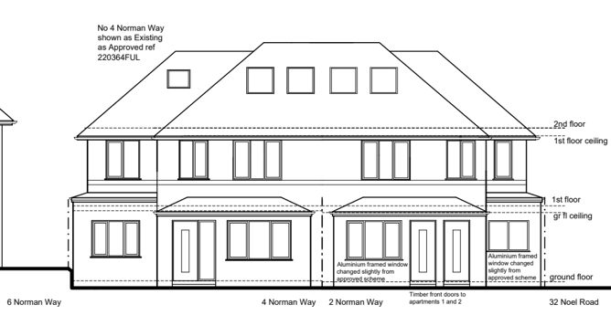
Proposed Elevation with front porches

11 Walton Way
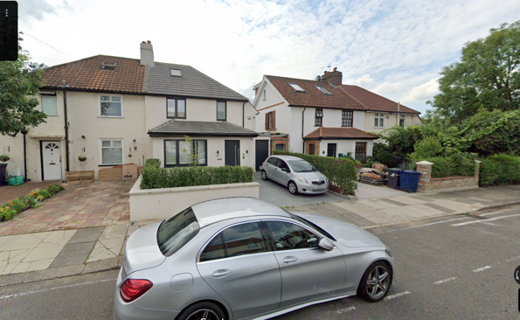

22 Walton Way the street behind Howard close
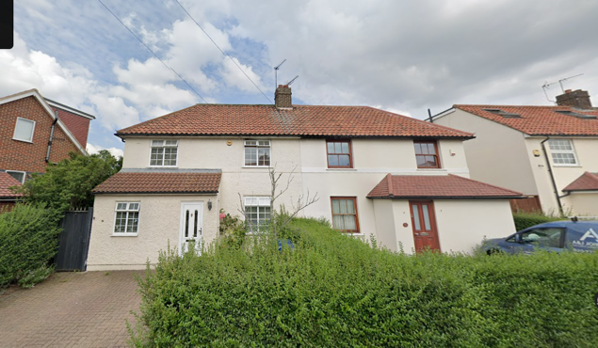

Wynton Place
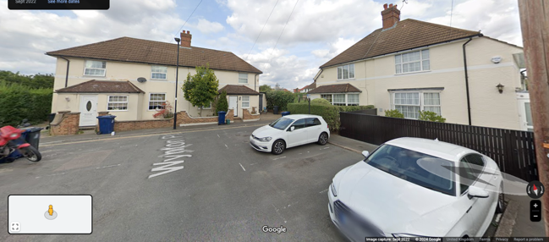

116 Saxon Drive and many other properties on Saxon Drive
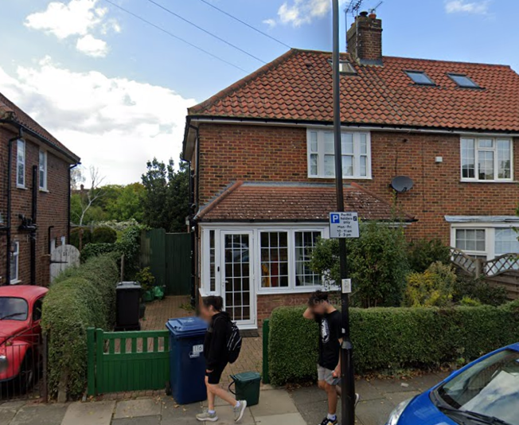

SITE PHOTOS 17 Howard Close:
No. 16 under construction for loft conversion as well as No.19

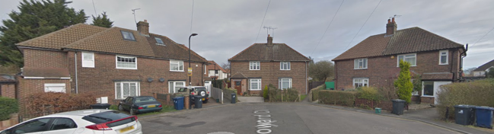

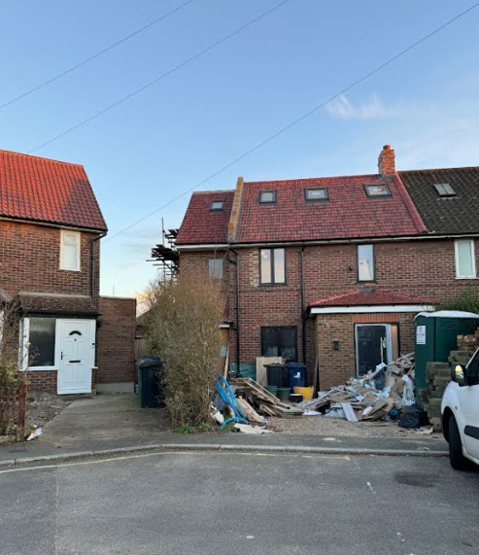
No. 19 Howard Close under construction with different building type (no original bay window)

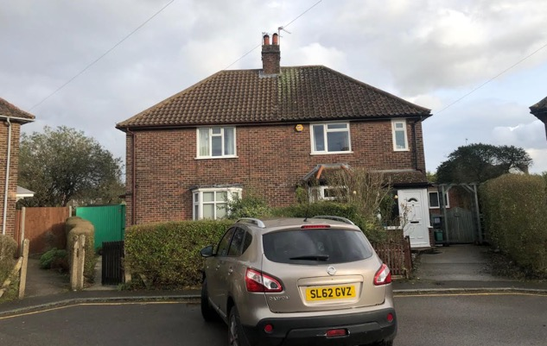
No. 17 Howard close front elevation before No.18 Loft conversion

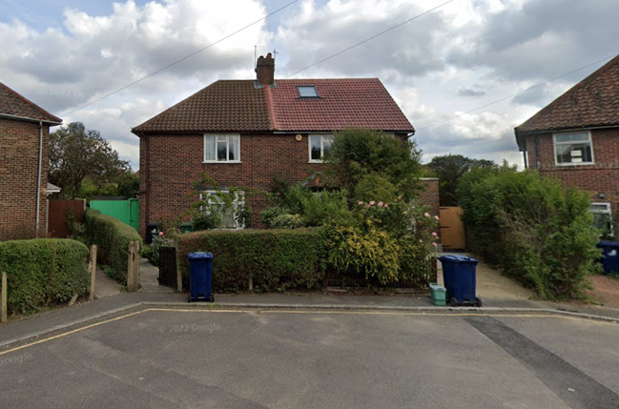
No.17 Howard Close site photo after No.18 loft conversion

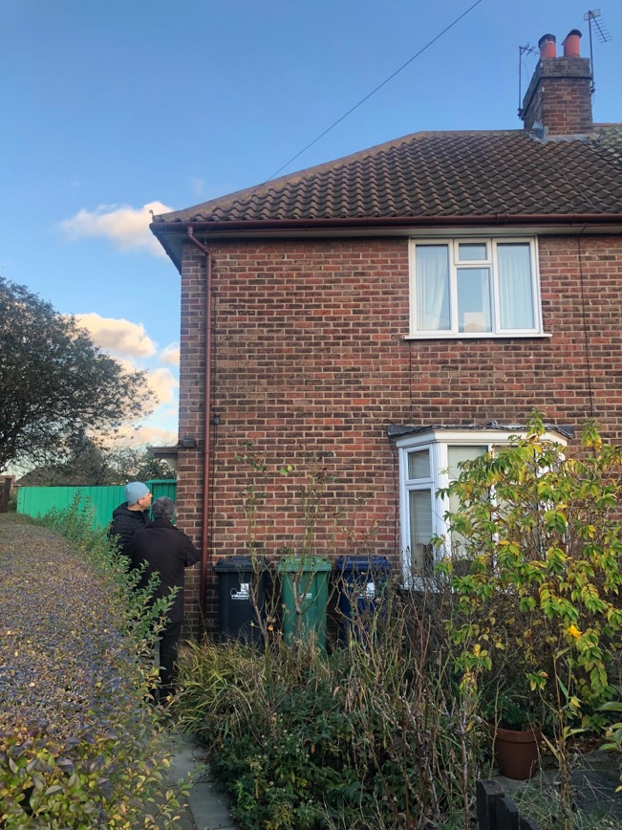
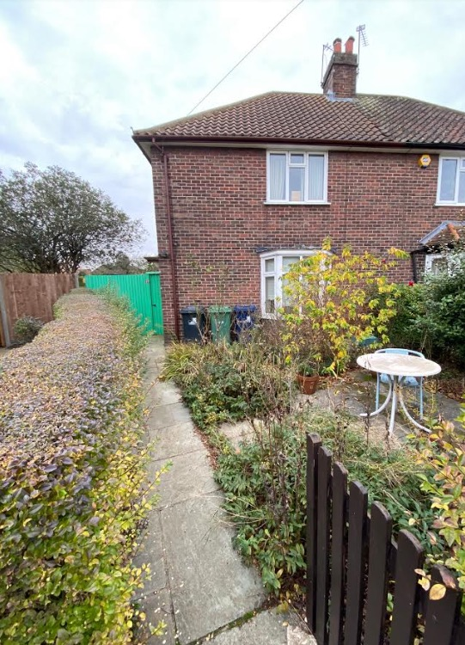
No.17 Howard Close Front forecourt

Rear garden
