Internal view of the existing conservatory

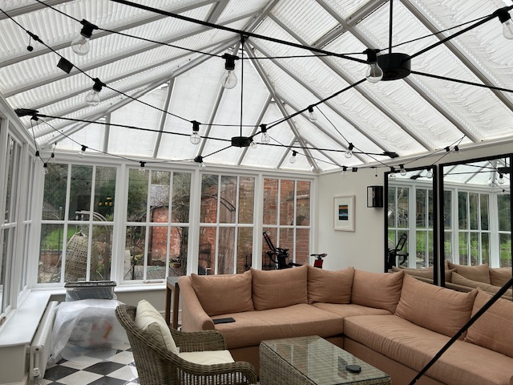

Water ingress from the leaking conservatory roof is undermining the structural brickwork to the rear of the house

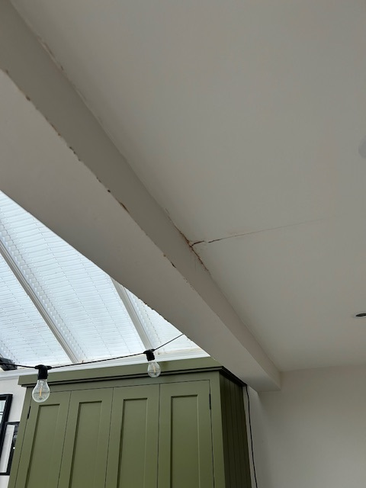

North flank conservatory wall – structural brick wall adjoining the courtyard to the rear of the property

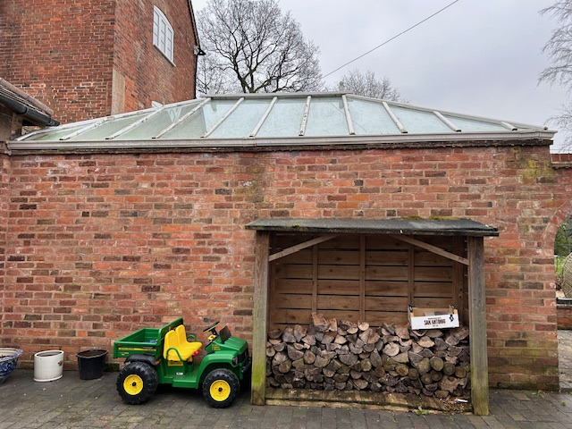

West flank conservatory wall – timber frame glass windows with brick footings

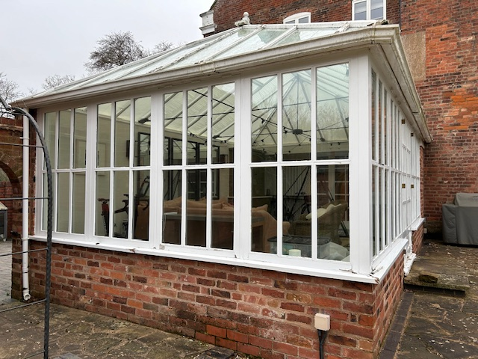

South flank conservatory wall – timber frame glass windows with brick footings and timber frame patio doors

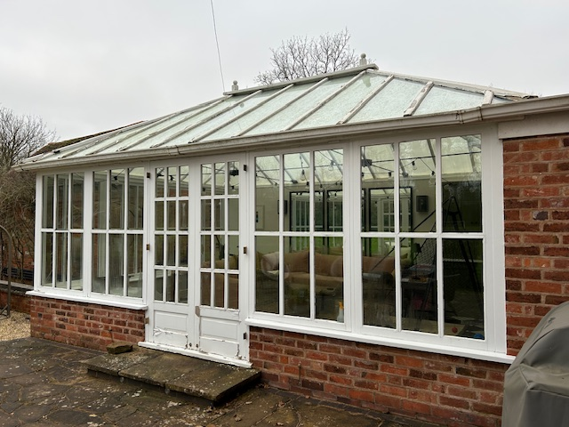

Conservatory roof – timber frame glass lantern roof, rotten structural roof timbers visible

