Design and Access Statement

Full Planning Application for

Proposed Alterations to 38 Belle Vue Road
Shrewsbury
SY3 7LL

For

Dr and Mrs Neil

FEBRUARY 2024

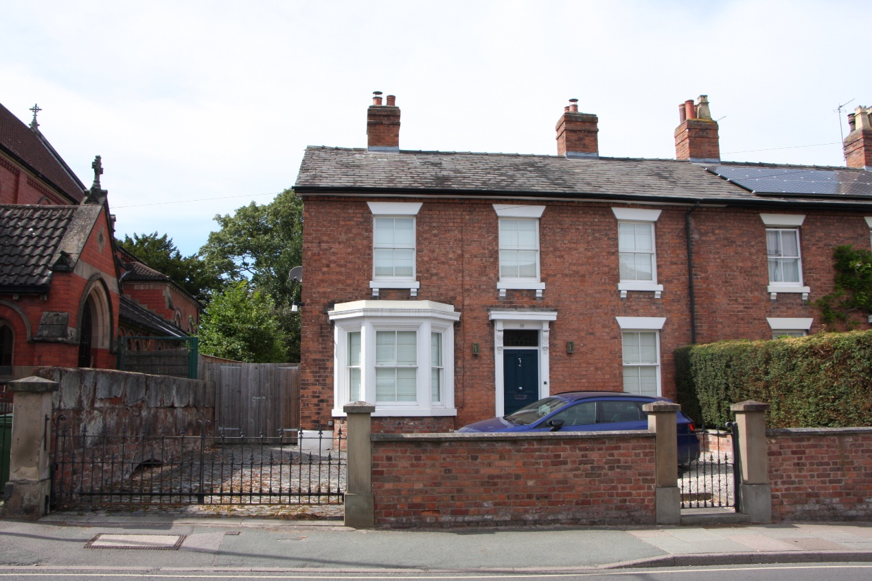

Front Elevation facing Belle Vue Road

Introduction.
This Design and Access Statement is in support of a full application for alterations to form a new kitchen/dining and living area plus repositioned utility room and toilet facilities at ground floor level with an additional bedroom extension with shower room and revised family bathroom position at first floor.

Site Assessment
The site is located in the residential area of Belle Vue.
The site is located within the Conservation Area of Belle Vue.
The dwelling is the left hand part of a traditional Victorian semi detached pair of dwellings.

The total site area is 660m2.

The dwelling currently consists of a walled car parking area facing on to Belle Vue Road and, internally, at ground floor level a central hall with a lounge, dining room, kitchen and family room off, with a utility and toilet facility situated off the family room. The Utility room and toilet are sited off a joint boundary wall with no 36 and are single storey with a mono pitched roof.

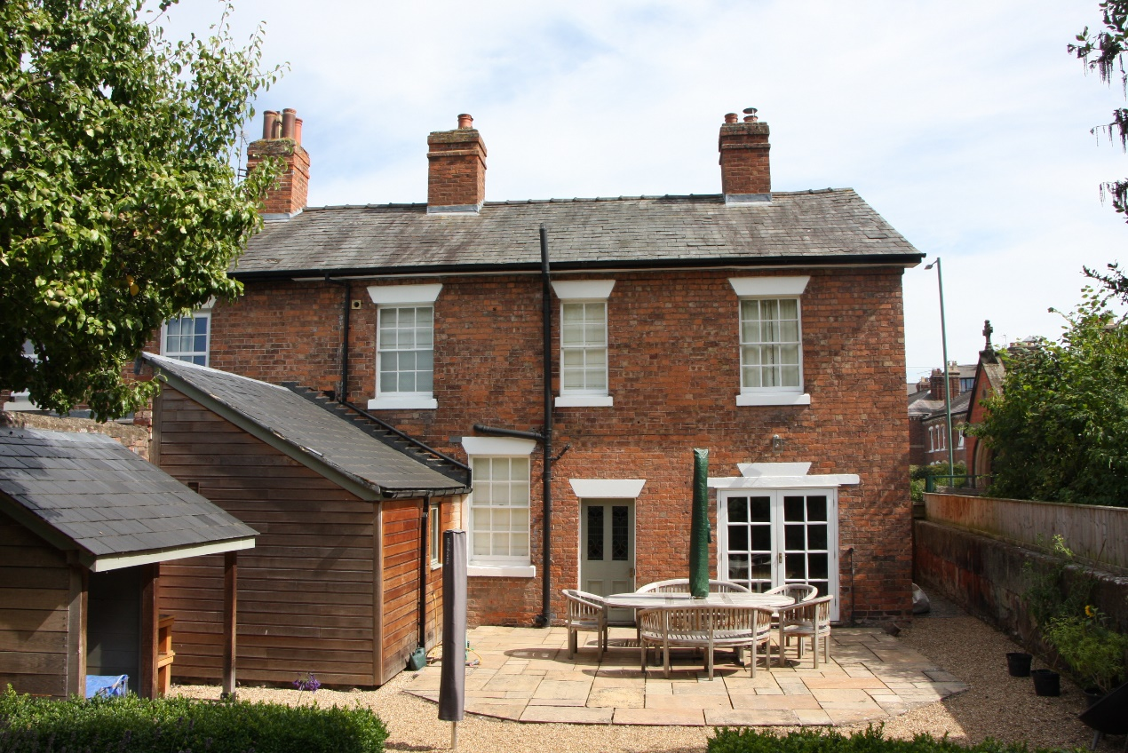

Existing rear elevation.

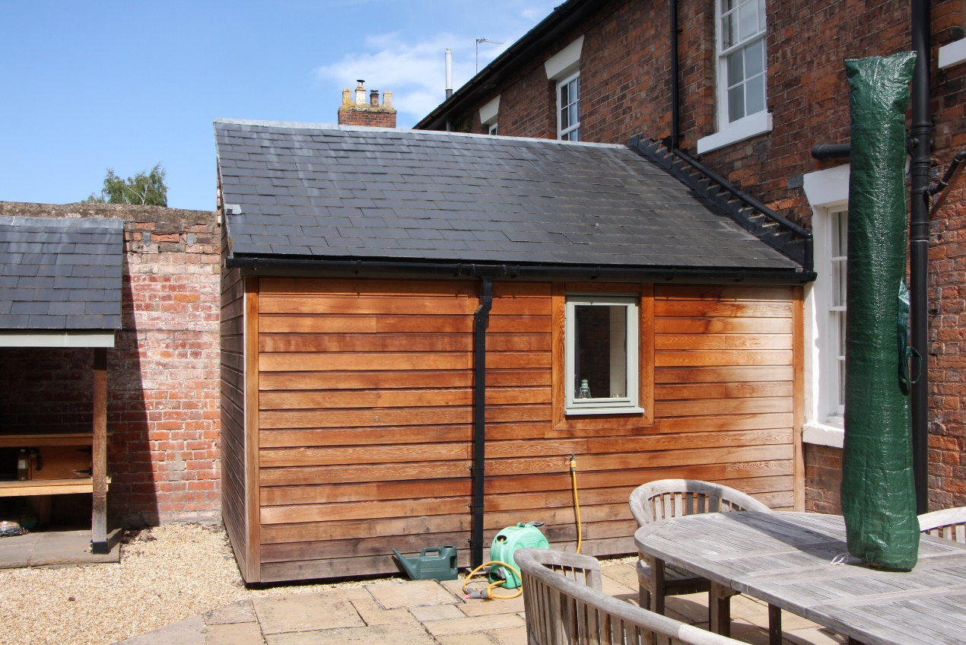

Lean to utility and toilet to be demolished. Existing boundary and screen wall retained.

There is direct access off the hall to the rear and also from the kitchen.
The first floor is accessed off a central staircase and has 3 bedrooms and a family bathroom off the hall.

Externally there is a side passage to the left hand side giving access to a large rear garden stretching to approximately 40 meters in length, bounded to the left by Holy Trinity church, to the rear by the rear garden of no7 Salters Lane and to the right by the garden of no 36 Belle Vue Road.

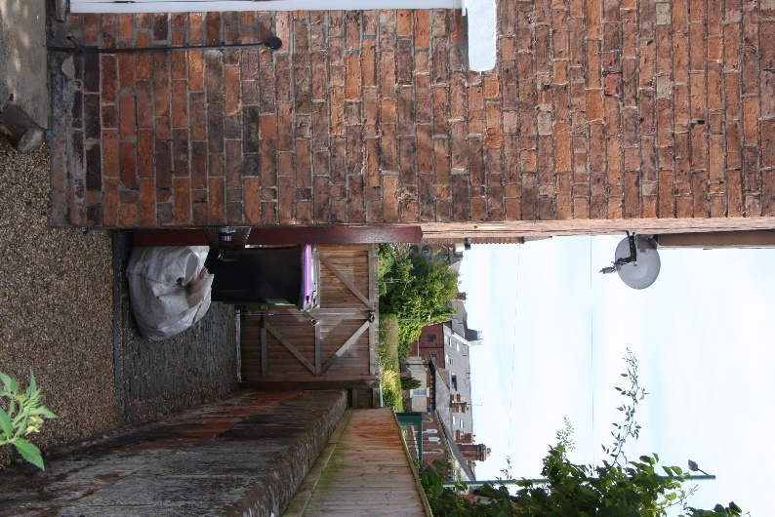

Existing side access to be retained adjacent to church.

Proposals.
The current layout of the ground floor is somewhat haphazard with the small kitchen area being remote from both the dining room and the utility room. The utility and downstairs toilet facilities are housed in an antiquated and uninsulated single storey side extension and can only be accessed through the family room.
On the upper floor there are 3 existing bedrooms and a large family bathroom formed in the past by the loss of a bedroom. The bathroom was formerly sited off the back end of the hall.
It is the intention to redesign the house to allow a more modern and more flexible layout and to bring up to date in the extension areas (and over time to the remainder of the house) much upgraded levels of insulation.
At ground floor the intention is to demolish the lean to utility room and toilet, to change the use of the kitchen in part to a utility room and also a toilet to meet current part M requirements and to build a new combined kitchen/living/dining and play room to the rear. This area will be formed by the demolition of the existing external wall to the existing family room and by the formation of a new fully sound/heat and fire resistant wall the existing party wall. The area will be part single storey with the inclusion of a lantern light and part two storey with a new master bedroom over.
At first floor the area will be remodelled to allow access to the new master bedroom, the existing rear left hand bedroom will be divided into a shower room off the master bedroom and a family bathroom accessed off the hall. The existing bathroom will be returned to its former use as a bedroom.

The proposals will increase the internal dwelling area by approximately 36.76m2 at ground floor and 20.74m2 at first floor.

External Appearance.
The walls of the extension will be facing brick to match existing.
The roof to the first floor element will be slate covered to match existing and hipped rather than gabled in order to enhance the appearance of a single slate roof line and in accordance with the recommendation’s from the Pre App the overall height and pitch of the new roof has been adjusted to reduce its impact.
The eaves line of the first floor extension has been dropped below the existing eaves line, however this is minimal due to the requirement to retain the existing window heights,
The two new windows at first floor level will be hardwood timber/double glazed to match the existing and the existing bathroom window (reinstated bedroom) will be replaced with a hardwood double glazed window to match the existing softwood single glazed window.
All headers and cills will be in reconstructed stone to match existing.
The gable wall facing the church has been enhanced with the addition of a reconstructed stone band course that mirrors similar features on the church and matches the head and cill details of the windows.
There will be a 3 course brick detail cat the eaves level.
The bi fold doors will be insulated aluminium powder coated to match all other openings.

Impact of development to surroundings.

- The area of the extension will sit 450mm forward of the existing gable wall of the utility/toilet structure.
- The existing boundary wall will be retained.
- There will be no direct access to the flat roof area.
- The only two new windows at first floor level will be to the master bedroom which is sited to look directly down the garden towards no 7 Salters Lane (some 47metres distant to the nearest window and a small window to the shower room cut through the existing gable facing the Church. The building immediately to the left is the Holy Trinity Church whose gable wall is some 7.6 metres from the gable (ground floor only) of the extension and has low and high level stained glass windows.

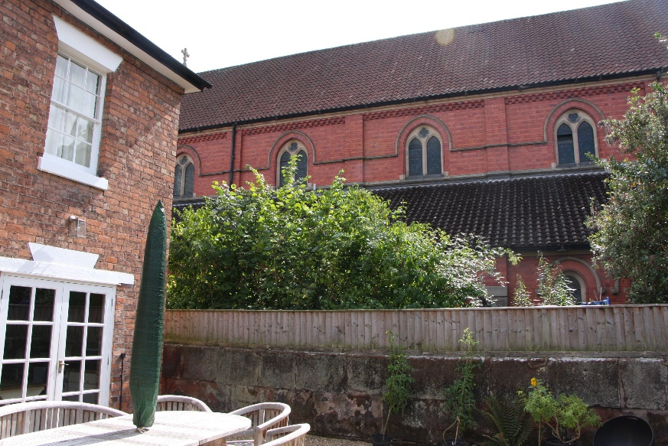

View towards Church from existing patio/proposed extension area.

- The extension is barely visible from any roads or to the public view.
- The surrounding boundaries to both the church and no 36 are well established screen fences, trees and shrubs.

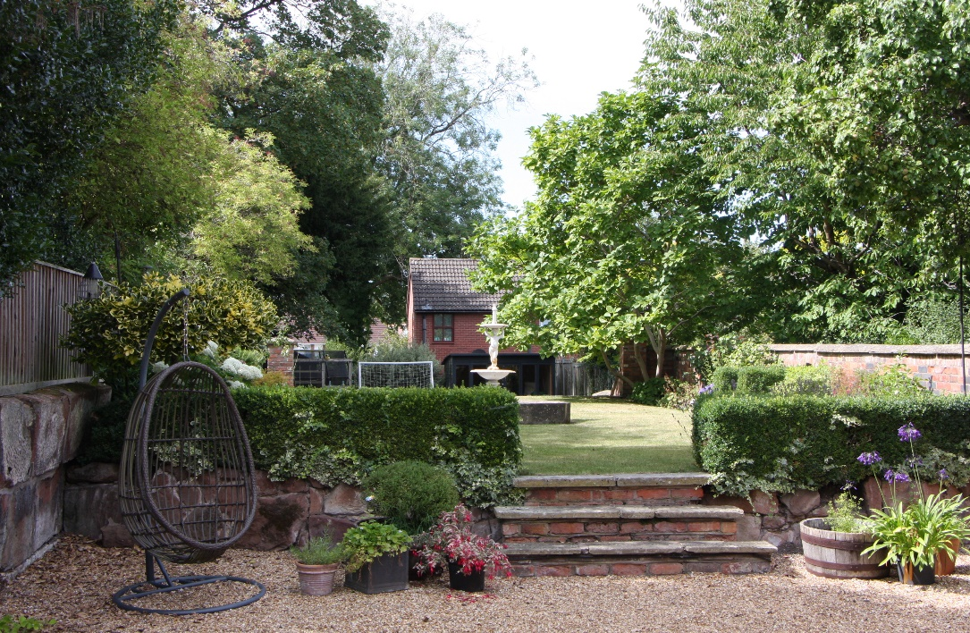

View from rear down garden to no 7 Salters lane in distance. Also indicating existing boundaries and screening.

- There is no visual impact on the frontage with the majority of the extension area screened by the existing dwelling.
- There is no requirement to remove or prune any existing mature trees.

Taking into account the above it can be seen that there is no detrimental impact to adjoining properties or to the immediate area.

Ecology

As the proposals relate to building on an existing hardstanding area and not near to any known ecological sensitive sites there is deemed to be no ecological impact created by the development.

Access
The site is located in an existing residential area in the residential area of Belle Vue and is not due to be amended or altered in any way by the development.

Environmental Sustainability

The extension and any alterations will be constructed in compliance with the current Building Regulations and will meet the energy performance requirements set out in them for the construction elements, heating, energy efficient lighting and ventilation.

Suitable space and facilities are already provided for storage and segregating recyclable waste and non-recyclable waste, with bin day collection being roadside.

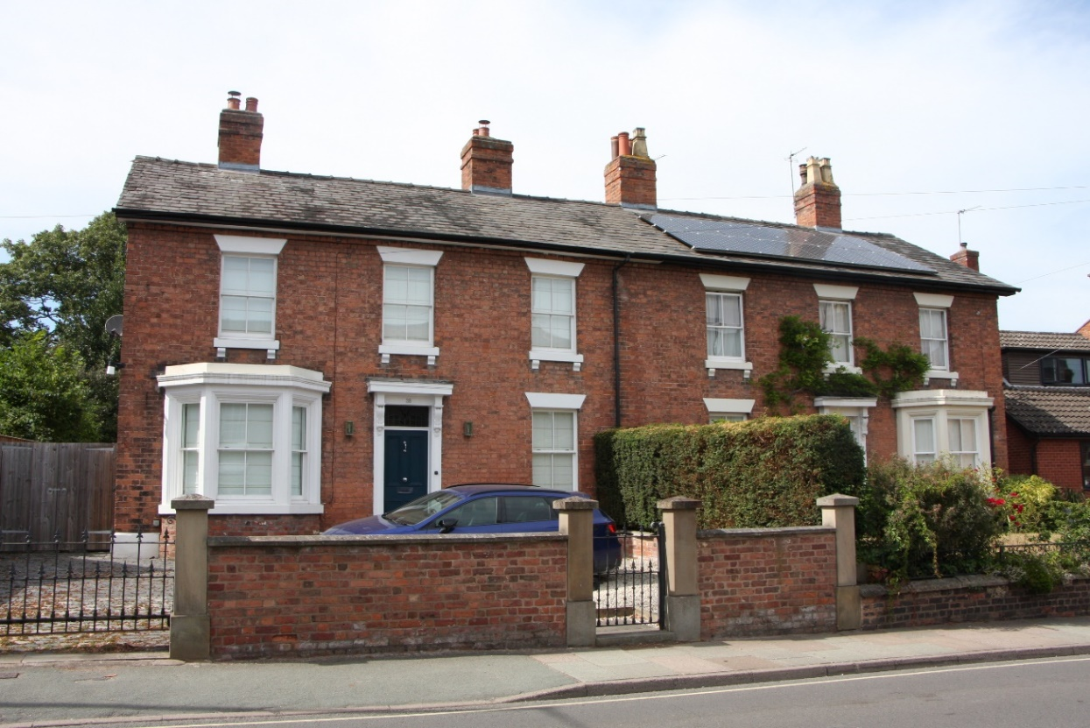

Existing front elevation indicating existing entire semi detached frontage.

Conclusion.

The development as proposed will allow for the reconfiguring of the dwelling into a modern family orientated style within an existing attractive Victorian framework without any detriment to the existing street scene and due to the utliisation of matching materials allow for a sympathetic treatment to the rear elevation.
The alterations and extension do not have any impact on the surroundings and will allow for further upgrading of the dwelling to meet current environmental and ecological standards.

