St Michael’s Church, Landrake
Tree at Tower : Works Supporting Statement
February 2024

- Condition and life expectancy: the tree has lost a major (11m long and 625mm diameter) living branch in the last storm. This landed 180 degrees from where it had grown but luckily avoided causing any material damage. It also has a number of dead branches high in the crown and a large area of fungal growths just above the lowest V in the tree (where, we are advised, Victorian pollarding is likely to have been done).

- Impact of work on health of tree: the works are to remove dead and decaying wood, and allow the tree to regrow from the historic pollarding position (see photos and extract from the Diocesan expert’s [Keith Rushforth] report).

“I met with the current churchwardens following the collapse of a stem of the sycamore. My view is that, although the remaining crown of the tree looks OK when seen in photograph 1 where the defective portion is hidden by the yew tree, the best option would be to pollard the tree at 2m or so and see how it develops.”

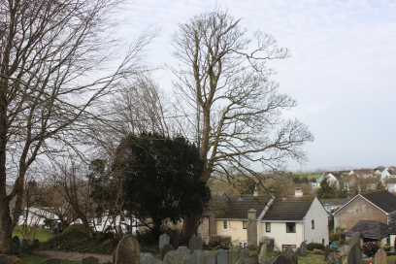
- Proximity to buildings, etc
The tree is of such a height so it is reasonable to suppose that, should the entire tree fail, it could land on the church tower (which is a Grade I listed building).
The tree has a large, living branch (similar in size to the one recently lost) overhanging the path alongside the War Memorial. The fear is twofold here, following the latest branch failure. Either we could hurt (or even kill) someone using the path, or the branch could end up damaging the war memorial.
The dead branches could fall at any time, and some of our most historic gravestones are at the foot of this tree.

- Good maintenance: we are advised by Mr Rushforth that this work will fit this criteria.

- Landscape setting: the tree is currently the largest tree on this part of the churchyard. However, see 7. Below.

- Good arboricultural and silvicultural practise (BS 3998) Given the other points addressed in this statement, we believe that good practise will be covered by this work.

- Replacement planting: not thought to be needed, as there is an established beech behind this tree that (once the works are done) will then have space to become a replacement feature tree.

