Design Statement

Prior to the work taking place, there was no cornicing to any of the ceilings in the flat nor any picture or other decorative rails installed. Whilst we were removing wall coverings in the living room, we noticed that there appeared to be evidence that there had been a picture rail in the living room at some point in the past so we decided that we would install picture rails in both the living room and in both bedrooms. New skirtings in a related style were installed throughout. We also decided that to complement this, we would also install an appropriate matching dado rail in the hallway.

Looking from the front of the flat to the back showing no decorative architectural features. Note doors and skirting of 70’s/80’s style

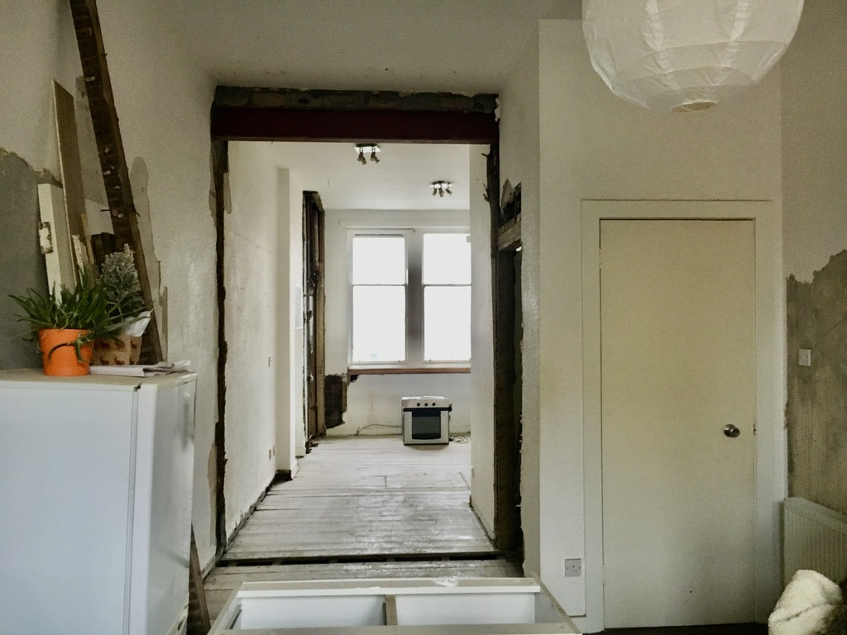

Looking from the back of the flat to the front – again no cornice/picture rail and plain doors

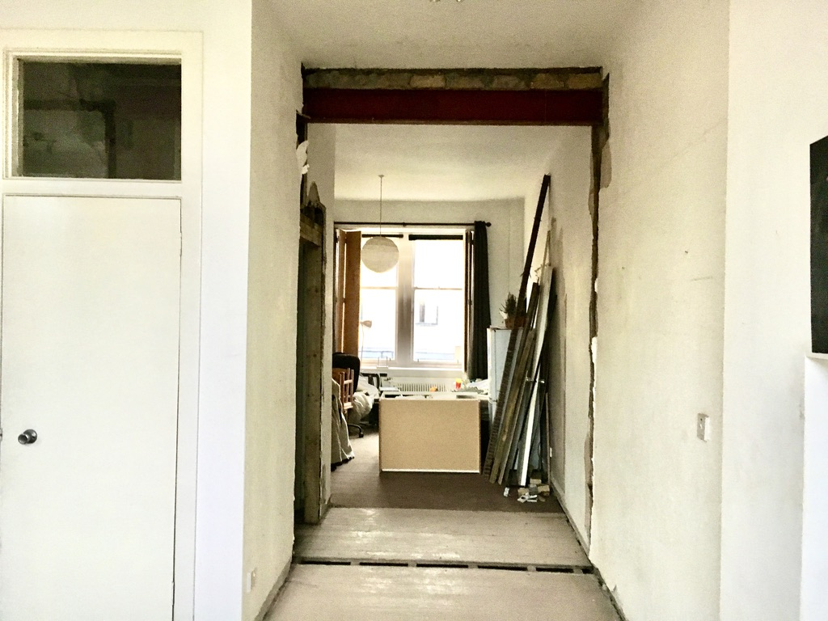

Living room complete showing new picture rail – rebuilt alcove and window seat

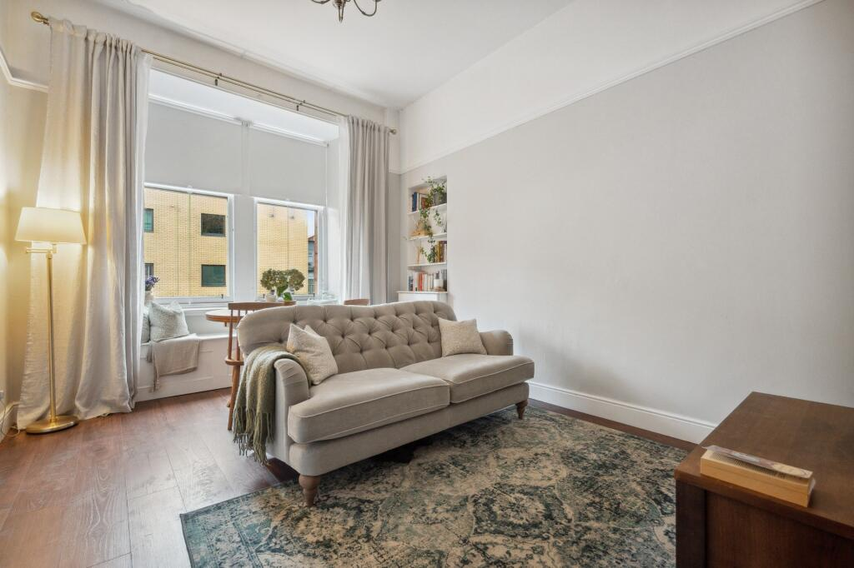

From other side showing more appropriate style doors and skirting.

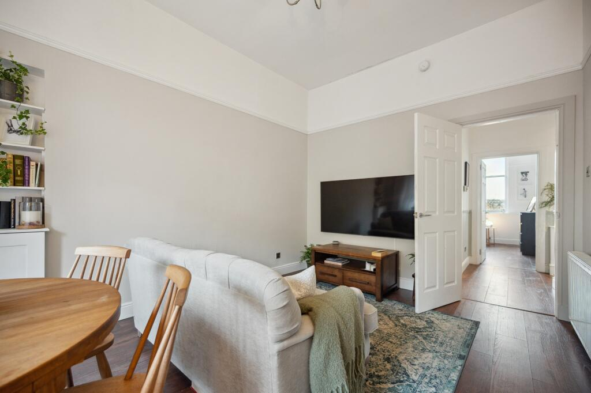

Completed Hallway showing dado rail and panelling to old front door.

