Survey report for 14A Lower Market Street Penryn TR10 8BG

This report was commissioned at the request of the present owners of 14A Lower Market Street Penryn TR10 8BG.

14A Lower Market Street Penryn TR10 8BG is a Grade ll listed property on the main thoroughfare of Penryn, Cornwall.
The owner approached Hopkins Joinery in July 2020 when the poor state of the windows was causing concern.
It was apparent that repairs to these had been carried out at different times and that the disparity was causing issues with the operation of the windows. All of the glass is 3 or 4mm float glass or the imperial equivalent and the difference in weight also impacted on the safety of the windows when opened.
All the windows to the front aspect of the property have been replaced. Planning agreement Application number: PA20/09693 received on the 7th June 2021

The proposal, taking the listing into consideration, is to retain the overall look of the property and restore the appearance that the original windows would have made. The poor state of the rear windows is detrimental to the property at present and purpose made replacements that replicate the original design will enhance the property to the benefit of the building, the locality and the present and future owners.
As the property is directly adjacent to the main street through the town, there is significant noise pollution which is detrimental to the comfort and well-being of the residents and therefore the acoustic insulation provided by modern sealed unit double glazing would be beneficial. Bringing the necessary savings in carbon emissions that are now imperative to both local and national commitments for habitable buildings, together with the increase in thermal and acoustic efficiency, is the only responsible alternative.

The following page illustrates the current rear elevation windows and details the issues that currently exist.
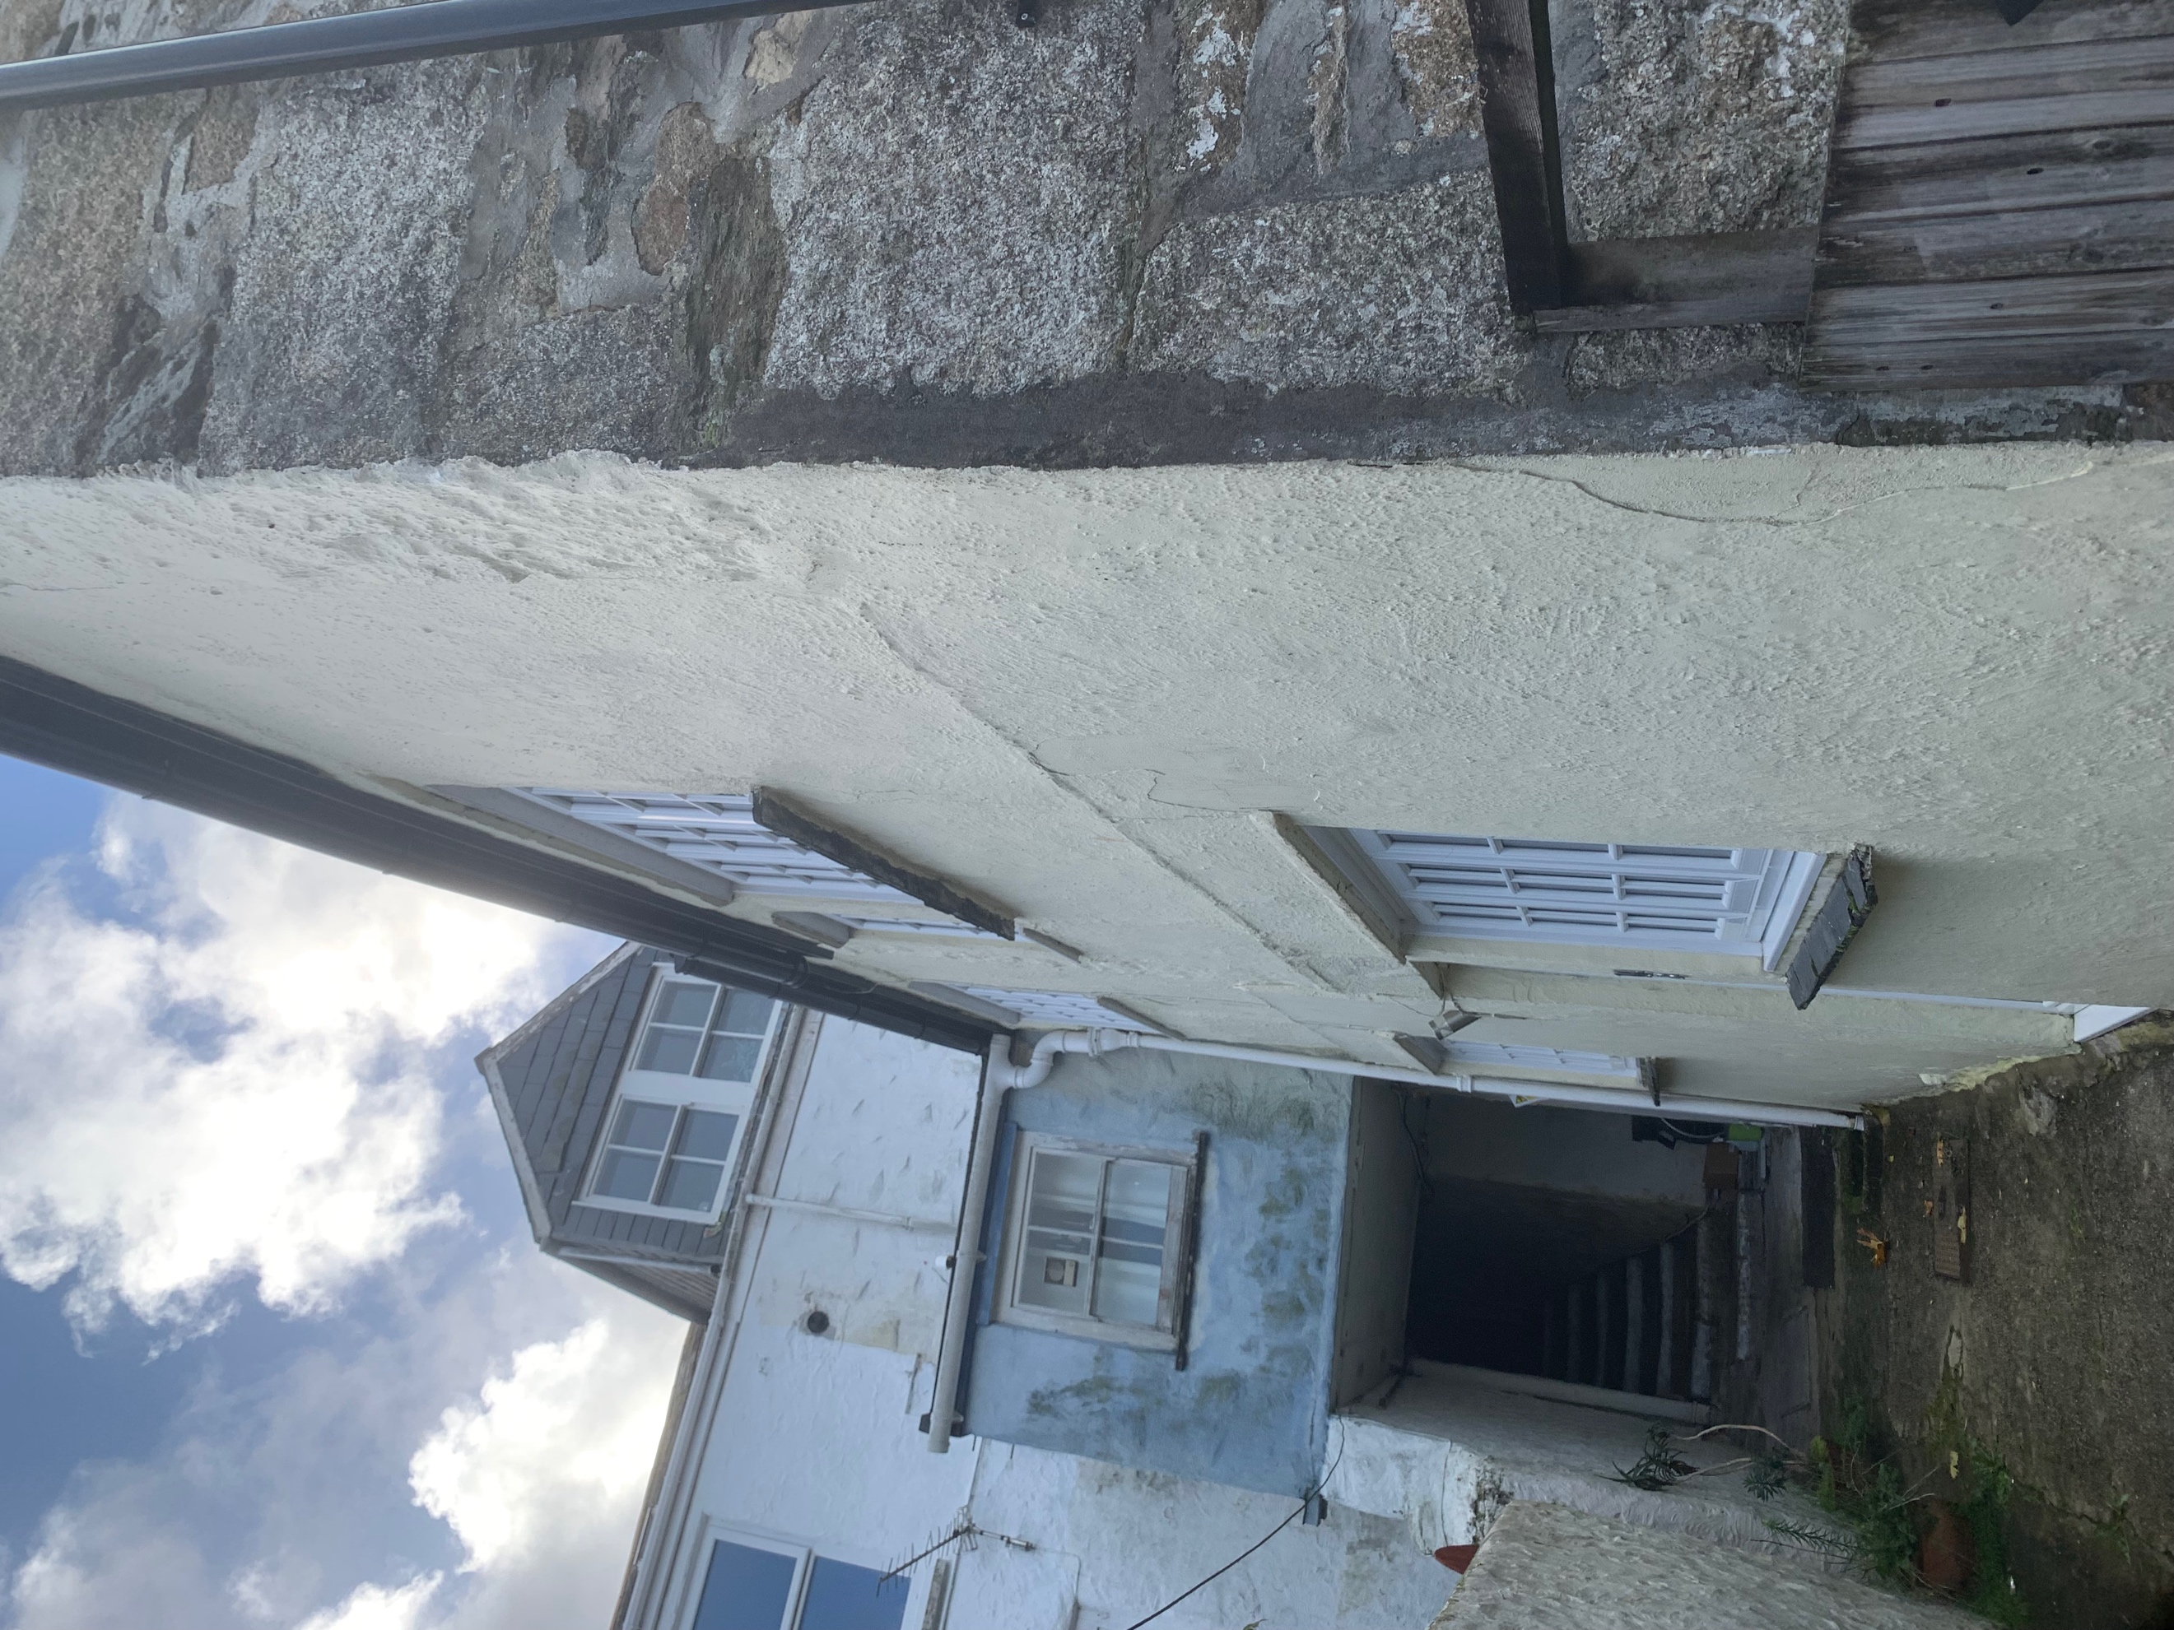
This view is from the rear of the property looking up towards the two rear elevation windows requiring replacement. It shows the restricted access alley way from the main street and the fact that the area is not overlooked from the main street.

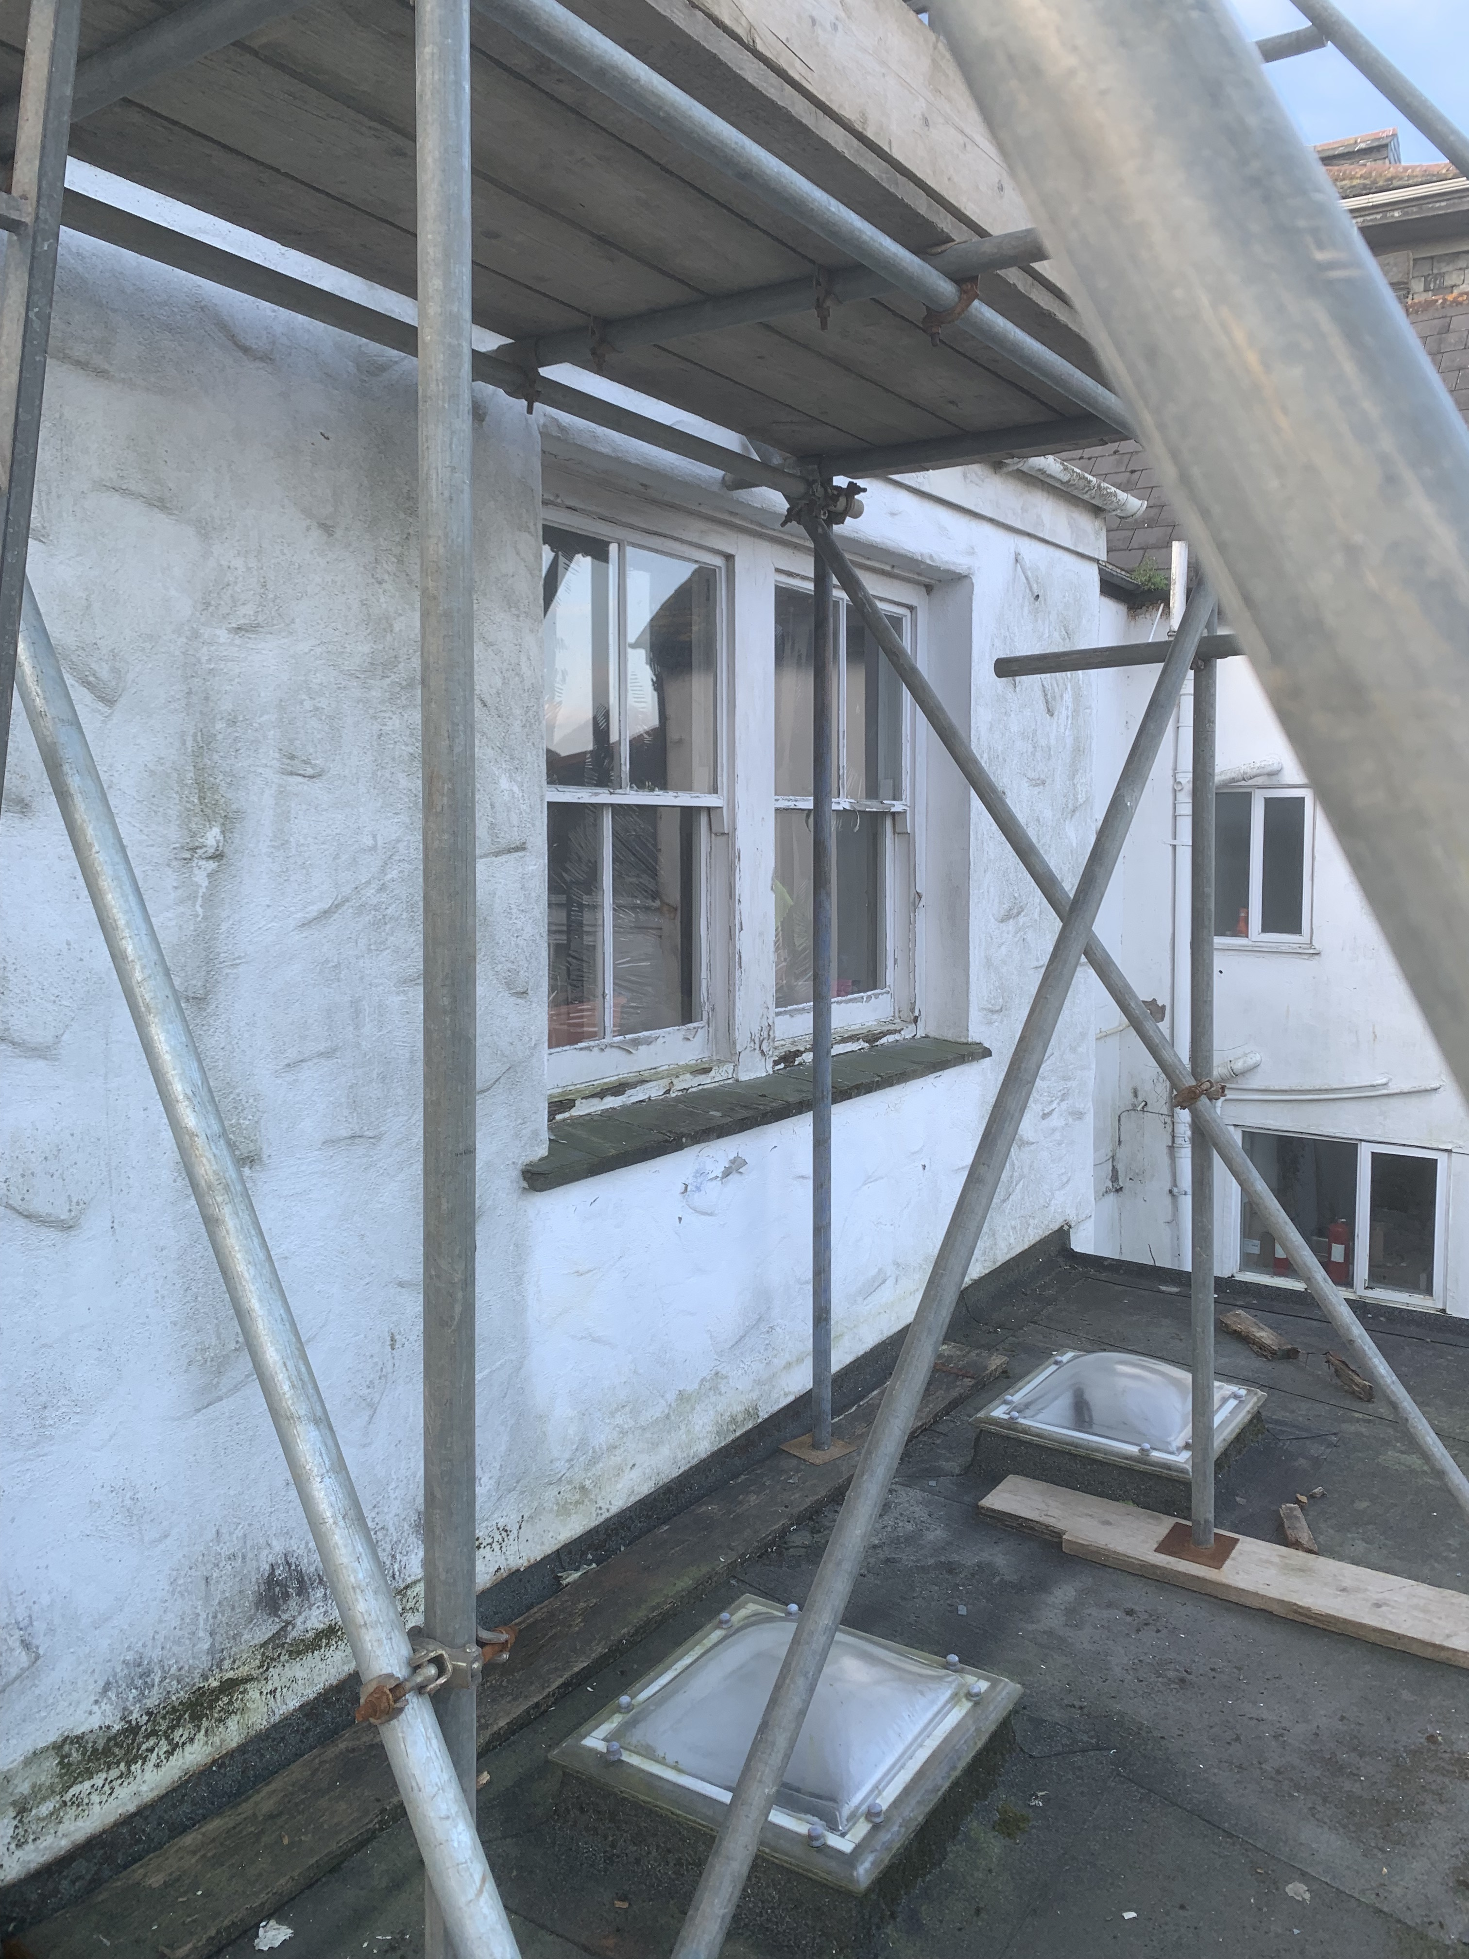 | Approx 30 years | 3mm or 4mm float or imperial equivalent | Extensive rot in cills and lower sashes with numerous repairs that have been carried out over the years. The construction is likely to have been machine produced profiles as the consistency of all surfaces and mouldings is very similar throughout. There is evidence of wedged mortice and tenon joints which have now deteriorated to the point where the sashes in particular are in danger of falling apart with use. Most of the exterior cover boards have either been replaced or repaired since the windows were fitted and the inconsistency of this is causing difficulty in operating the sashes. In addition, the sashes are so worn on the sliding edge that it is easy for these to jam when being opened accentuating the need for replacement. There is considerable space around both the box and the meeting rails where draughts and noise have become an issue in colder weather and leakage in wet weather. | Replace both frame and sashes with new hardwood frame and sashes replicating original design and dimensions. Incorporating standard 24mm sealed units will enhance the thermal and acoustic  properties in addition to providing protection from condensation which is the principal cause of rot and mould.
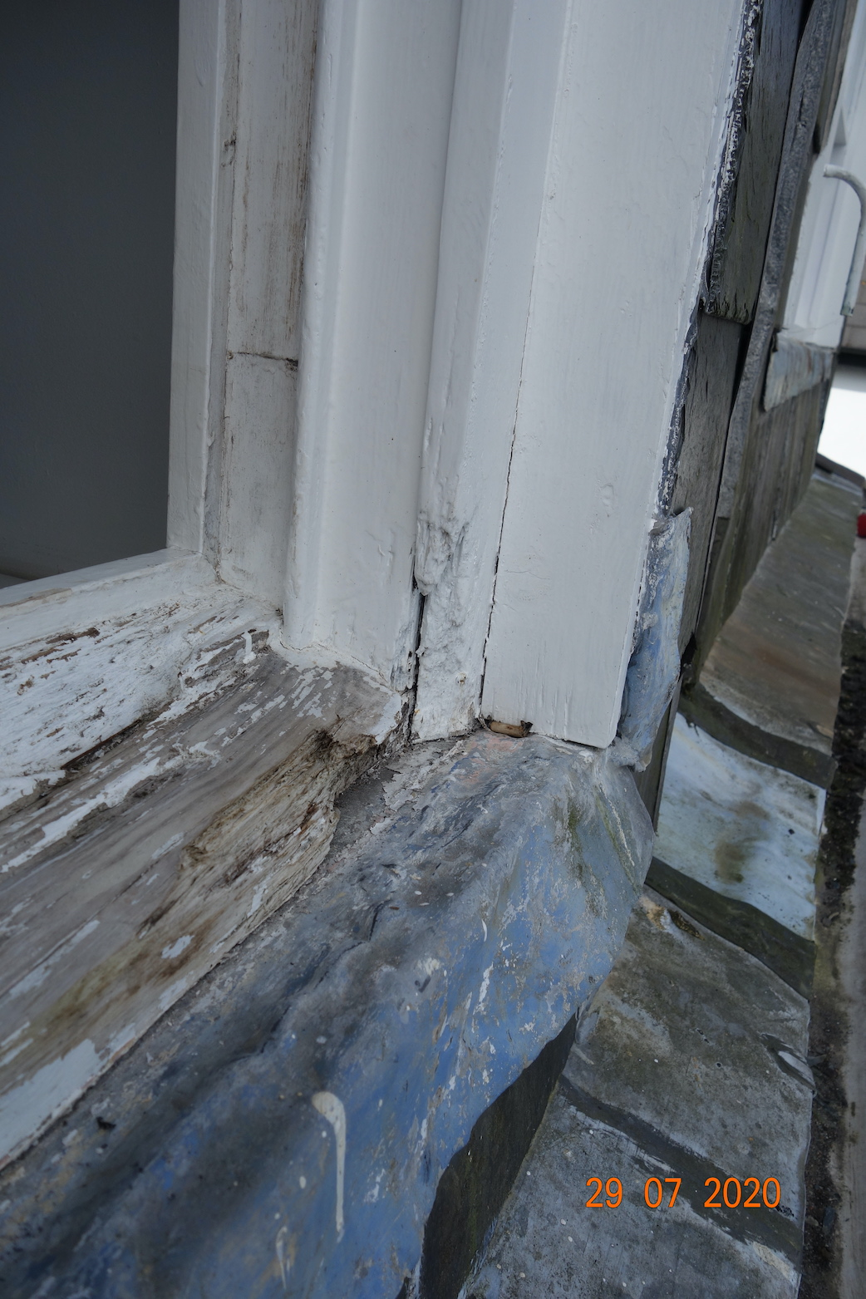  Kitchen window | 30 years |  | Extensive rot in cills | Replace both frame and sashes as above
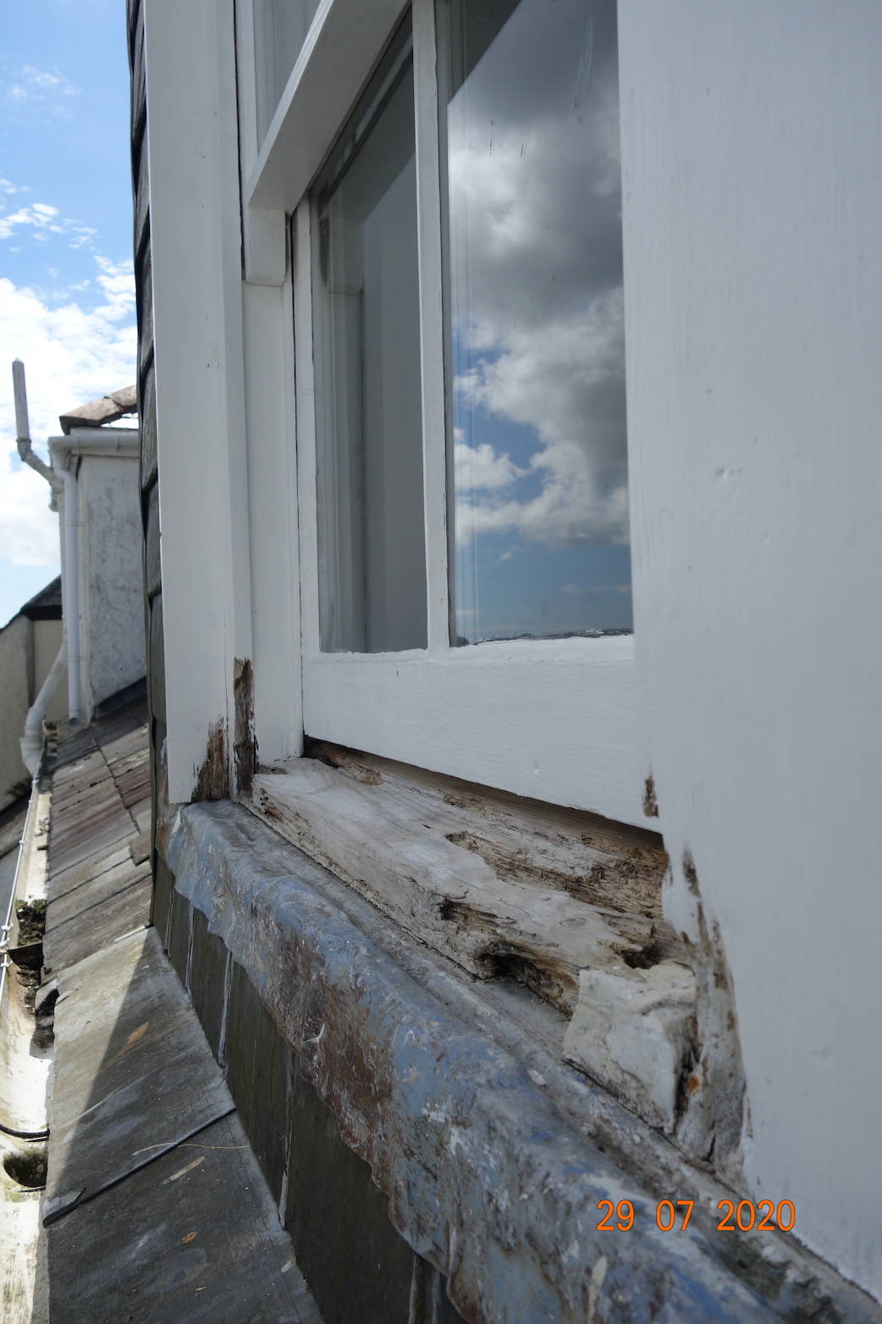  Stairway window | Approx 30 years | 4mm float glass | As ‘a’ above | Replace both frame and sashes as above
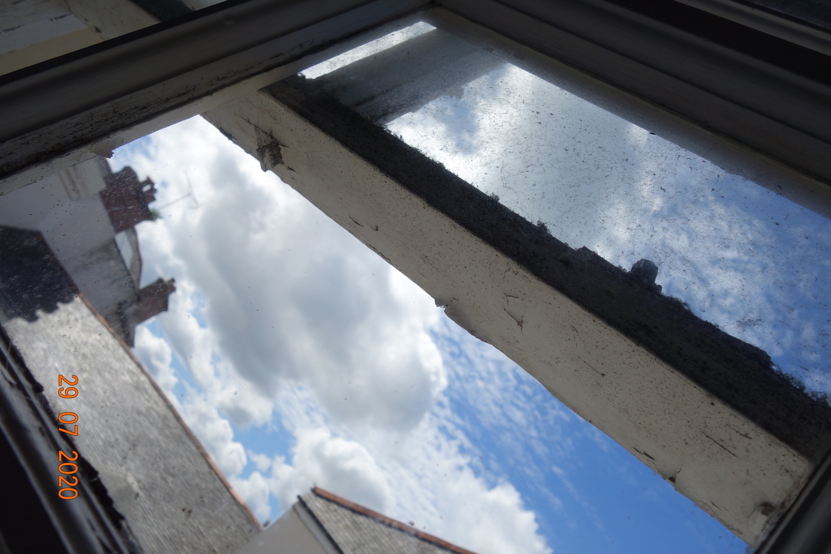 | Approx 30 years | 4mm float | This picture shows the failed mortice tenon and wedge joint | existing windows.

