STATEMENT OF JUSTIFICATION FOR PROPOSED WORKS
AND IMPACT TO LISTED BUILDINGS
AT;
14A LOWER MARKET STREET PENRYN CORNWALL TR10 8BG

Existing Property Information
PENRYN
SW7834SE LOWER MARKET STREET 580-1/6/97 Nos.14 AND 14A 22/09/71 (Formerly Listed as: LOWER MARKET STREET (North side) No.14)
GV II
Town house with later shop. Early C19 on C17 site. Render replacing stucco on rubble to front; dry slate roof; probable rear stacks; cast-iron ogee gutter. Double-depth plan including rear outshoot and stair wing. 2 storeys, 2-window range. C20 sixteen-pane horned sashes; C20 copy or repaired early C19 shop front on the left; round-arched dressed granite open (through-passage) doorway on the right. INTERIOR not inspected.
Listing NGR: SW7854434398
Initiation of proposed works
This justification is for the windows to the rear of the existing property. It should be noted that the windows to the front aspect of the property have been replaced in accordance with the planning officer’s recommendations and instructions reference Application number: PA20/09693 dated 7th June 2021.
The present owners are aware of the fragility of the windows to the rear of the property. Both windows are either unusable or causing difficulty in use and the owners approached Penryn Joinery for advice. The initial survey identified that the timber in many of the windows had deteriorated beyond economical repair.
Considered decision
Although the property is directly on the main thoroughfare of Penryn town, the rear of the property is difficult to access and is not overlooked. Access from the main street is through an alleyway shown in the picture below.

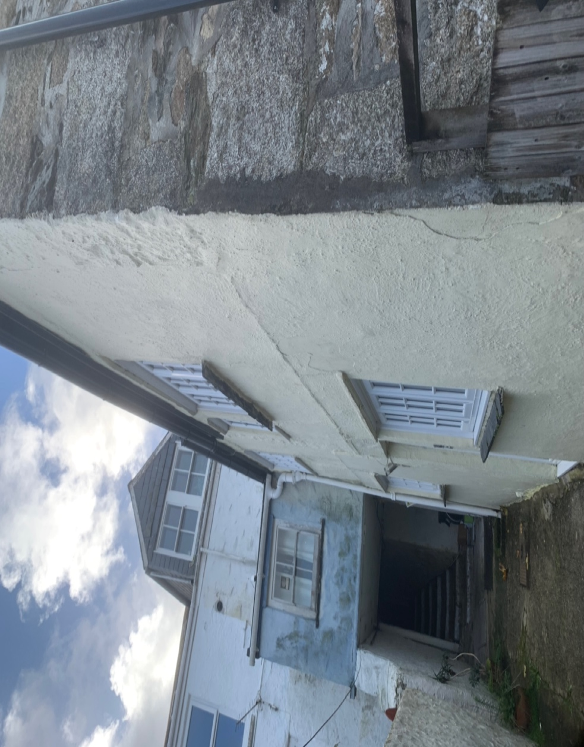

In order to improve the thermal efficiency of the existing single glazed windows, the decision has been made to replace the windows with identical design and appearance yet incorporating better quality materials and build standards.
After due consideration and having taken careful advice, the owner of 14A Lower Market Street has decided that, in the interests of preserving the property for the long term and giving full respect for the local and wider environment, the best and right decision was to commission replacement windows made from sustainable hardwood that replicated as far as possible the original design and incorporating sealed double-glazed glass units. It was noted that such sealed units have been installed at several listed buildings and that these promised to enhance both the thermal and acoustic efficiency whilst retaining the visual aesthetics and prolonging the life of the windows and doors.
Penryn Joinery were consulted and commissioned to provide detailed information on the condition of the existing windows and doors and provide suitable drawings for the proposed replacements with a view to acquiring the necessary permissions. The following is an overview of their findings.
Proposed Changes are: -
- Replace existing rotted windows on rear aspects with new made to measure units replicating original design and style within tolerances to retain visual appearance. New windows will be sustainable hardwood, sealed units double glazed 24mm with argon cavity U-Value 1.2 with applied glazing beads and duplex bars.
Impact
Penryn town has an eclectic mix of buildings and individual buildings have within themselves a variety of window design, some Georgian, some Victorian as well as later designs that reflect the development of the town over the years. Many of the buildings have shops at ground level and flats above; 14A is one such arrangement. The replacement double glazed windows will improve thermal efficiency and reduce noise pollution. This would be in keeping with emerging policy. The overall visual appearance will be in keeping with the original design of the property and retain the character of the property whilst making a positive improvement to the comfort of the occupants. It will also reduce energy consumption with the associated carbon savings to both local and general environment.
Environmental considerations
The current owner of 14A Lower Market Street has considered the wider impact of the proposed works. Whilst the principal aim is to retain the originality of the property that is documented in the listing, there is a recognition that the organic materials used in the construction of windows and doors have a finite lifespan. The majority of the windows are less than 30 years old. There is no old glass in the windows, all have recent float glass of 3 or 4mm.
Now that there is a need, some of that urgent, to replace the windows to the rear of 14A Lower Market Street, the decision has been taken to ensure that the works proposed can reduce the carbon footprint of the property for many years. Thus, the use of sustainable hardwood, properly treated and painted in durable microporous paint, and the incorporation of more efficient sealed units to the property, will greatly enhance the property whilst retaining the character.

