HERITAGE STATEMENT IN SUPPORT OF
PLANNING AND CONSERVATION AREA CONSENT

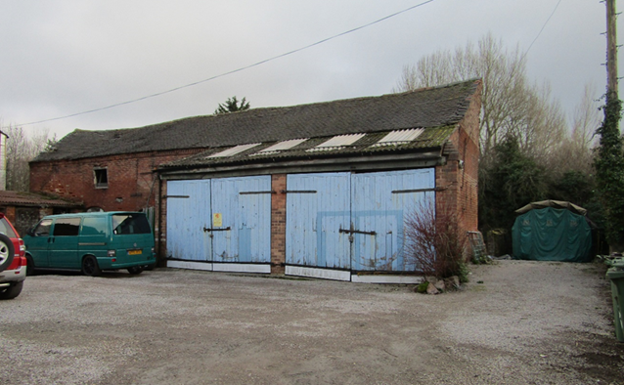

Front Elevation of Existing Barn

Project
New Barn on land at and
Adjacent to No 9 The Green
Croft’ LE9 3EQ
Client
Mr Stuart Elliot
No 9 The Green
Croft LE9 3EQ
Council
Blaby RDC Leicestershire

Project Description

The original plan for the barn was to repair where possible and use and make good the building. After consultation with a structural engineer, planning officer and ourselves we felt that the barn will need to be demolished taking into account the points below.
1, Since the roof collapsed through high winds in 2020 the structure became very unsafe and many of its features lost
i.e. tiles, beams and trusses putting the retention of the original barn beyond reach.
2, The building regulations and the environment agency will require the barn to be built out of the ground as much as 1000 mm in case of flooding. This issue brings into account all door and window heights thus destroying many main points of this asset.

By the time planning permission had been granted taking down the barn sympathetically, saving what we could to reuse and retain the original features was virtually impossible due to the extent of the collapse over the last few years. Unfortunately, before planning was granted the barn first lost its roof making it very unstable and unsafe, then during further storms the walls slowly fell in with the weight of the roof pushing on the walls etc. During the salvage operation of the barn the bricks of the existing barn were cleaned up and sorted into the different sizes. Over the years lots of alterations and add ons to the barn meant 3 different sizes of brick and instability of the walls resulting in its collapse. All the bricks are ready to rebuild the barn in the reclaimed bricks plus additional new reclaim looking bricks due to the shortfall in quantity as a result of damaged bricks in the collapse of the building.

Introduction
The heritage statement has been prepared to accompany the planning and conservation area consent application for the proposed works on land at the rear and adjacent to No 9 The Green Croft LE9 3EQ. The purpose of this document is to assess the impact of the proposal on Heritage assets including conservation areas and listed buildings.

The Nature of the Asset
The asset that was reluctantly intended for demolition was within a conservation area and was once a barn forming part of a working Farm. The asset was over 100 years old and was typical a long structure with gables on both long ends. The barn had many nice features in design and brick shapes i.e. corbels to the soffit, round arches to both doors and windows also square door and window tops with brick soldier pattern above. The condition of the Barn was very poor with bulging brickwork especially on the gable ends and timber deuteriation to the Ä frames, resulting in the collapsing of the barn from 2020 onwards. In the later years of the barn before its collapse the barn had the addition of large garage doors for a work shop, this in our opinion compromised the overall appearance of the asset and definitely the structure which has resulted in its collapse.

The Extent of the Asset
The asset is situated away from the village street scene and cannot be seen from the road, but is reached by a small lane between No.9 and No.9b The Green. The asset can be found in the Garden of No.9 and uses the same driveway entrance. The Cottages No.8 and No.9 Are on the assets western side and to the north can be found several cottages fronting Dovecote Rd. The asset was once part of a farm surrounded by many workers cottages and community buildings but sadly most of them have fallen into disrepair and disappeared leaving only a few remaining as mentioned above. Over the years with the loss of old buildings and the surrounding area changing, the Barn is now found on the outskirts of the old village of Croft Leicestershire. The asset is set in the middle of the plot where to the rear and the east a large garden is retained. To the front and west is a large courtyard and to the south is waste land which is situated in a flood plain. Surrounding this proposed dwelling starting from high ground to the east runs an earthwork called a bund {flood defence} some 2m high and approximately 5m wide. This bund travels along the southern perimeter of the property and ends again on high ground to the west. Regarding any archaeological interest I cannot find any evidence of research about this in the past.

Below is a 1250 Ordnance Survey Map Showing the Barn, the Bund,
and the Outlying Area and Cottages

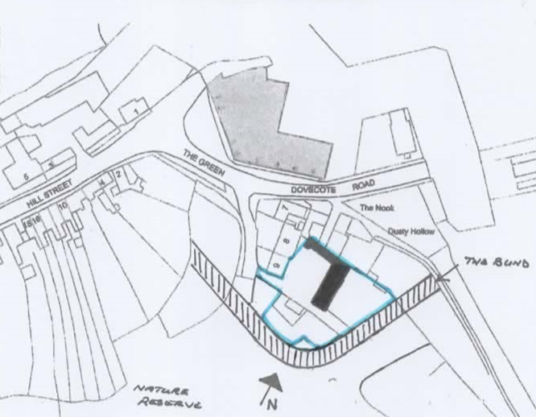

The Significance of the Asset
The Barn was once part of a working farm and formed part of a network of buildings in the area the Barn is well over 100 years old and has gone through different phases of use in that time. In its later years since being acquired by the quarry company it has been used for some kind of workshop or garage for large trucks. It has small rooms for storing tools, goods, and parts on 2 floors but the greater part of the barn is laid out and forms part of the garage area. Part of the garage front with large doors was added but required large amounts of structural work to be carried out. Inside large Ä frames in oak support an open vaulted ceiling in most of the barns floor area and a roof of blue rosemary clay tiles. Over the years the asset has been altered to accommodate larger vehicles and this has destabilised the construction by altering the integrity of the structure. It was being shored up on the gable end to stop the total collapse of the roof at the beginning of this planning journey, sadly the weather took its toll on the building which meant the loss of Staffordshire blue rosemary roof tiles. The Barn had many features with round topped doors and windows with solder designed bricks above also different openings in the brickwork to create small windows. The nicest feature is the corbeling underneath the soffits along the front and rear façades. There are also many brick shapes all of different designs on walls inside the asset, which we are to incorporate in brickwork in the new dwelling. The Barn is built in old farmhouse red bricks with oak Ä frames inside holding a roof of blue clay rosemary tiles.

The Proposed Works
The proposed work on the site is to build a three bedroomed family home in a style which we feel will complement the old Barn and its History which we have considered at all times while producing this proposal. The vision is to achieve a building that allows the new owners to experience the Barn in comfort and have longevity in terms of design and usability. Investing in this dream would allow this to be achieved whilst giving the area and its history a new lease of life with this new dwelling. Although the new Barn will have modern features of design, finish and amenities they will be blended with older features of the old Barn ensuring that the vision for the new building’s future can be achieved in the most sympathetic way. The scale of the new Barn overall will be very similar to the existing structure and its small outbuildings.
The length will be 21m, the width 7m and the height of the barn ridge to ground level is 7.5m.
This is considerably smaller than plans passed in 2003 ref No. 03/0685/1/04.
The new Barn will be built in a conventional method using the barns reclaimed bricks (to complement the Barn) new slate roof, flushed finished casement windows and doors in pearl grey coloured UPVC, Garage doors in oak wood. Also, to be integrated into the design would be black iron imitation restraints. The old Barn features with round topped doorways and windows will be used, hay loft doors, small slotted windows and dovecote style entrance hall design. The property at the rear is already laid to lawn with cobbled path leading to a pond and mature borders. Internally the main Barn will be open plan with high vaulted ceilings achieved by installing three large Ä frames in oak wood to support this high structure. Also, inside will be brick features which will include large walls in reclaimed bricks displaying brick design, different shapes of old bricks and an open log burning fire place surround all in the old Barns bricks.
To the front will be a court yard which is already set out in Croft granite chippings. To the outside perimeter of the dwelling is the bund with mature trees and bushes screening the garden from the nature reserve beyond.
Investing in this new barn will allow this vision to bring the area back to life and achieve a new setting of tranquillity and keep the history of the building alive for another 100 years.

Relevant Planning History
The property has already been put forward for planning consent when an application for three houses was proposed and passed in 2003 ref. 03/0685/1/04. The consent was then extended in 2011 -2014 ref. 11/0174/1/PY. This planning consent was never taken up and the property was put up for sale in 2013 when Mr S Elliot bought it. The design passed in 2003 involved the demolition of the Barn and outhouses and three 3 bedroomed barn style properties being built. The design of the application was very big with the three houses taking up a lot more of the plot and increasing car spaces, 6 car plots required plus car spaces for No.9.
Planning permission 19/0439/FUL is the most recent and is almost identical to this application. The building itself in layout and design are the same, however a finished floor level was stipulated as a condition raising the floor level considerably. This has only come to light once groundwork had begun and planning officers visited the site. Because of the height of the finished floor access to the building needed to be considered, Ramps to gain entry to the front door and to the rear with a raised patio area to accommodate the three doors.

The Impact on The Asset

Unfortunately, the impact of losing the barn can’t be helped, the weather took its toll on the aging building. The planning permission in 2011 sadly had no consideration for the old barn, but the client has this vision that the new barn will sit in the same position and replicate an historic barn that sat there for 100 years. With the loss of the old outbuildings with tin roofs and rebuilding in existing brick a series of new cart sheds designed with 4 cart arches, the arches built for car spaces will allow the courtyard to be a larger open space and giving a better view of the barn. As said previously all of the design features of the existing barn will be incorporated in the new barn and many more Barn characteristics too, to give a sympathetic replacement. The Barn will not in any way block any more views than the old Barn already did.

Application for Demolition

In my opinion based on conversations with the planners in regard to reaching planning consent, never has the subject of this asset been mentioned with bringing a positive contribution to the area. Although it was in a conservation area, I feel that the Barn although displaying in its old self a certain beauty as a building, it did not represent a positive contribution to the village and surrounding district, unfortunately it can hardly be seen, only via a footpath. Demolition in the end wasn’t needed, unfortunately it became a salvage operation.

