DESIGN AND ACCESS STATEMENT

PROPOSED EXTENSION TO EXISTING PROPERTY

83 BURTON ROAD
LINCOLN
LN1 3JZ

14th February 2024

1. Introduction & Background

1.1 This statement supports a Planning Application for a Single Storey Extension to a building that lies within a Conservation Area.

1.2 The proposed application is for a Single Storey Extension.

1.3 The building is located within the City of Lincoln Conservation Area No.1-Cathedral and City Centre.

1.4 The building is a Residential Dwelling.

2. Design and Access Statement:

2.1 Use: The building has been used as a dwelling house since construction.

2.2 Layout: Existing external access shall be retained.

2.3 Scale: Proposals include the addition of a Single Storey Extension, which includes plans to replace an existing dilapidated Shed and Toilet structure.

2.4 Gardens: The scheme not affect existing garden layout.

2.5 Appearance: The proposals include a mid-sized ground floor extension, which has been designed to be sub-servant to the existing dwelling, with materials chosen to show the evolution of the property.

2.6 Access: The building is located on the east side of Burton Road. The existing access will not be affected by the Proposal.

3. Photographs

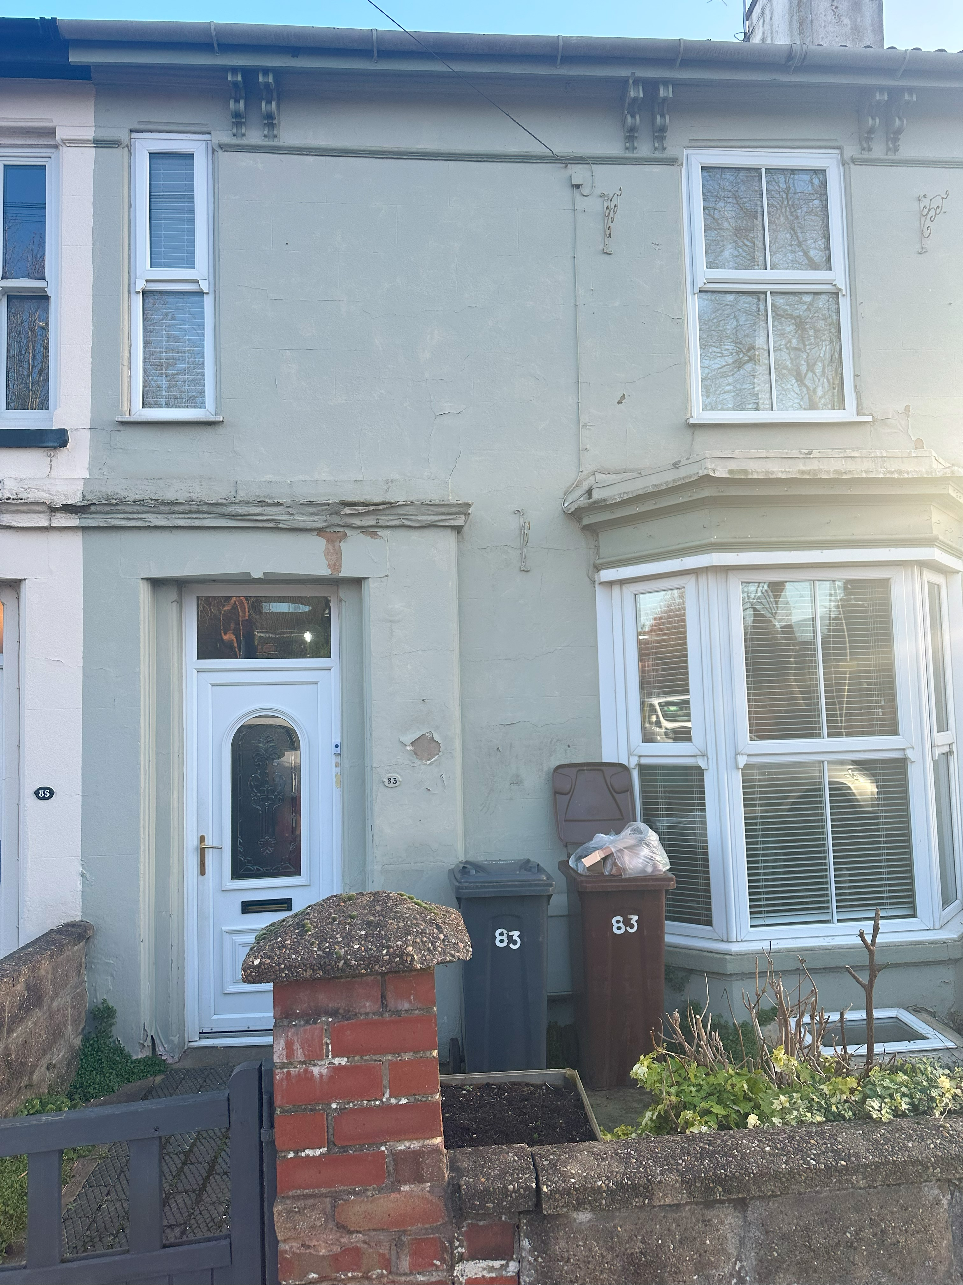

Existing Frontage as viewed from Burton Road

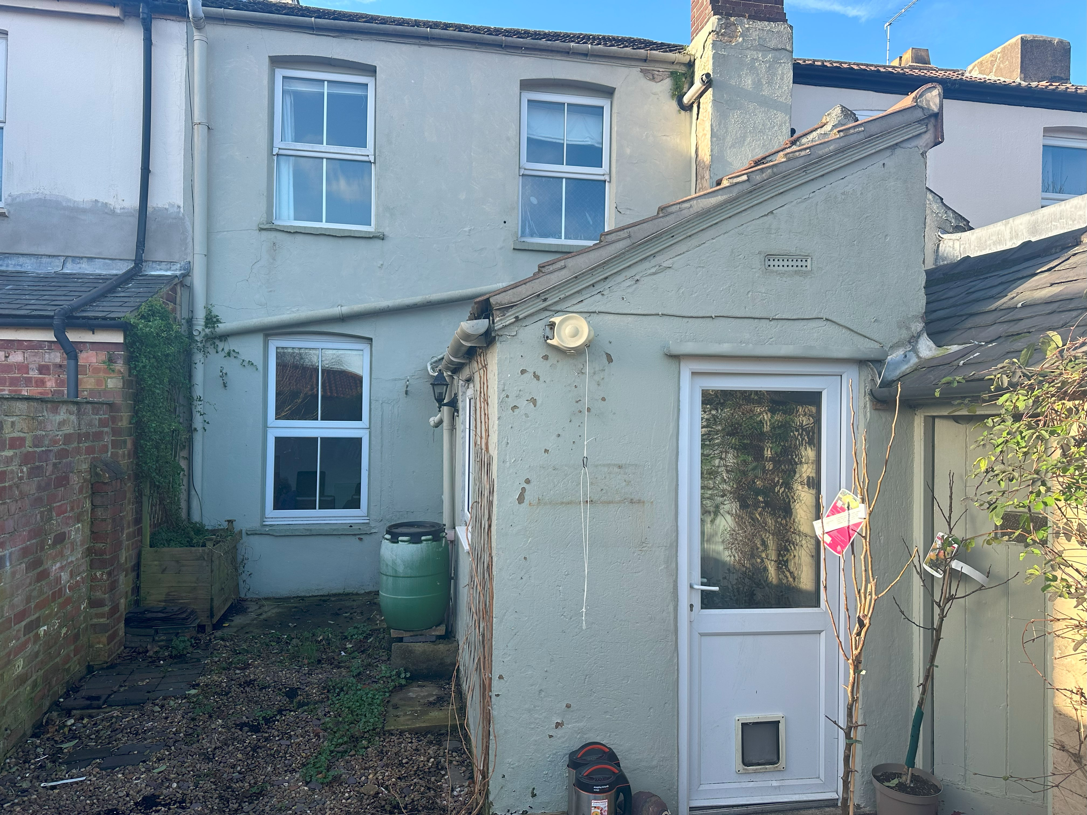

Existing Rear View

4. Proposals

The building is in reasonable condition, with signs of deterioration and small defects apparent which are largely of a decorative nature. The layout has remained largely unchanged through the years.

A new extension with a roof lantern will be built, in materials to match existing as follows;

Walls – white render.
Roof – Grey Single Ply Membrane (Sarnafil or similar).
Windows – White PVCu.
Fascia – Softwood, painted black.

5. Conclusion

5.1 This application seeks to provide a low-impact Ground Floor Extension.

5.2 The works will be carried out on the rear of the property.

5.3 The proposed Extension is appropriate in the predominantly residential setting and we hope the proposal will be supported.

