Nationwide Building Society,
415 The Strand,
The Strand,
WC2R 0NS

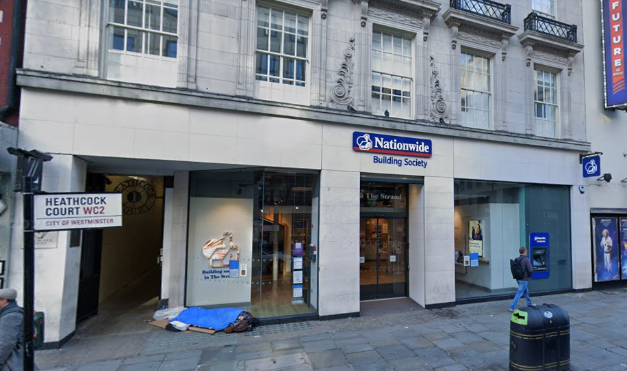

Heritage Statement
This statement has been prepared to support our Listed Building Consent application to replace the external signage at The Strand branch of Nationwide Building Society. The property is not listed however it is located within the Covent Garden Conservation Area and neighbours the Grade II listed Adelphi Theatre.
The Proposals:
Works will include:
Externally:
- Replace 1no. Projecting hanging signage with new 600mm. Retain existing bracket.
- Existing Projecting sign bracket to be painted in blue to match new fascia.
- Replace 1no. Logo with 1no. New 490mm blue heritage logo height. Logo to be externally
- illuminated.
- Install new trough light, colour to match wall.
- Replace 1no. ATM surround and decals with new.
- Install new internally applied vinyl window message ''A good way to bank.''
- Replace internally applied vinyl safety manifestation with new.

The property is currently occupied by Nationwide.
The following statement explains the heritage context and appraises the property as a heritage asset.

Building Appraisal:
The Strand Nationwide branch occupies the ground floor of 415 The Strand. The property is not listed however it is located within the Covent Garden Conservation Area and neighbours the Grade II listed Adelphi Theatre.
The following details the Grade II listed Adelphi Theatre:
The Adelphi Theatre, located at City of Westminster, The Strand, WC2 TQ 3080 NW, designated as No 411 72/105, is classified as Grade II. Its history dates back to the Sans Pareil Theatre of 1806, with subsequent extensions and rebuilds in 1824, 1834, 1846-48, 1858, 1868, the 1880s, and 1900-01, culminating in the last major rebuilding in 1930 by Ernest Schaufelberg. The theatre retains its original side and rear walls, reminiscent of Nos 18 to 20 Maiden Lane. Its terracotta facade facing the Strand exhibits an angular "moderne" design, standing at a height equivalent to four storeys with a three-bay width.
The ground floor is fully canopied, featuring chrome-framed glazed doors leading to the foyer. The front section, with its right-hand two-thirds recessed, bears a full-height broad black-painted sign panel and is topped with a parapet, an alteration from 1937. Directly above the canopy, concealed by hoarding, lies a large horizontal elongated octagon window adorned with hexagonal and lozenge glazing patterns, an original feature of Schaufelberg's design.
Internally, the theatre boasts a long rectangular foyer adorned with 1930s chrome and plaster decor and light fittings. The auditorium is characterised by its angular straight-sided design, featuring two concrete-framed cantilevered balconies, a squared-off faceted proscenium, polished wood flush panelling on the walls, and upcast house lights. The Royal Entrance and stage door/dressing room block, dating circa 1868, can be found at Nos 18 to 20 Maiden Lane.
Heritage Category: Listed Building
Grade: II
List Entry Number: 1264304
Date first listed: 01-Dec-1987
List Entry Name: THE ADELPHI THEATRE
Statutory Address 1: THE ADELPHI THEATRE, 411, STRAND WC2
District: City of Westminster (London Borough)
Parish: Non Civil Parish
National Grid Reference: TQ 30353 80695

Source: https://historicengland.org.uk/listing/the-list/list-entry/1264304?section=official-list-entry

Impact Summary

The building is not listed however the original building fabric will not be altered, removed, or concealed. All existing original features will not be affected by the proposed works.

No discussions have been made with neighbours in relation to the proposals; the works are not considered to have any adverse impact on neighbours. The works are not considered to have any adverse impact to the existing appearance and amenity of the application site and that of its neighbours, rather, the proposals will benefit the front elevation. Access to the building will remain unchanged. The proposals will not affect public routes. There are no alterations proposed to the landscaping nor is there any opportunity to make improvements.

All works are intended to involve the minimum intervention and preserve the original look and feel of the existing building within the context of its conservation area.
The significance of the building has been considered and will retain its existing character. It is considered these works will improve the elevation and therefore makes a positive contribution to the conservation area.

