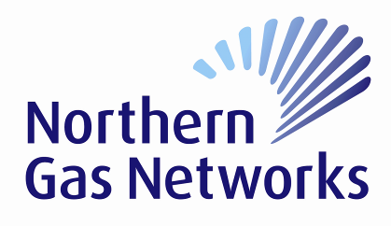

Important Safety Guidance
Northern Gas Networks is the gas distribution company for the North East of England, Yorkshire and Northern Cumbria. We own about 37,000km of gas mains, and other vital equipment, which supply gas to some 2.7 million homes and businesses.

If you or one of your contractors plan to work near gas pipes or other Northern Gas Networks’s equipment, you must let us know.

Damaging gas pipes is danagerous and potentially expensive. Not only could it lead to a fire or explosion, it could result in the loss of the gas supply to local communities.

Safety is therefore Northern Gas Networks’s top priority. We need to ensure no-one damges our equpment and puts either themselves or membes of the public at risk. Our work in this area is encapsulated in the Pipeline Safety Regulations, and by the Northern Gas Networks’s safety case, which is approved by the Health and Safety Executive (HSE).

Our website, www.northerngasnetworks.co.uk has safety guidance booklets that can be downloaded to assist you when carrying out any works. Please use these as reference gides prior to commencing works. Should you have any difficulty in downloading these documents, please either call 0800 040 7766, option 5, or via email: beforeyoudig@northerngas.co.uk

The guidance documents include this one and the following:

- Safe working in the vicinity of high pressure gas pipelines and associated installations
- Avoiding injury when working near gas pipes up to 7 bar
- Avoiding injury when working near gas pipes

If at any point during your works, you smell gas, call the National Gas Emergency Service immediately on the Freephone 0800 111 999.

Examples of higher risk works are, but not limited to, the following:

- Any excavation works within 0.5m of low/medium pressure mains and 3m of intermediate and high pressure mains (the distance is measured from the proven position of the gas main).
- Demolition works within 15m of low/medium pressure mains and 150m of intermediate and high pressure mains.
- The use of explosives within 30m of low/medium pressure mains and 250m of intermediate and high pressure mains.
- Excavations within 10m of a pressure reduction unit.
- Excavations deeper than 1.5m.
- Heavy loading eg cranes, spoil deposits and heavy construction traffic.

