6 BOLLO BRIDGE ROAD, ACTON, LONDON, W3 8AT.

DESIGN AND ACCESS STATEMENT

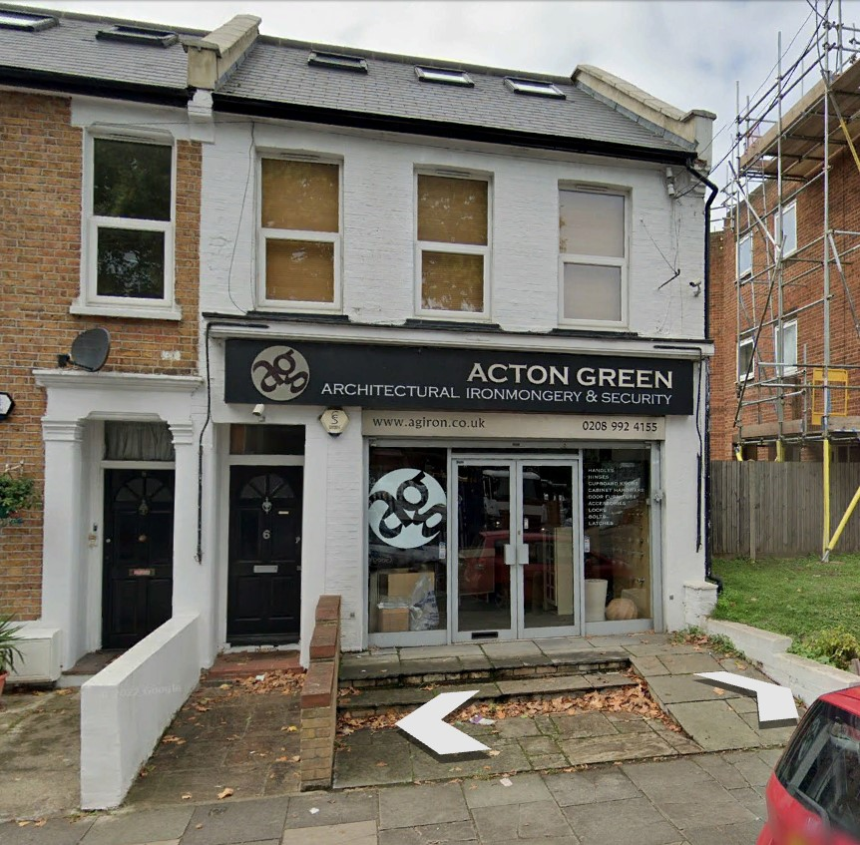

- EXISTING PROPERTY.
The property is an end of terrace two storey property with an existing loft conversion. The upper floors are a self-contained flat and the ground floor is a shop.

Planning approval was granted in October 2006 to rebuild the original rear extension.
(P/2006/ 1022-PE)

- PROPOSED SCHEME.
The application is to convert the ground floor into a two-bedroom, three-person flat.

These works would include demolishing the existing side extension to create a lightwell and part of the rear extension to enlarge the garden area.

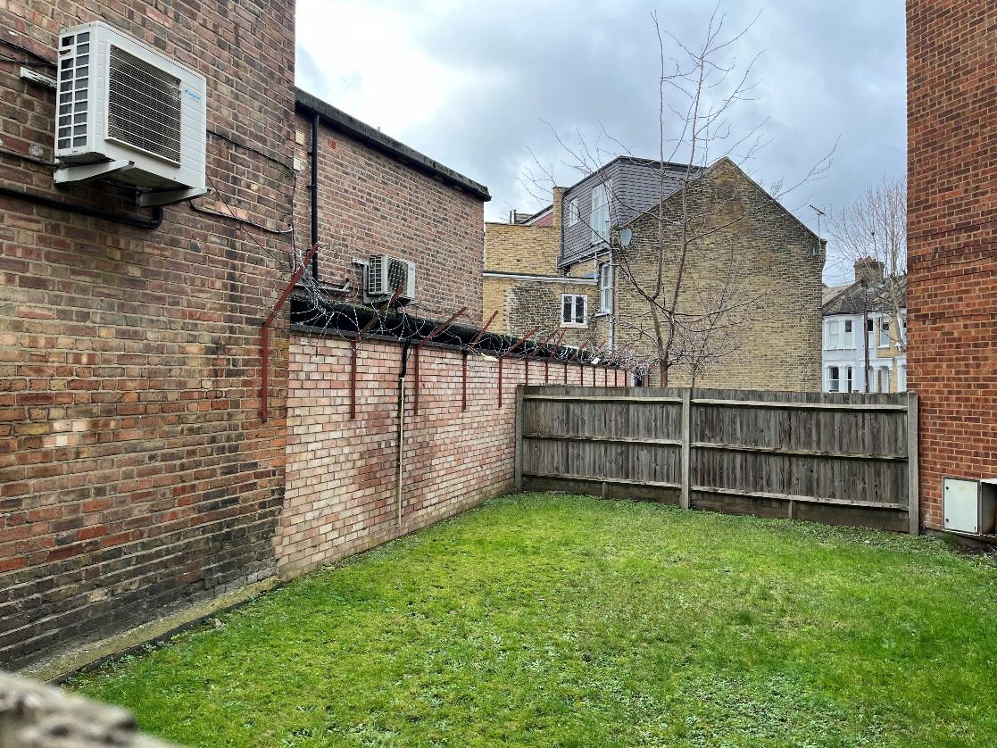
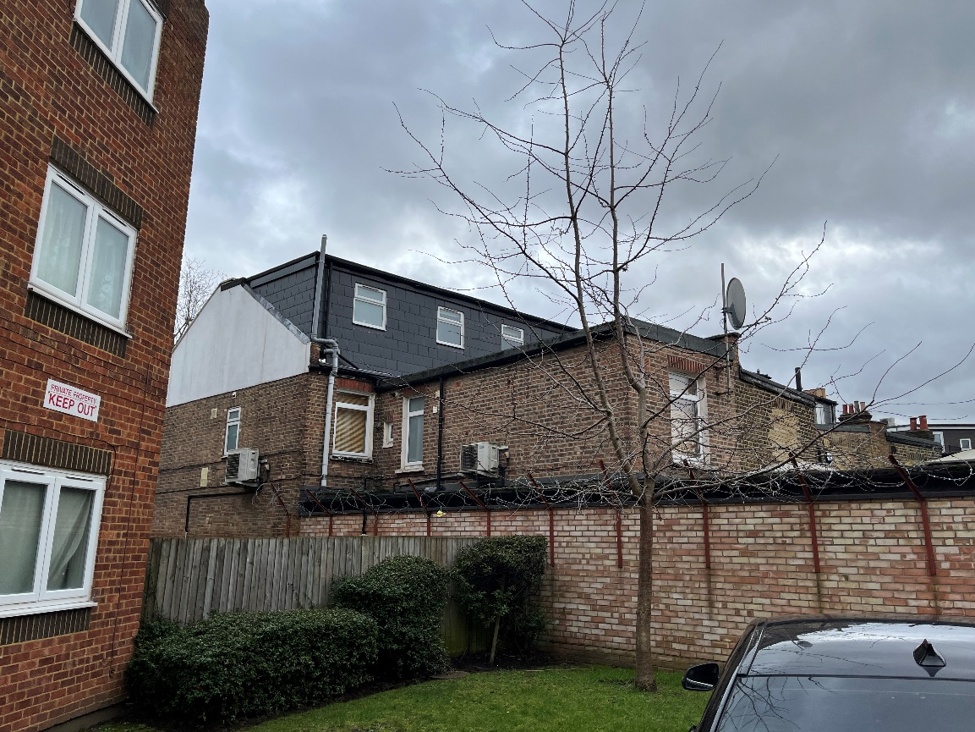

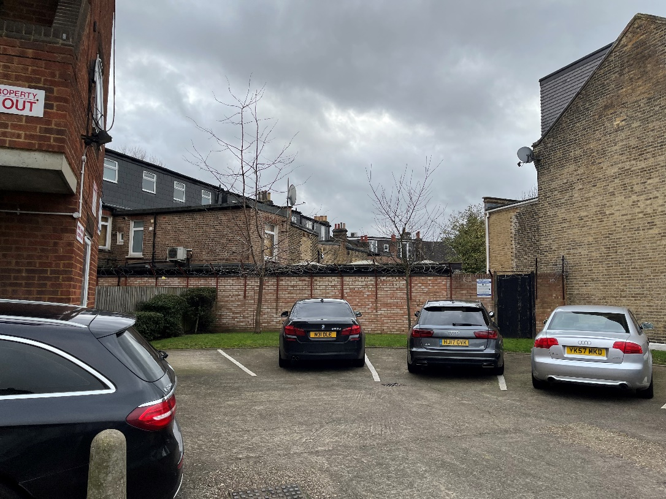

- DRAWINGS.
The drawings included with application are:

1882 / 01 AS EXISTING floor plans
02 AS EXISTING elevations and section
03 LOCATION PLAN
04 AS PROPOSED floor plans
05 AS PROPOSED elevations and section

- LONDON PLAN COMPLIANCE.

FLOOR AREA
The floor area created is 63.4m². The minimum space standard for a two-bedroom, three-person flat, under London Plan, is 61m².

CYCLE STORAGE
A cycle store is proposed in the rear garden. Access to this area is already available via Leythe Road.

BIN STORAGE
Wheelie bin storage is proposed in an enclosure on the forecourt to the Bollo Bridge Road elevation.

AMENITY SPACE
By demolition of part of the existing rear extension a garden measuring 15.5m² is proposed.

- DISABLED ACCESS.
The proposed works will include level access to the new front door to the Bollo Bridge Road elevation. The new flat will incorporate such features as wider doors and accessible level light switches and electrical sockets as well as ramps at the entrance doors.

