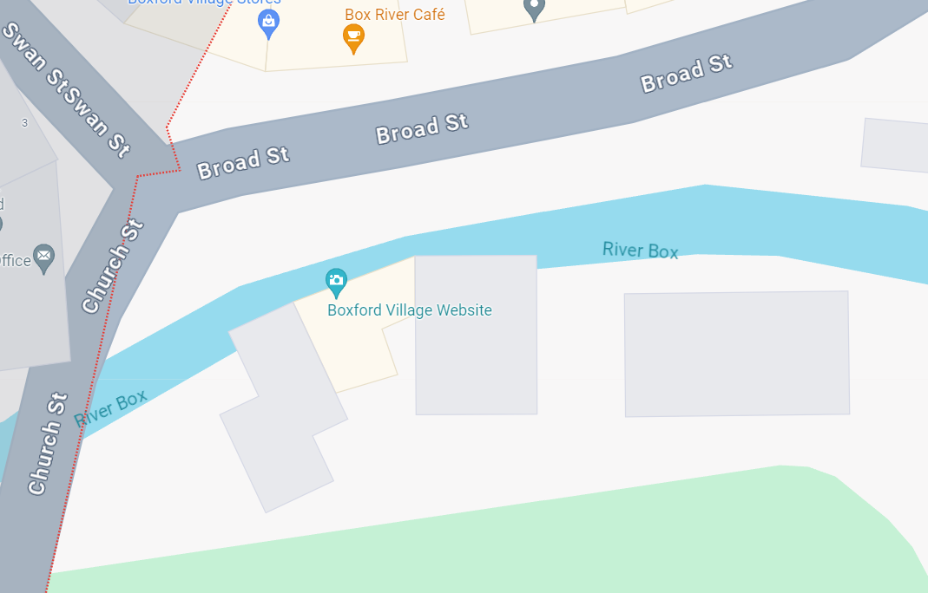
Image 1: Plan of area with location of tree marked with red circle (©Google Maps).
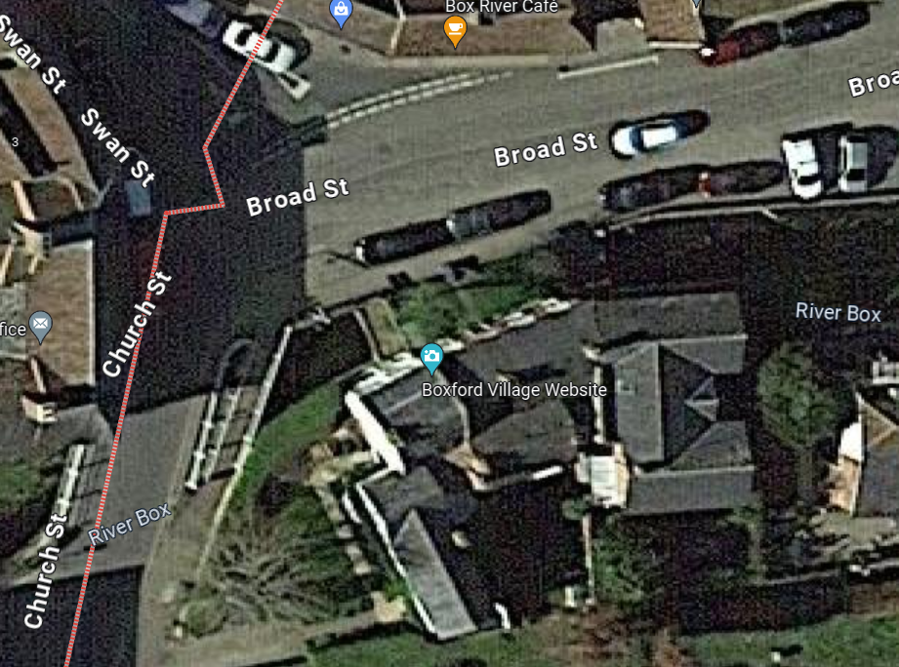
Image 2: Satellite image of area with tree marked with red circle (©Google Maps)
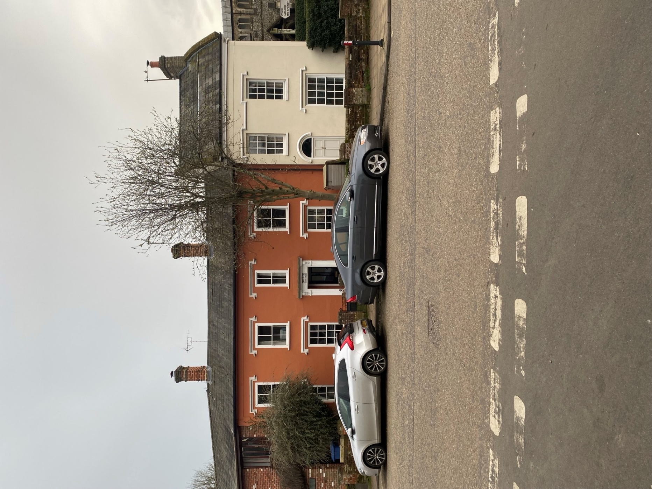
Photograph 1: North elevation of 3 Broad Street, Boxford with tree highlighted
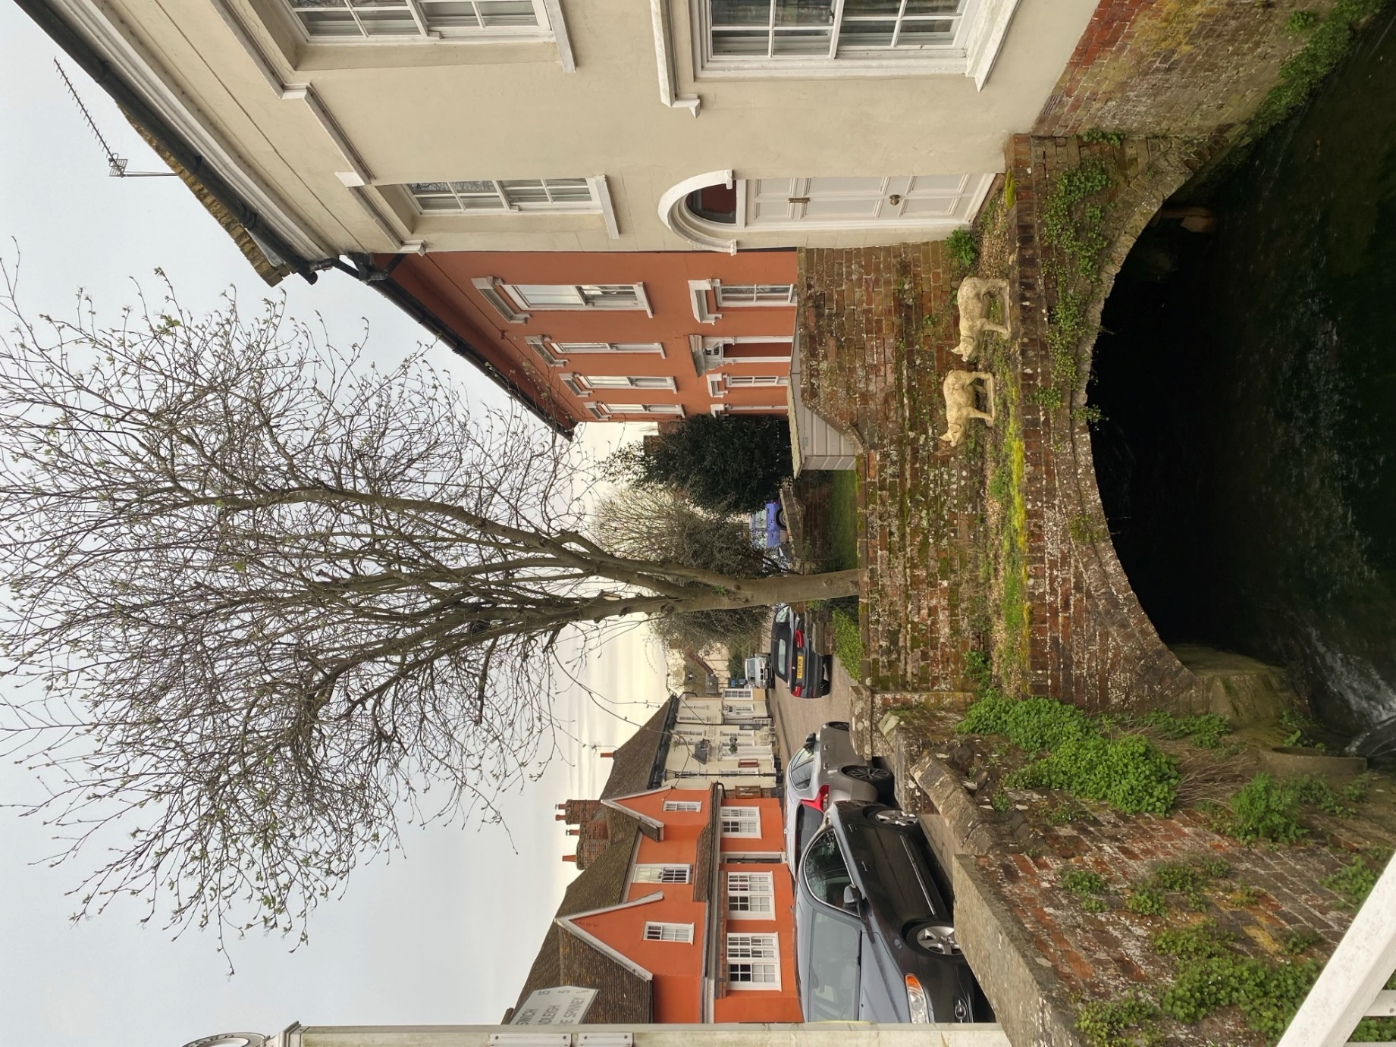
Photograph 2: Tree as viewed west to east (from road bridge over River Box), with bridge structure beneath front garden of 3 Broad Street visible
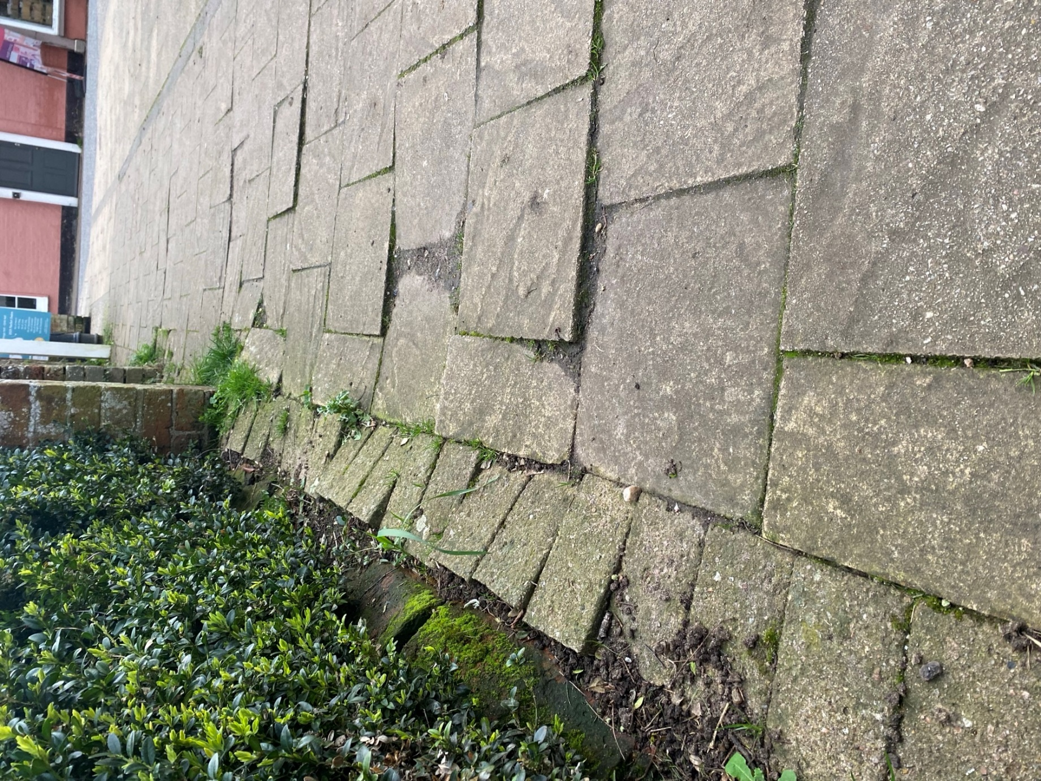
Photograph 3: Condition of public pavement immediately adjacent to tree
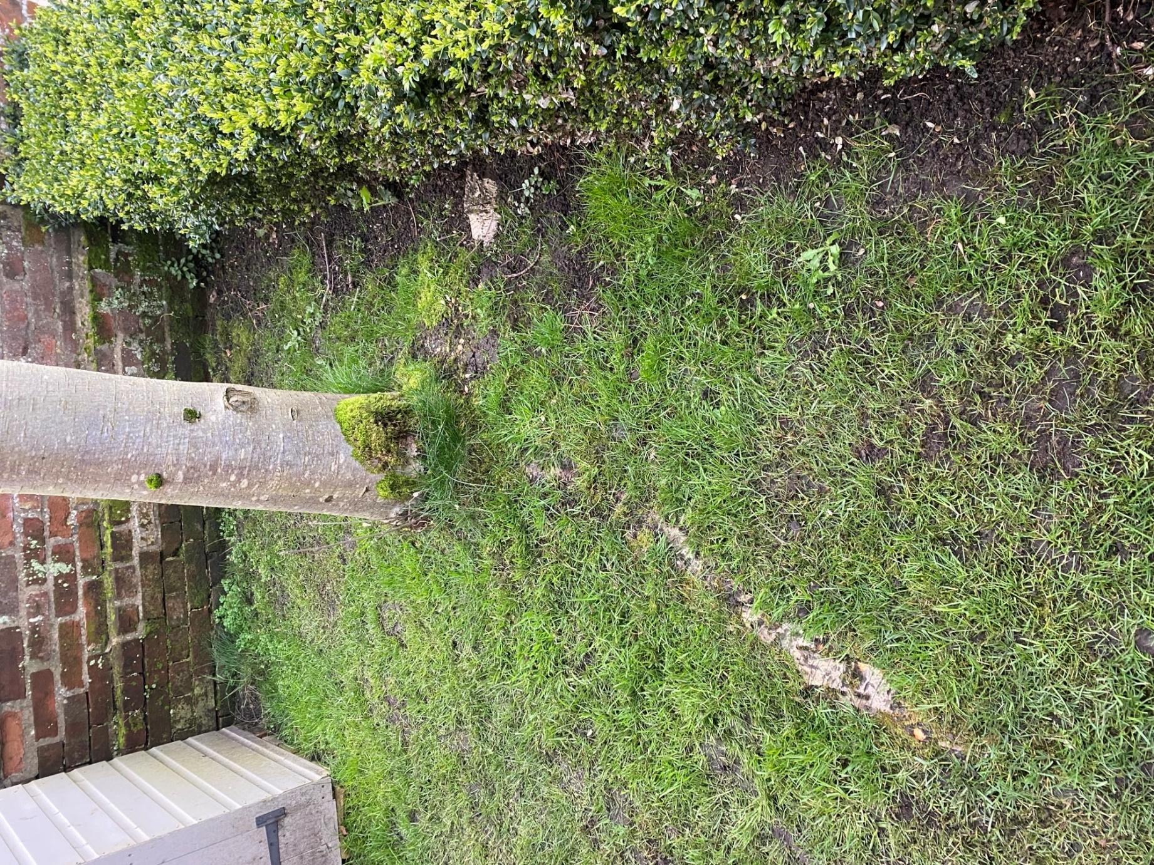
Photograph 4: Exposed/surface roots of tree (root centre right of photograph is adjacent to public pavement depicted in photograph 3)

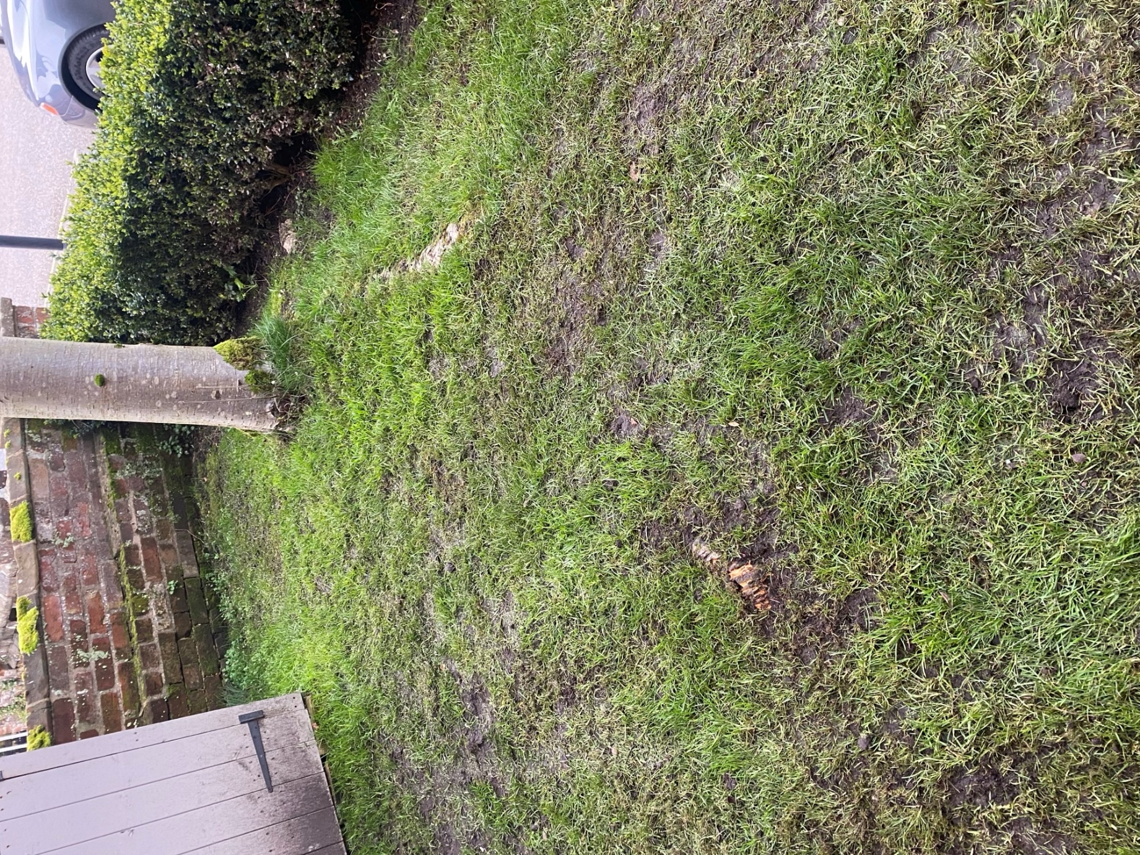
Photograph 5: Exposed/surface roots of tree

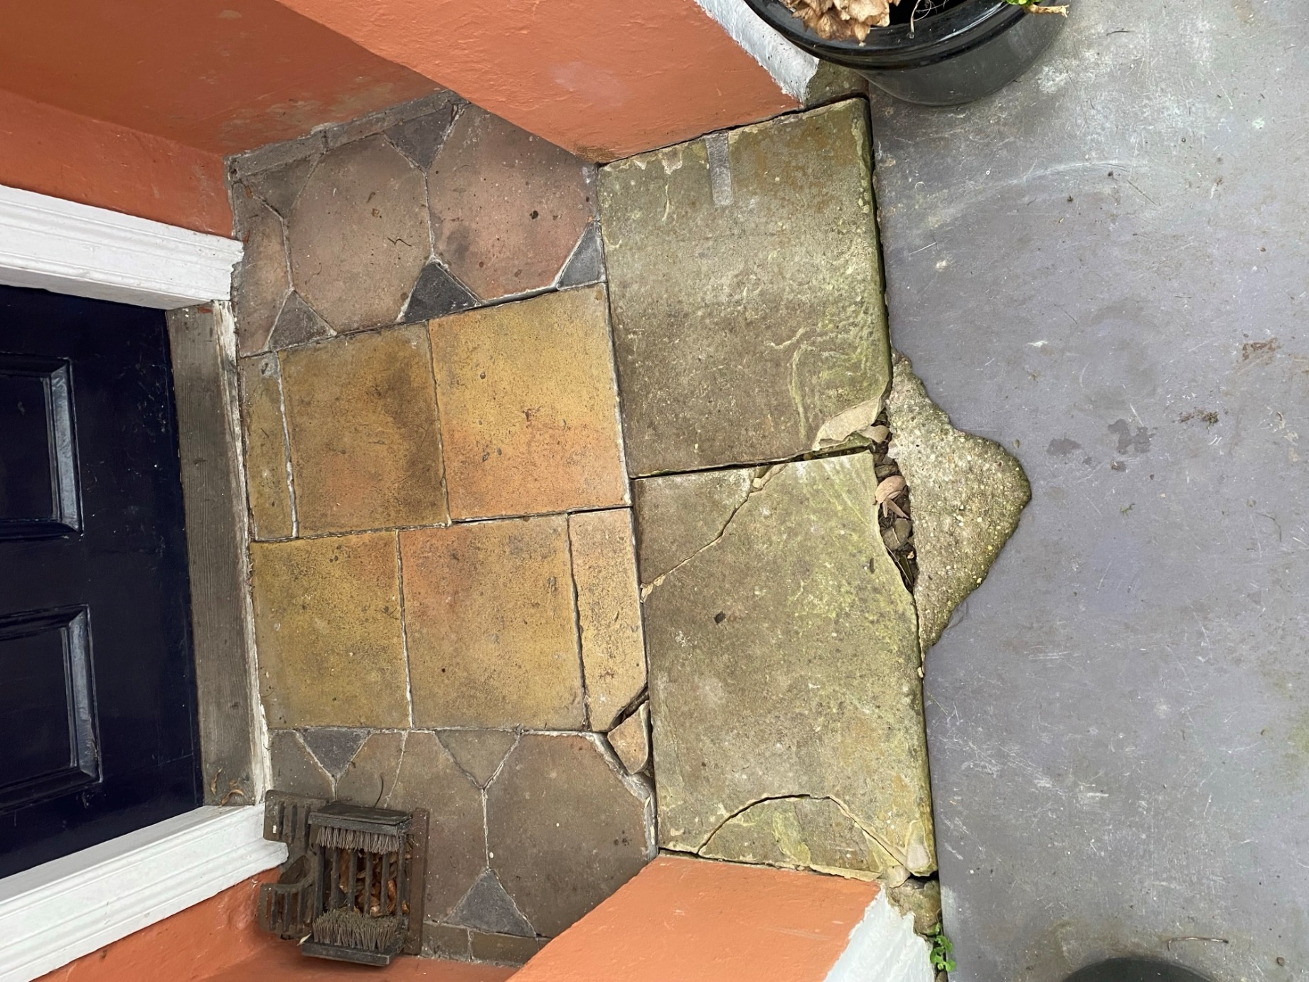
Photograph 6: Damage to porch tiles/stone caused by tree roots (roots since removed as trip hazard)

