Flood Risk Assessment
Project Title 16 Cooks Road, Elmswell
Date 18 March 2024

Introduction
This statement has been prepared to assist with the understanding of the proposals for the above site which are currently submitted to Mid Suffolk District Council for determination.
This document should be read in conjunction with the supporting documentation submitted for consideration.
The Proposal
The proposal comprises of the addition of a two storey extension to the rear and side of the property to provided both additional living space and bedrooms to accommodate a growing family.
The Site
The property is positioned centrally within the village of Elmswell
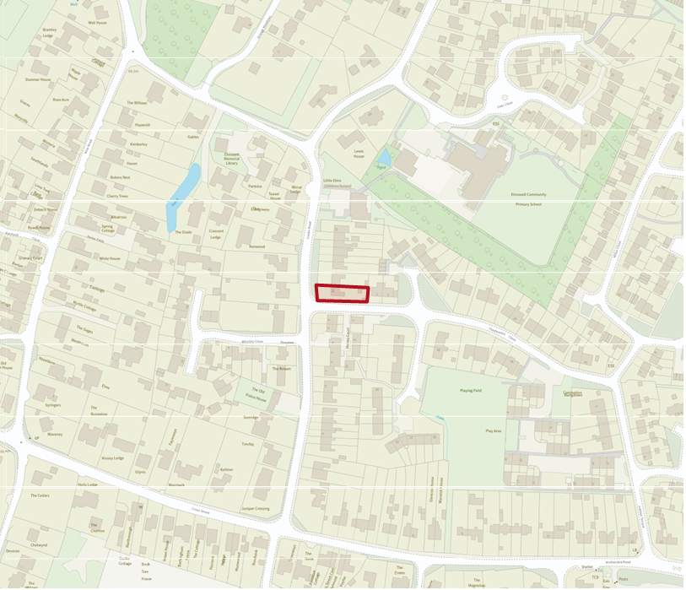
Flood zone 2 Flood zone 1
Referring to the Environment Agency website (shown above) notes that the site is within Flood Zone 1 and as such is not considered to be at risk of flooding from any source.

The Environment Agency flood map for the site confirms that ‘you may need to do a flood risk assessment if your site is any of the following:
· Bigger than 1 hectare
· In an area with critical drainage problems as notified by the Environment Agency
· Identified as being at increased flood risk in future by the local authority’s strategic flood risk assessment
· At risk from other sources of flooding (such as surface water or reservoirs) and its development would increase the vulnerability of its use (such as constructing an office on an undeveloped site or converting a shop to a dwelling.
The proposed conversion works will not increase impervious run off, or enhance flood risk elsewhere.
It is proposed that the works will be carried out in accordance with the
recommendations in ‘Improving the Flood Performance of New Buildings; Flood
Resilient Construction’.

Conclusion

The site is not greater than 1 hectare.

The site has not been identified by the EA as having a critical drainage problem.

The site is not identified within a SFRA as being at increased flood risk in future.

The proposal demonstrably does not introduce a more vulnerable use.

It demonstrably creates no greater risk that currently exists in the use of the host dwelling.

