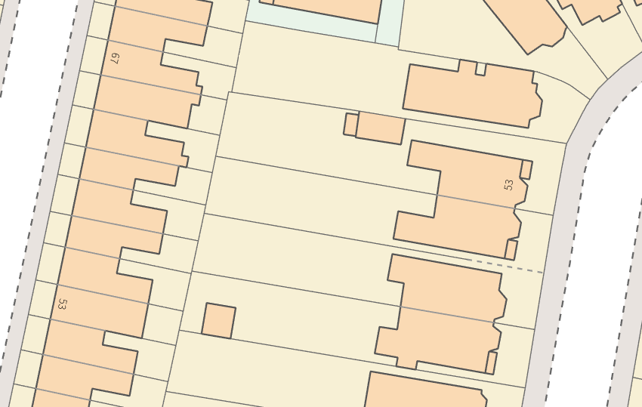

The intended works are for general upkeep and maintenance. The Chestnut is a fairly large specimen and just about encroaches 4 gardens. If left unattended, it would end up getting too large for the location. None of the works would be detrimental tree the tree nor affect the amenity value.

Chestnut

Bay

Westbourne Street

Pembroke Crescent

51

55

53

**North**

**Not to scale**