70 Foxtail Drive, Hythe, SO45 4NZ
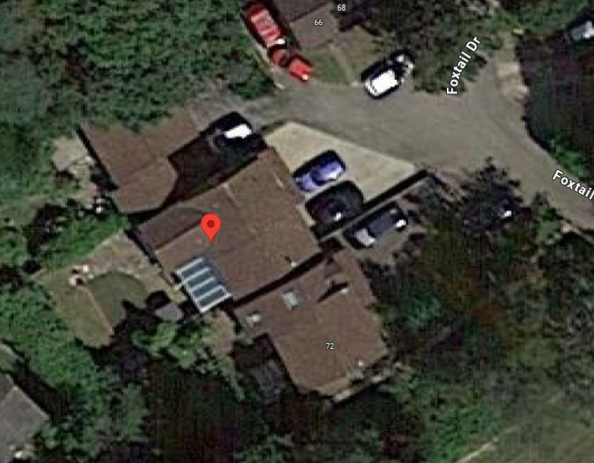

- Site
  - The application site contains a detached property and is located within area of Dibden Perlieu
Application Site

- Site & Planning History
  - New Forest District Council website shows 3 planning history for the application site (including this application)

- Proposal
  - The proposal is to raise the roof of the main dwelling by 1.36m to accommodate a further 2 bedrooms. There will be an addition of 2 front dormers and 1 rear dormer.
  - The property sits within a cul de sac of similar properties. There are a variation in both roof heights and land levels in this location and there are other properties which have steeper higher roofs. The neighbouring property has been extended to the side and this has incorporated a cat slide roof with a dormer to the front. Number 70 has been extended previously to the side with a two storey addition along with a conservatory to the rear. The proposed roof alterations would include increasing the height of the roof by approximately 1.36 metres and this would result in steeper pitch being introduced. The increased height of the property would be comparable with other neighbouring properties and with the variation in heights within the street these alterations would not appear out of keeping.
  - In terms of materials, the tiles on the roof will match the existing and the dormer cheeks will be cladding to match with the neighbouring dormers.
  - There is onsite parking available along with visitor parking spaces within the cul-de-sac and therefore the additional bedroom would not create a highway safety concern.

