DESIGN AND ACCESS STATEMENT
ONE PROPOSED NEW DWELLING
(PLOT OF LAND BETWEEN MANOR BARNS AND BARTON HOUSE)
AUNSBY ROAD (NORTH SIDE OF THE CHURCH)
AUNSBY
SLEAFORD
LINCOLNSHIRE
NG34 8TA
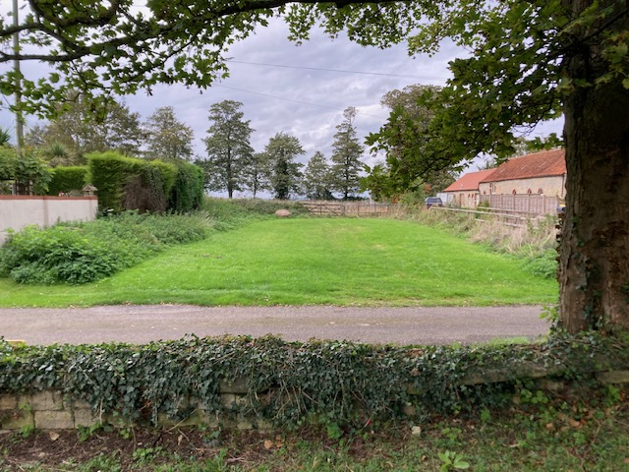
Prepared by David Morris MRICS
November 2023
1.00 INTRODUCTION
This Design and Access Statement is presented to support a full planning application submitted into North Kesteven District Council for one proposed new residential dwelling.
The site is a plot of open ground (grass), situated between Barton House - a two storey brick and tile hung private dwelling house with a front attached double garage - on the west side of the site and two single storey, stone and tile barn conversion dwellings on the east side of the site.
The site provides access across the plot, through a rear centre timber gate, into a north grass field.
The site is not within a Conservation Area and not in a Flood Risk Area.
South across the single track tarmac road (Aunsby Road), is the village church and church yard.
A separate Heritage Statement has been prepared to support the application as the site is on the north side of this Grade II* Listed church.
Please see the submitted drawings and site photographs.

2.00 USE
The site is an open area of reasonably level grassed land measuring approximately 16m wide x 26m deep (416 sq m). The land has an open frontage with grass verge up to the tarmac surface of Aunsby Road. The site grass is mown, possible by a local resident.
The proposed new dwelling will have an ‘L’ shaped plan form with a one and one half storey height for the front south section of the dwelling. The upper rooms being partly within the front pitched roof space. The rear east side wing is single storey.
The dwelling with have a west side access drive, a west rear garden area and a car parking and turning area at the rear north end of the site. Sufficient room (1.5m) has been allowed along the east side of the dwelling to accommodate foundations and services (drains and cables) and for future maintenance access.
3.00 AMOUNT
This area of land is an ideal building plot which has no current use apart from providing means of access into the rear grass field. This access will be relocated and maintained.
A modest carefully designed new dwelling with a garden area and off road car parking and turning area can be accommodated on the site.
The site is situated between existing residential dwellings with an open field behind.

4.00 LAYOUT
The location and orientation of the proposed new dwelling, the access drive with entrance and garden and car parking have all been carefully considered.
The front elevation of the dwelling faces south towards the village church across Aunsby Road. Minimum openings - a recessed porch and 4 narrow glazed vent slot openings - have been incorporated into the south stone elevation of the new dwelling. This will help the new dwelling reflect and harmonise with the former farm stone barns on the east side of the site - Church and Manor Barns which are two residential barn conversion dwellings.
Windows in the east side elevation have only been placed towards the front south end, into the kitchen and utility room. Natural light into the rear east rooms is delivered through roof-lights. All other fenestration is within the rear north and west side elevations, which mainly look out onto the rear garden.
The rear west side garden will be a private amenity space for the occupants to enjoy. Agricultural vehicle use of the west side access track into the rear field, will be fairly infrequent (hay making in Spring etc.).
The west side drive will provide access to the rear car parking and turning area behind the dwelling.

5.00 SCALE
The scale of the site development has been carefully considered not only for the layout as described above but also the height and form of the new building and the selected materials.
On the west side of the site is a two storey house which has upper walls clad with red tiles with buff/grey brick to the lower walls, including the front south double garage. Each have a concrete tile covered pitched roof, the garage roof is hipped.
On the east side of the site is a front south single storey stone walled barn conversion dwelling. This has hipped roofs covered with red clay pantiles.
The proposed new dwelling at the front is one and one half storey height with natural stone walls under pitched hipped roofs, covered with red clay pantiles. This proposed building form and design balances between the taller west side house and the east side single storey building.
The rear north east wing of the dwelling is single storey and subservient to the slightly taller front part of the dwelling. We feel this adds interest and variety to the design but the use of similar materials (stone and pantiles) will bring harmony to the overall design.
We feel the scale and setting of the proposed new dwelling makes full and appropriate use of the site, reflecting all of the adjacent buildings in the locality.

6.00 LANDSCAPING
The front of the proposed new dwelling reflects a barn. We therefore consider it appropriate to retain the front area of ground, outside this new building, as a simple grass verge. The absence of shrubs and flower borders along the front elevation will further help reflect a simple rural barn.
The garden area is at the rear west side of the new dwelling. This will receive afternoon/evening sun. A simple timber post and rail fence is proposed as a division between the west gravel access drive and the garden.
The existing west side site boundary is a rendered wall at the front south end, 7.7m long and approximately 1.7m high. Behind this wall the west boundary is a mature Leylandii hedge approximately 4m tall. This will prevent overlooking from the first floor east windows of Barton House into the new dwelling and its garden.
The site rear boundary will be a new west side timber 5 barred gate and timber post and rail stock proof fence.
The site east side boundary is a timber post and rail fence to be retained or replaced with an identical fence.

7.00 APPEARANCE
On a site very close to the village church and church yard we considered an elaborate, ornate, decorative new dwelling design to be inappropriate. The selected simple rural barn front elevation provides the appearance of a building often found within a village street. A barn also reflects and harmonises with the existing east side barn conversion buildings. Natural local stone and red clay pantiles also match the material of the east side barns.

8.00 ACCESS
Access into the rear north field behind the site is currently available across the grassed site, through a timber field gate although this appears to be little used. In order to maintain access into the rear field for farm vehicles and machinery, a 4m wide access will be formed along the west edge of the site. The position of the rear gate into the field will be adjusted and moved to the west side. The existing central gate will be infilled with timber post and rail fencing.
At the front south west corner of the site, a new 4m wide vehicular entrance will be formed, all to Lincolnshire County Council highways specification and standards. The entrance will be hard bound paved (probably black tarmac) for a minimum distance in from the edge of Aunsby Road (public highway) of 6m.
This west side entrance and access drive will also serve the new dwelling and will be gravel surfaced after the first 6m entrance tarmac.
A car parking area in the rear north east corner of the site and a north west turning space will be formed and gravel surfaced to allow vehicles to leave the site in a forward direction.
Access into the new dwelling will be available through a 1m wide front entrance door set into the porch and also through a pair of rear west side glazed doors, one of which can have a level threshold.
As required by the Building Regulations, the property has a ground floor level accessible toilet.

David Morris MRICS
Chartered Building Surveyor
November 2023.

