Application No. TPP/0161/24 |  |  | Adress:- Queen Elizabeths School  Queens Road  Barnet  EN5 4DQ |  |  |  |  |  | TPO ref:  19/TPO/012 |  |  | Date: -  26/03/2024
Assessment by: | JM |  |  | Species: Oak
Proposed works | x 1 oak (T260 applicants ref) remove/reduce decayed limb over access road to sports field at Queen Elizabeth's School EN5 4DQ. Standing within A1 of order.
Reasons for works | Dangerous limb
Importance of position in landscape (Helliwell tb 4) | 1 | Presence of other trees  (Helliwell tb 4) |  |  | 1 |  |  | Suitability to setting (Helliwell tb 7) |  |  | 4
Comments: | Tree located on a bank and part of a long row between school buildings and sports fields
Ownership | Tree within application address |  | Yes | If no |  |  | Owner consulted |  | Yes/no
Past tree management | Minimal
Condition of tree | Upper crown: |  | N/A
 | Main stem and branches |  | Branch with significant decay and likely to fail. Cavity with potential for bat roost, advised to retain cavity if possible.
 | Base of tree
 | Rooting area
 | Other observations
Safe useful life expectancy | 50 |  | Visual appearance/form:  Part of a row of trees.
Suitability of works | Acceptable
Recommendation | Allow 5 day notice
Photographs
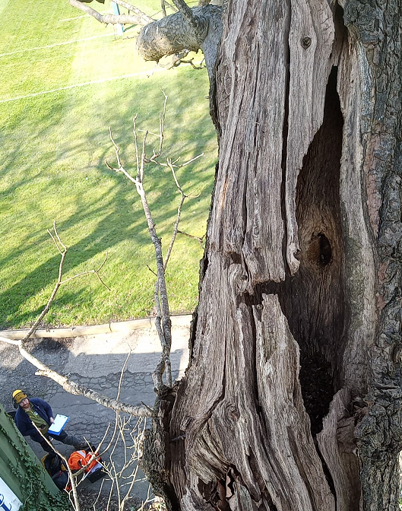 |  |  |  |  |  | 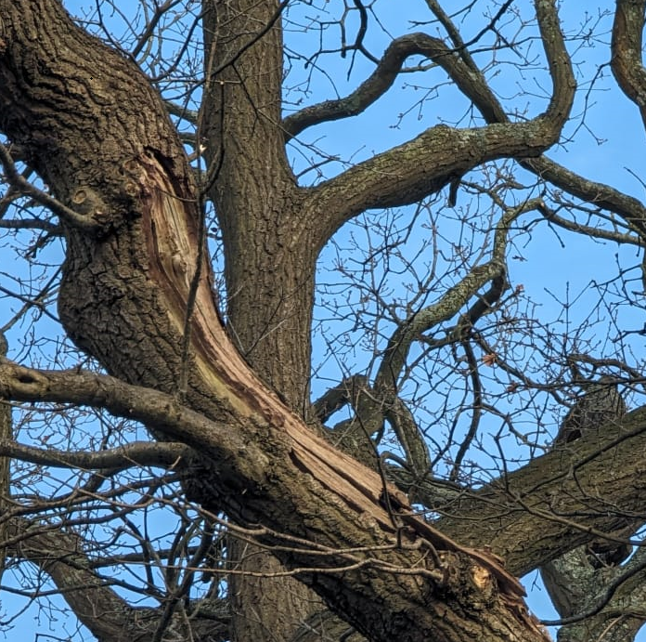

Key:-
Table 4 Scores for importance of position to the general populace
“No importance” = Score 0
“Very little importance = Score 0.5”
“Little importance” = Score 1
“Some importance” = Score 2
“Considerable = Score 3 importance”
Table 5 Scores for the importance of

Table 6 Scores relating to the presence of other trees
Woodland = more than 70% of the visual area covered by trees, and at least 100 trees in total Score 0.5
Many = more than 30% of the visual area covered by trees, and at least 10 trees in total Score 1
Some = more than 10% of the visual area covered by trees, and at least four trees in total Score 2
Few = less than 10% of the visual area covered by trees, but at least one other tree present Score 3
None = no other trees present in the area Score 4 under consideration

Table 7 Scores for relation to setting
Suitability to setting Totally unsuitable (Much too large, much too small, obscuring attractive view, disrupting formal composition, totally wrong colour, etc. Landscape would be improved if tree removed.) Score 0
Moderately unsuitable Score 0.5
Just suitable Score 1 Fairly suitable (Fairly well placed. A definite asset to the landscape.) Score 2
Very suitable (Well placed or screening unsightly views.) Score 3
Particularly suitable (Well placed and screening unsightly views, or making a special contribution to local character.) Score 4

