LOCHHEAD COMMUNITY GARDEN, LOCHWINNOCH
PHASE II SITE INVESTIGATION REPORT
EXECUTIVE SUMMARY
ERS undertook this Phase II site investigation into environmental conditions at a site on Lochhead Avenue, Lochwinnoch, on behalf of Lochwinnoch Community Development Trust.
The investigation was initiated to assess suitability of proposed use of the site as a community garden.
This report should be read in conjunction with the Preliminary Risk Assessment, January 2023, produced by ERS. The conceptual site model formed during the preliminary risk assessment indicated that there were a number of potentially significant pollutant linkages that required further investigation.
The methodology and results of the intrusive investigation are detailed in this report.
Human Health Risk Assessment
The human health risk assessment identified exceedances of the ‘allotment’ GAC in at least 1 sample for the following COC: lead, and 5 PAHs (benzo(a)anthracene, chrysene, benzo(b)fluoranthene, benzo(a)pyrene and dibenzo(a,h)anthracene). Asbestos was also detected in 1 no. soil sample. Further assessment was undertaken by also comparing results to GAC for a ‘public open space (park)’ end use, which is considered suitable for the slightly less sensitive end use, for areas of the site in which produce will not be grown.
It was concluded that there is a potential risk to human health from lead in the NE area of the site where produce will be grown (via ingestion pathways i.e. consumption of grown produce), and a localised risk from PAHs and asbestos in made ground in the south eastern area of the site (around TP01 and TP03).
Water Environment Risk Assessment
The water environment risk assessment involved comparing leachate results to assessment criteria for groundwater and surface water. The water environment risk assessment identified exceedances of freshwater EQS in leachate for: lead, copper, zinc, and exceedances of groundwater RPV lead. However, on further assessment and consideration of the data, it is considered that the potential risk to water environment receptors from the site is low. It is, therefore, concluded that it is unlikely that Significant Pollution of the Water Environment (SPWE) or Significant Potential of SPWE is occurring at this site.
Recommendations
Remedial action / mitigation measures are required to address the potential pollutant linkages identified by the site investigation. For the areas of site where growing of produce is planned, a suitable thickness of clean imported soils (as a capping layer above the site soils or within raised beds) is required to address the potential risk from concentrations of lead in site soils.
Remedial action is also required to address the localised risk from PAHs and asbestos in soils in the south eastern area of the site around TP01 and TP03; this may comprise source (made ground) removal and/or a clean capping layer of suitable thickness. Production of a remediation strategy is recommended.
Main Results
Given the proposed end use of the site as a community garden including growing of produce,
it is deemed appropriate to compare all soil results with GAC (Generic Assessment Criteria) for the standard land use ‘allotments’. Although some of the site will not be used for growing produce, it is considered that, although overly conservative for some areas of the site, this will serve as an appropriate screening methodology. The analysis showed that several non-volatile PAHs (Polycyclic Aromatic Hydrocarbons - a class of chemicals that occur naturally in coal, crude oil, and gasoline) exceed the ‘allotment’ GAC at 2 sample locations: TP01 0.2m and TP03 0.2m; asbestos was also detected in TP01 0.2m. TP01 and TP03 are both located in the south western area of the site. The lead GAC of 80mg/kg was exceeded in one or more samples from all trial pit locations (and in verification location IP02), indicating potential site wide risk to human health from lead in soils on site.
As previously described, the proposed garden layout plans indicate that growing of produce
will only be undertaken in parts of the northern / eastern area of the site, and the rest of the
site will generally be paved or left as greenspace with shrubs/grass, wildflowers and trees.
Therefore, further assessment has been undertaken by comparing the soil results for the
locations outwith the growing garden area, to the GAC for the standard land use ‘public open
space (park)’, considered suitable for the slightly less sensitive use / areas of the site, in which
produce will not be grown. The analysis shows that there are no exceedances of the GAC for lead (1,300mg/kg); however, locally elevated concentrations of PAHs in TP01 and TP03, and asbestos in TP01, still exceed these less conservative GAC.
Therefore, the human health risk assessment indicates that there is a risk to human health in
the north eastern growing garden area from concentrations of lead in soil on site, and for the
remainder of the site (south western area) there is a localised risk from PAHs in shallow made
ground at TP01 and TP03 (and asbestos in TP01.
Recommendations
Remedial action / mitigation measures are required to address the potential pollutant linkages identified by the site investigation. For the areas of site where growing of produce is planned, a suitable thickness of clean imported soils (as a capping layer above the site soils or within raised beds) is required to address the potential risk from concentrations of lead in site soils.
Remedial action is also required to address the localised risk from PAHs and asbestos in soils in the south eastern area of the site around TP01 and TP03; this may comprise source (made ground) removal and/or a clean capping layer of suitable thickness. Production of a remediation strategy is recommended.
It is recommended that construction workers be made aware of the previous history of the site, use appropriate Personal Protective Equipment (PPE) and adopt suitable Health and Safety procedures whilst working onsite to control these risks during the construction period. Site workers should notify the project manager of any malodorous or suspicious appearing soil or waters on the site, the significance of which should be assessed by a suitably qualified and experienced engineer. The findings should be referred to ERS for inclusion in the risk assessment.
To prevent the potential for contaminated dust generation and migration offsite, ERS recommends mitigation measures are incorporated into the construction phase of the project; these should include dampening down of contaminated areas, especially during dry periods, which will ensure that ground-working does not release airborne particulates.
It is recommended that any soakaways planned for the site are not constructed in the areas identified with elevated concentrations of contaminants. This will ensure that mobilisation of contamination and contaminated leachate production is kept to a minimum.
It should be noted that all risk assessments undertaken at the site have been made on the assumption that groundwater from the site will not be used for human consumption. Should a private water supply at this site be considered, ERS should be approached to make an assessment on the suitability of the groundwater for potable water purposes.
Waste Management
This site has been assessed against a standard of “suitable for use”. This means that residual contamination, if any, will not pose an unacceptable risk to any receptor identified during the investigations, including buildings, humans and the water environment.
There is, however, no direct relationship between waste management classification and contaminated land legislation. Therefore, even though soil is suitable for use, it does not mean it is inert or suitable for local disposal.
If there is any potentially contaminated soil to be disposed of from this site, including a site scrape, and foundation or trench arisings, full details of the site should be provided to the responsible contractor to permit accurate classification of waste, and the identification of appropriate disposal routes.
ERS has a contracting division which would be pleased to provide a quotation for waste disposal, should this be required.
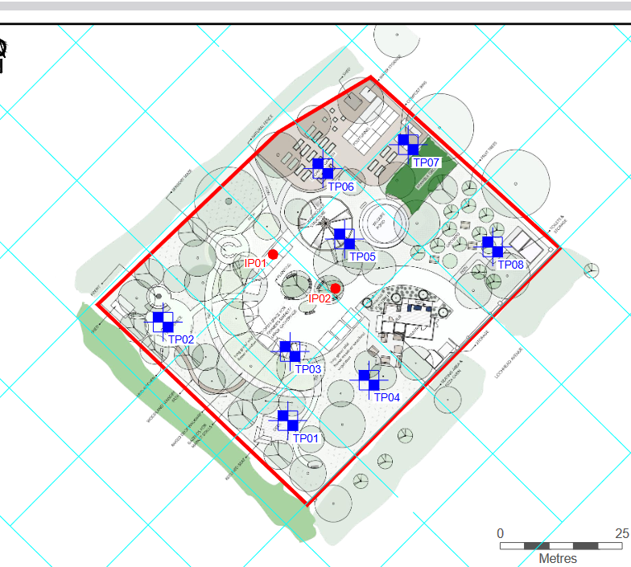
N

