32 Old Street – Proposed area of render repair

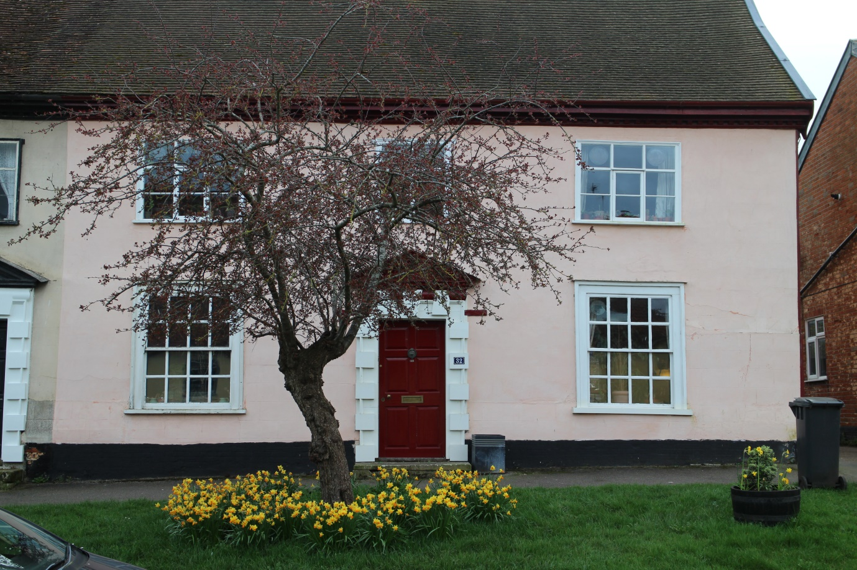
Area of render to be replaced

The front face of the house is lime rendered on wire mesh apart from the lower section where this has previously been replaced with lime render on wooden laths.
The wire mesh is rusting and there is cracking and bulging in the render. Part of the section on wood laths has lost its key to the laths and is coming away from the wall.
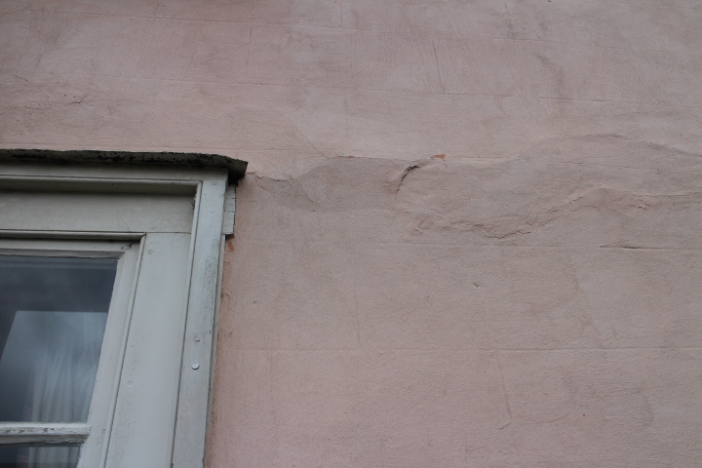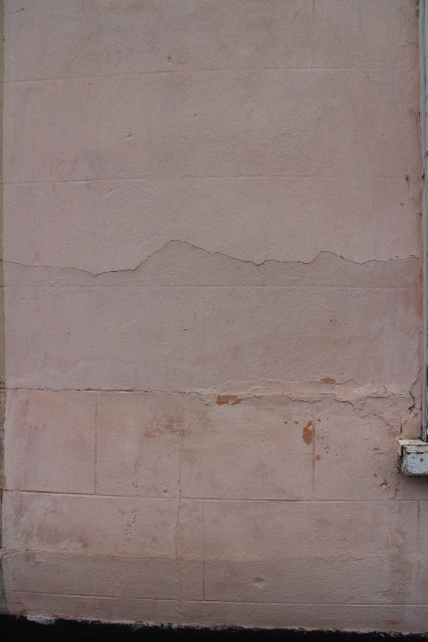
Areas of failed render on wire mesh backing

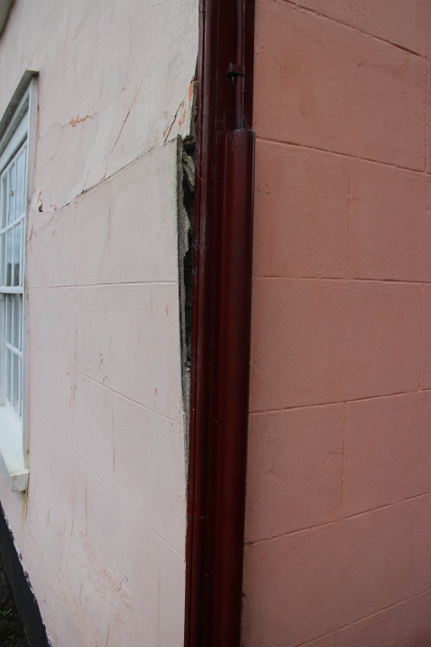
Section of render which has lost its key to the laths

