HERITAGE STATEMENT – 32 OLD STREET, HAUGHLEY
32 Old street is part of a divided pair of Grade 2 listed buildings with the following listing:
Two houses, built as one in late C16; possible earlier core. 3-cell plan with
lobby entrance. 5 windows. 2 storeys. Timber-framed and plastered.
Plaintiled roof with a detilled wooden eaves cornice. An axial chimney, the
shaft rebuilt in mid C20 red brick. 3 early C18 small pane sashes with thick
glazing bars at ground storey , those at No.32 restored in C20. Various C18,
C19 and C20 casements at 1st storey. Two good early C18 doorways with Gibbs
surrounds, pulvinated friezes and pediments, entrance doors with 6 fielded
panels. Late C16 queenpost roof surviving in part; most of the roof was
rebuilt in pine in C18. Mulbra House has some massive unchamfered floor
joists of C16 type; framing otherwise mainly concealed. This building is
believed to have been a Town-house in C18, and previously a guildhall.
However, its construction appears to post-date the dissolution of the guilds
in 1545.
Listing NGR: TM0277462114
The house is shown in its setting in Old Street in the photograph below.
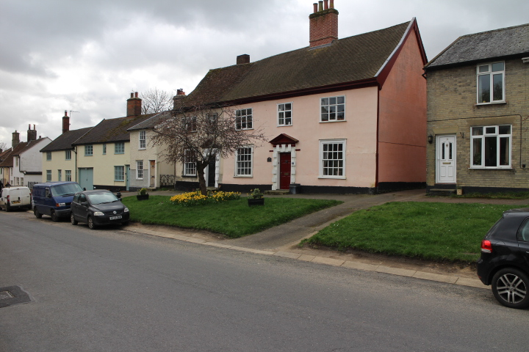

A view of the front face of the house in more detail is shown in the photograph below. All of the proposed work is to the front of the house so any possible impact of this would be on this face.
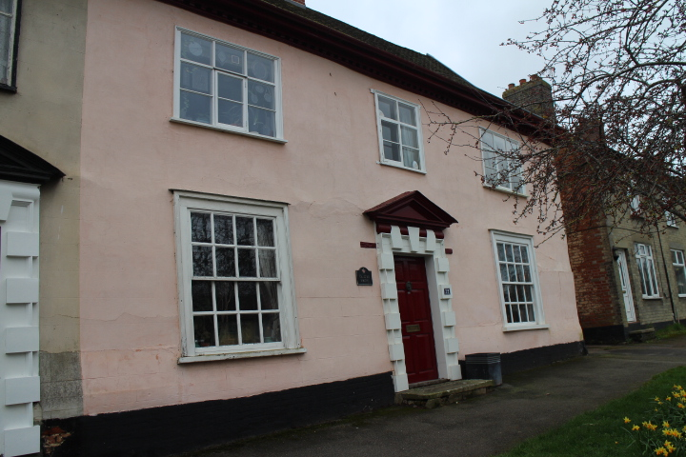
The proposed work is to replace the rendering on the front face of the house. The details of the work are specified in the listing application.
It can be seen that the house plays a significant part in the outlook of the street, so the proposed works are sensitive to maintaining and, where possible, improving this.
The principle behind all the work is to only replace parts of the original fabric that have deteriorated beyond reasonable repair, i.e. the render. Where worn out original material is replaced it will be replaced with the correct material of appropriate appearance.
The front elevation of the house is of Georgian appearance with a fine C18 door and surround and the intention is that the proposed changes should be in keeping with and enhance its overall appearance.

