Heritage Statement to Accompany Application DC/24/01541
This application is to install structural reinforcement in the cellar of Lime Kiln House, Old Ipswich Road, Claydon, IP6 0AD. The location of the cellar which is the subject of the application is shown in file “cellar.jpg” which is attached to this application.
Lime Kiln House itself is Grade II listed (although we have been advised that this does not include the outbuildings at the back of the property). We believe the house dates from around 1440 and was at one time a mediaeval hall house. Much of the timber frame, particularly at the first and second floors remains intact, including crown posts. The ground floor has been replaced in large part with brick walls and Georgian windows and doors have been added. Over the years it has been adapted and extended, notably with the addition of the Lime Kiln Cottage wing to the North side of the house.
The heritage impact assessment considers the impact of reinforcement of the cellar roof.
The cellar is located outside the original timber-framed house, underneath a utility room and in a part of the house believed to date from the early 20th century. A purchase survey of the house indicated it may have been used as a war time bomb shelter during WW2.
The reinforcement is necessary for the reasons outlined by structural engineers, JP Chick in the report attached to this application. Photos of the cellar are shown below:
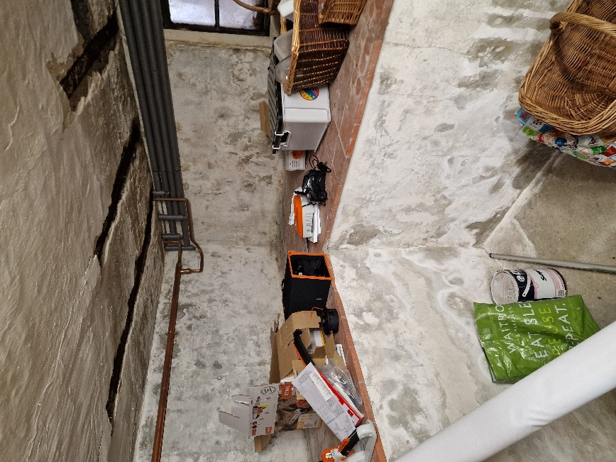
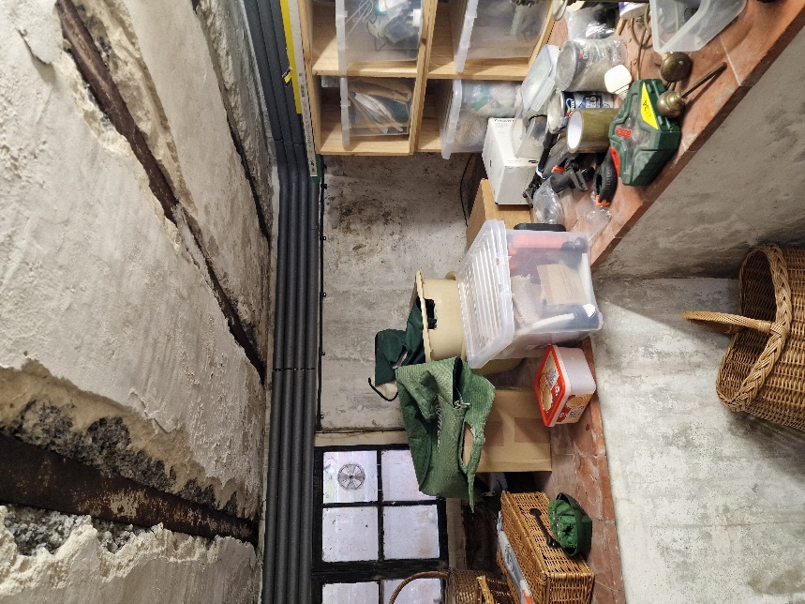

No change in nature or character is planned beyond the addition of the steelwork shown in the plans.
There is not believed to be any viable alternative to the works planned. The works are necessary to prevent harm to the main house above the cellar and to ensure the cellar can be used safely.
It is not anticipated that the works will have any significant impact on the character or setting of the house, indeed they will not be visible anywhere other than the cellar itself. There should not be any loss of historic fabric and the original structure will remain visible as it is today.

