93 Hampton Road
Hampton Hill
Hampton
London
TW12 1JQ

Tel: +44 (0)20 8943 8800

info@mbaplanning.com
michaelburroughsassociates.com

Bournemouth, Christchurch and Poole Council (“BCP Council”)
Planning Department
Kingsland Road
Poole
BH15 1QE

 | Our ref: | E5449
 | 26th February 2024

Dear Sir / Madam

POOLE: 10 STATION ROAD, PARKSTONE, POOLE BH14 8UB

This is the Planning and Heritage Statement in respect of a Full Planning Application for the change of use of the two upper floors of these premises to two flats.

The Full Planning Application comprises a copy of the following:

- Completed Planning Application Form;
- Dwg. No. ** Existing ground floor plan;
- Dwg. No. ** Proposed ground floor plan;
- Dwg. No. ** Existing first and second floor plans;
- Dwg. No. ** Proposed first and second floor plans;
- A covering letter prepared by Michael Burroughs Associates dated 26th February 2024;
- A completed CIL Form 1 additional information form; and
- The applicant will pay £1,018 plus £64 Service Charge being the appropriate fee electronically via the Planning Portal

- Location

- The application property is in the Ashley Cross and Broadstone district centre and the Ashley Cross Conservation Area. It is part of a locally listed Victorian terrace (orange) opposite Ashley Cross Green that is identified as a positive contributor the Conservation Area Appraisal.

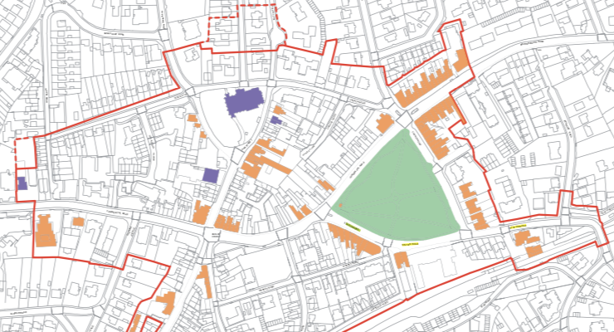

2.0 The Site
- The first photo below shows the front of the application building from Station Road and the second the long rear car park from Wessex Road.

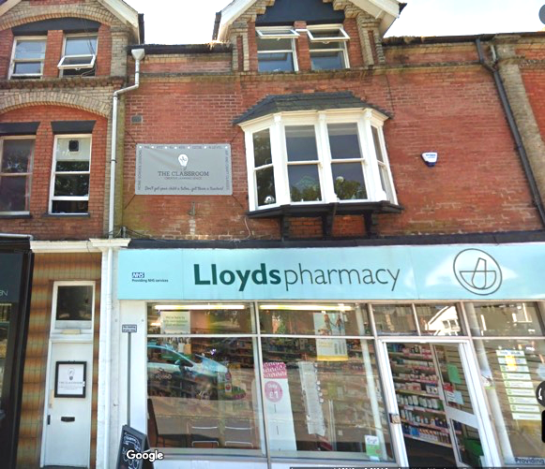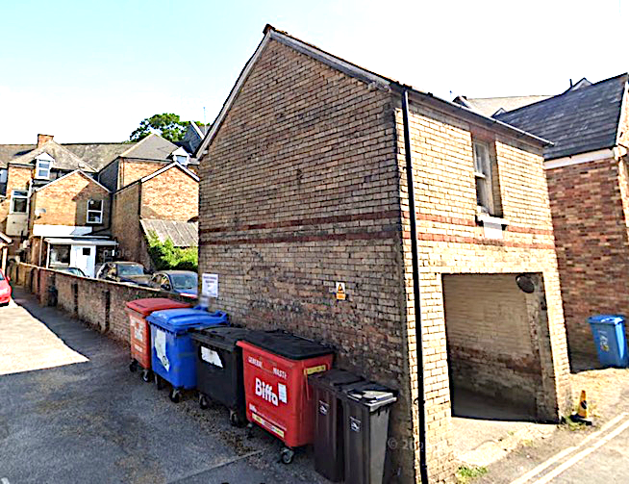

- The proposed change of use does not affect the external appearance of the building. The first and second floors are vacant but were used most recently as ‘The Classroom’, which seems to have been a tutorial establishment. There is no sign of any consent being granted for what seems to have been a Use Class F use, which seems to have shut a year or so ago and been unused since.

3.0 Planning Policy

- Adopted Local Plan paras 6.3 and 6.6 say: The Poole Local Plan contains a suite of policies to maximise the reuse of brownfield land to encourage higher densities, redevelop public sector land, allocate brownfield sites and provide more locations where flats can come forward…The urban capacity work that supports this Plan identifies there is potential for windfall to remain an important part of supply over the plan period. To further assist with maintaining windfall delivery, this Plan adopts a more flexible approach to the location of higher density development such as flats. However, as the Council cannot guarantee that windfall will continue to come forward at past rates, this Plan sets a pragmatic allowance of 150 homes per year from this source, which will contribute about 15% of the overall housing supply.

- The site is previously developed land and will provide a windfall gain in units.

- The Local Plan Policy Map below shows the site is within the Sustainable Transport Corridor (faint brown vertical hatching) which its Key Diagram says is a Potential Location for Flats with Good Access to Bus and Rail Services.

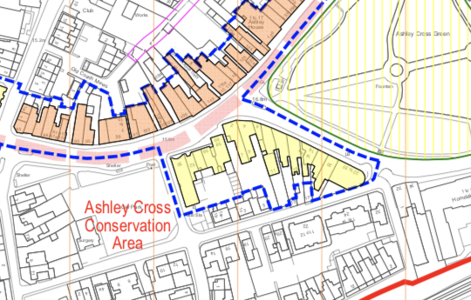

4.0 The Proposal

- This involves the subdivision of the first and second floors to provide a 2 bed 4 person flat measuring 75 sqm on the first floor and a 1 bed 2 person flat on the second floor measuring 57 sqm as shown below:

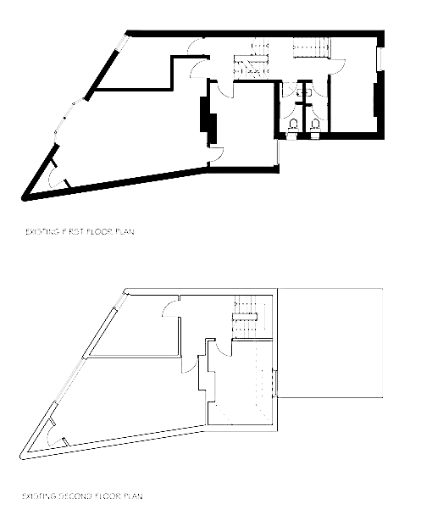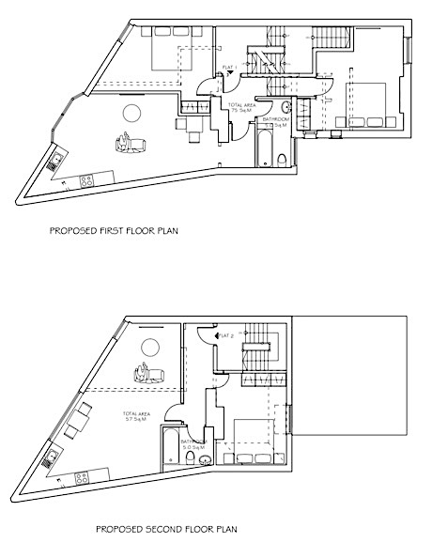

- The flats satisfy all the relevant nationally described standards, and the park opposite provides easily accessible amenity space. Access to the flats is either from the front or the rear doors and bin stores and cycle parking will also be provided at the rear as shown below:

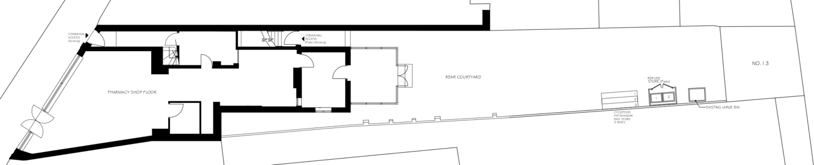

- The proposal satisfies all the relevant Local and National planning policies.

5.0 Heritage Issues

- The Conservation Area Appraisal describes the significance of the area as follows:

Ashley Cross Green is a 3.14 acres green space at the heart of the conservation area. The park defines the area around it with its mature trees. The triangular space is bounded by Commercial Road, Church Road and Station Road….Other locally important features within the conservation area include, Parkstone Railway Station, and the historic road bridge over the railway complete with historic, ornamental street lights at Station Road. This together with the brick railway arches over Sandbanks Road and Salterns Road mark the coming of the railway to Poole at the end of the 19th century. The buildings in the area, both residential and commercial properties, date from the comprehensive Victorian and Edwardian development of the area. These strong architectural and landscape features give the area its special individual character. It is this character which merits the designation as a conservation area.

- The building dates from the time when shopkeepers commonly lived above their shops and so the proposal will reinstate the upper floor’s probable historic use. As the proposal will not affect the appearance of the locally listed terrace, its effect on the character and appearance of the Conservation Area will be neutral.

We look forward to discussing these matters with the allocated Case Officer in due course.

Yours faithfully

Michael Burroughs
Consultant

For and on behalf of Michael Burroughs Associates Limited
michael@mbaplanning.com

