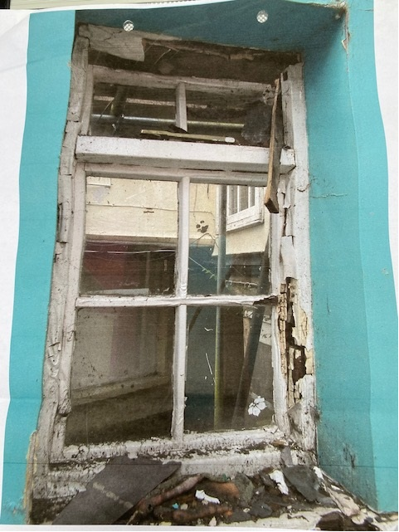

Ground floor window looking from restaurant into rear courtyard

