Energy Strategy

PROJECT: DA206 FRANKS

Meraki
High lanes
Wadebridge
Cornwall

DATE: 08.04.2024

ASSESSOR: Dave White (CW58-0001)

EXECUTIVE SUMMARY

This Energy Strategy has been compiled to demonstrate the above proposal complies with Cornwall District Council Climate Energy DPD Policy SEC1 and should be read in conjunction with the following documents:

- energy-summary-tool-sap-v2_1.xlsx
- Full SAP Calculation Printout - Franks.pdf

INTRODUCTION

The proposal is for a 4-bedroom detached dwelling on a garden plot at High Lanes, Wadebridge. The floor area of the dwelling is approximately 414m² over two floors.

The following methodology detailed in this statement, with SAP calculations demonstrate a space heating demand of less than XXXX and a total dwelling energy demand of less than XXXX These results have been achieved with sufficient renewable electricity generation in line with Policy C1 of the Climate Emergency Development Plan (February 2023).

PRINICIPLES TO REDUCE ENERGY CONSUMPTION & CARBON EMISSIONS

FABRIC

Low U-Value & satisfactory detailing will help to limit heat loss through the fabric elements of the proposed dwelling.

All non-repeating thermal bridges will be specified to Recognised Construction Details or equivalent, ensuring the PSI can be met in this SAP calculation. For the less standard details and junctions, tailored PSI calculations will be required.

FENESTRATION & SOALR GAIN

Consideration has been given to the fenestration of the proposed, with low U-values required to limit heat loss through these areas. Suggested would be, advanced double glazed or triple glazed window units to achieve this.

The glazing design has allowed for passive heating of the building through solar gain. However, to minimise the risk of overheating within the dwelling glazing on the southern elevation has been limited. There is also sufficient shading, via a balcony canopy over the large southwest terrace. Glazing will also be openable where practical and internal shading will be employed where necessary.

MECHANICAL SERVICES

It is crucial that a well-designed building envelope is complemented by suitable mechanical services & technology within the building.

The proposal will utilise an air source heat pump for the heating and hot water systems. In addition, a mechanical ventilation with heat recovery unit (MVHR) will be installed. This will ensure a supply of fresh air to the dwelling given the relatively low permeability targets proposed as increasing the efficiency of both the building fabric and the heating system - recovering heat which would otherwise be lost.

PASSIVE DESIGN

The buildings orientation and principal elevations are approximately north-south facing. (fig .1)

This positioning allows for cross ventilation in the warmer months, with an achievable path of air flow through the building via openable windows.

Solar panels are proposed on the building’s roof, these will insalled to make the most of the southerly aspect.
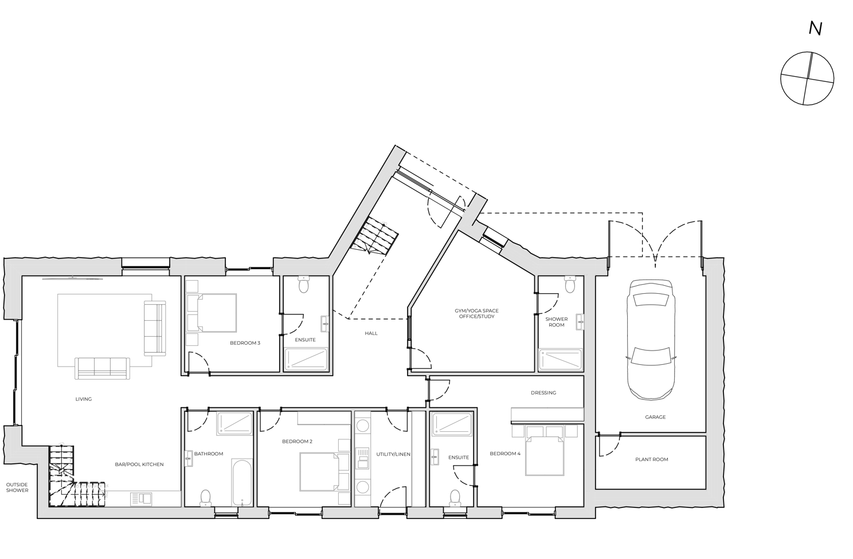

LIGHTING

The proposed lighting plan will be specified with energy efficient lights only. These will have fittings will have lamps of a luminous efficient of at least 120 lamp lumens per circuit-watt.

RENEWABLES

The proposed design employs an air source heat pump and solar photovoltaic panels.

Other forms of renewable technologies have been considered. However, given the location of the site and local infrastructure. These may not be suitable for this proposal – please refer to the table below for further detail.

OVERALL PERFORMANCE

The following tables detail the specification of the building at this stage, incorporating the design principals listed above. Additionally, indicated are the buildings performance levels in relation to both building regulates and planning requirements.

SELECTING RENEWABLES

Table 1 – Feasibility Matrix of Appropriate Renewables

Technology | Requirements | Requirements met | Appropriate?
Photovoltaic panels | Roof facing east to west (through south) | Yes | Yes
 | Little/no or modest overshading | Yes
 | Flat roof or pitched roof not greater than 45° | Yes
 | Any size development | Yes
Solar thermal | All requirements as for photovoltaic panels | Yes | Yes
 | Hot water tank possible | Yes
Air source heat pumps | Suitable external wall | Yes | Yes
 | Aesthetic considerations | Yes
 | Noise impact | Yes
 | Any size development | Yes
Ground source heat pumps | External space for horizontal trench or vertical borehole | Yes | No
 | Medium to large sized development | Yes
 | Archaeology | Unknown
 | Best suited to underfloor heating | No
Biomass | Space needed for plant, fuel storage and deliveries | Yes | No
 | Medium to large sized development | No
 | Minimal impact on residents (air quality, deliveries) | No
Combined heat and power | Space need for plant, access and servicing | Yes | No
 | Large sized development (large heat demand) | No
District heating | Available network | No | No
 | Very large sized development (substantial heat demand) | No

Showing the considerations in choosing appropriate renewables for this site.

PROPOSED FABRIC & SERBVICE SPECIFICATION

Table 2 – Baseline Compliance

Category | Item | Reference/Source | Value/Details
Building Fabric (W/m²K) | Ground Floor | Calculated from Specification | xxxx
 | External Walls (Cavity) | Calculated from  Upgraded  Specification | xxxx
 | External Walls (Timber Frame) | Calculated from Specification | xxxx
 | Pitched Roof, Sloping Ceiling | Calculated from Specification | xxxx
 | Flat Roof | Calculated from Specification | xxxx
Fenestration (W/m²K) | Fully Glazed Door and  Window | Assumed | xxxx
Thermal Bridging (U-value) | Recognised Construction Details | Calculated | XXXX
Ventilation | Air Permeability (m³/hm²) | Assumed | 5.00
 | Mechanical Ventilation | Assumed | Whole house MVHR system provided e.g. Vent Axia Sentinel Kinetic Plus B
Heating | Primary Heating System | Assumed | Air source heat pump, e.g. Mitsubishi Ecodan PUZ-WM85VAA
 | Controls | Assumed | Time and temperature zone controls
 | Heat Distribution | Assumed | Radiators and Underfloor Heating
 | Water Heating | Assumed | 300 litre cylinder fed from heat pump
 | Secondary Heating System | Assumed | None
Additional Features | Low Energy Lighting (lm/W) | Assumed | 120
 | SAP Appendix Q | Assumed | None
 | Renewables | Assumed | None
 | Regulation 36  Compliance  (litres/person/day) | Assumed | Less than 125
Showing the specification used to achieve the heating demand and overall energy use targets. This goes significantly beyond the specification required to achieve Part L compliance but does demonstrate that the fabric and services needed to comply with policy SEC1 is achievable.

Table 3 – Proposed Renewables

Category | Item | Reference/Source | Value/Details
Additional Features | Renewables | Assumed | 30-45kWp
Showing renewable energy generation added to the specification.

The roof plan below indicates a proposed 10.00kWp system, split into 4 panel arrays of 2 x 8 panels, 12 panels & a fouth 5 panel array.

These values have been achieved by calculating a total of 25 panels, assuming a 400Wp output per panel.
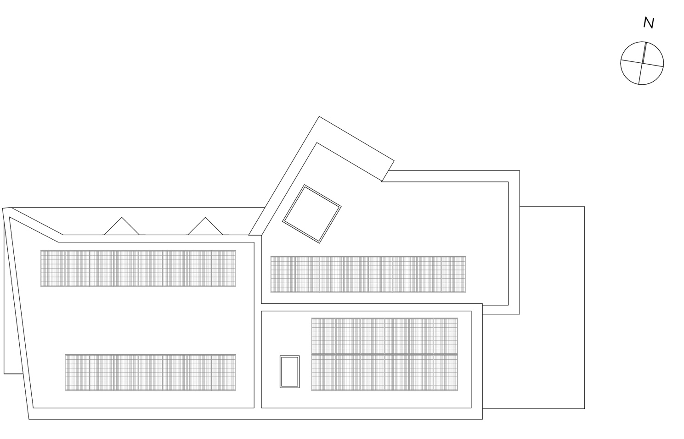

Table 4 – Summary Table

DWELLING | Predicted Space  Heating Demand  (kWh/m²/year) | Predicted Total Energy Use (kWh/m²/year) | Predicted Renewable  Generation (% total energy)
 | 27.7 | 30.7 | 106

For further details please refer to the SAP Calculation Printout and Energy Summary Tool.

