Slatted Lodge style wooden gate in a 30/70 format

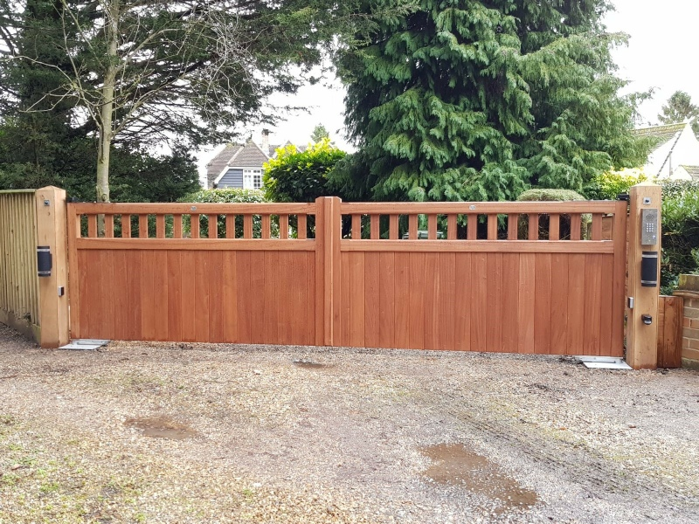

https://gatewrights.co.uk/woodendrivewaygates.html

