Planning Statement and Management Plan
Paddle Steamer, Gallowgate Street, Largs

PROPOSAL
This statement is in respect of application submitted for consent to place temporary style seating and barriers adjacent along the promenade adjacent to the Paddle Steamer, the application premises.

- The proposal is for ten tables and twenty chairs surrounded by freestanding post and canvas barriers.
- The furniture will be placed on the promenade between the hours of 8am and 10pm only, or hours as considered appropriate by the planning authority.
- During periods of harsher weather, particularly high winds, the furniture and barriers will be kept inside.
- In consultation with the council and other key local bodies, and when requested to do so, the furniture will not be set out, specifically during periods of heavy footfall on occasions such as the Viking Festival.

BACKGROUND

The premises manager met with Mark Henry of the Roads Department and Councillor Alan Hill on 8th March last and details of this proposal were discussed. The proposed seating was set up so that it could be visually assessed and photographs are attached below. All agreed that a substantial depth of the promenade would remain.

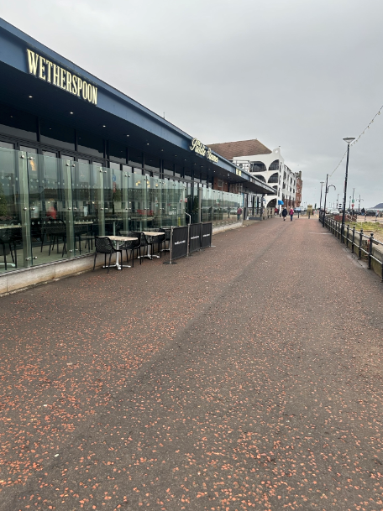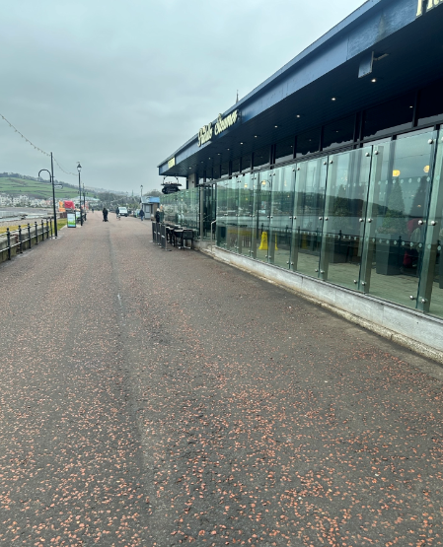

THE REASON

During periods of clement weather it is customer preference to sit with a drink and or/meal outside and the additional seating will provide this option to a greater clientele of the Paddle Steamer. Particularly with being a seaside town, and the wonderful views offered at this location, there is always a greater demand to sit outside.

THE MANAGEMENT

- Members of the front of house team will be visible within the external areas at all times in the course of their duties delivering food to tables, carrying out their regular cleansing and clearing of tables. They will be vigilant of any situation arising not considered acceptable and will seek to resolve promptly. A manager will always be close at hand to step in if required to do so.

- During busier periods and particularly later in the evenings a member of management staff will conduct walk rounds of the external areas every 15 minutes to monitor. Any unsatisfactory customer behaviour will be given a warning and if breached this will result in customers being asked to move inside or leave the premises.

- If any complaints of noise disturbance, or otherwise, are received by a member of staff, the complaint will be brought to the attention of the manager on duty and immediate steps will be taken to prevent a recurrence of the situation.

- All furniture will be removed from the Promenade after permitted hours and stored on the premises.

- Litter will be collected at regular intervals throughout the day from the immediate vicinity and disposed of with the premises waste. After use each day the surface will be swept and washed down when necessary.

- Staff will be asked to be vigilant to ensure that all furniture remains in the approved locations to prevent further obstruction into the promenade walkway.

SAFETY AND SECURITY
- Full digital CCTV coverage of the premises will be provided with images retained for a period of 90 days. Bodycams are also provided which link into the main CCTV system. Image quality will allow for identification. All management staff will be trained in downloading images from the system on request from the Police or other statutory authority.

• Training is provided to all employees commensurate with role and grade. All staff involved with the sale of alcohol receive training in Don’t Do Drunk (the Company’s policy to prevent excessive consumption of alcohol) and Challenge 21/25(The Company’s proof of age policy). Training is refreshed on a twice yearly basis.
• Signage will be erected notifying customers that no items are to be removed from the external seating area.

COMPANY POLICY
It is the policy of JD Wetherspoon plc that all of our venues will operate in such a way so as to not cause a negative impact on our neighbours. A significant number of our premises have residents, businesses and other noise sensitive uses adjacent to them. We have always emphasised the importance of building close relationships with our neighbours. Our managers are expected to resolve any complaints from those neighbours quickly and effectively. If they cannot be resolved at premises level they are referred to an Area or General Manager for resolution. We attach the utmost importance to the careful investigation and prompt resolution of any complaint made in relation to the day-to-day running of any of our premises.
The Company does not offer irresponsible drinks promotions such as Happy Hours, all you can drink for x . The promotions the Company does have are largely linked to food i.e. a free drink (alcoholic or non-alcoholic) with most main meals, which does not encourage excessive consumption of alcohol over a short period of time which is linked to intoxication and poor behaviour.
The nature of our food and drink offer and the competitive pricing structure encourages a broad range of customers including families and pensioners to our premises which assists in creating an atmosphere in which troublesome customers do not feel comfortable. This premises do not offer music which would encourage a younger clientele.
The above policy has formed the formulation of this plan and will form its implementation

JD Wetherspoon PLC
April 2024

