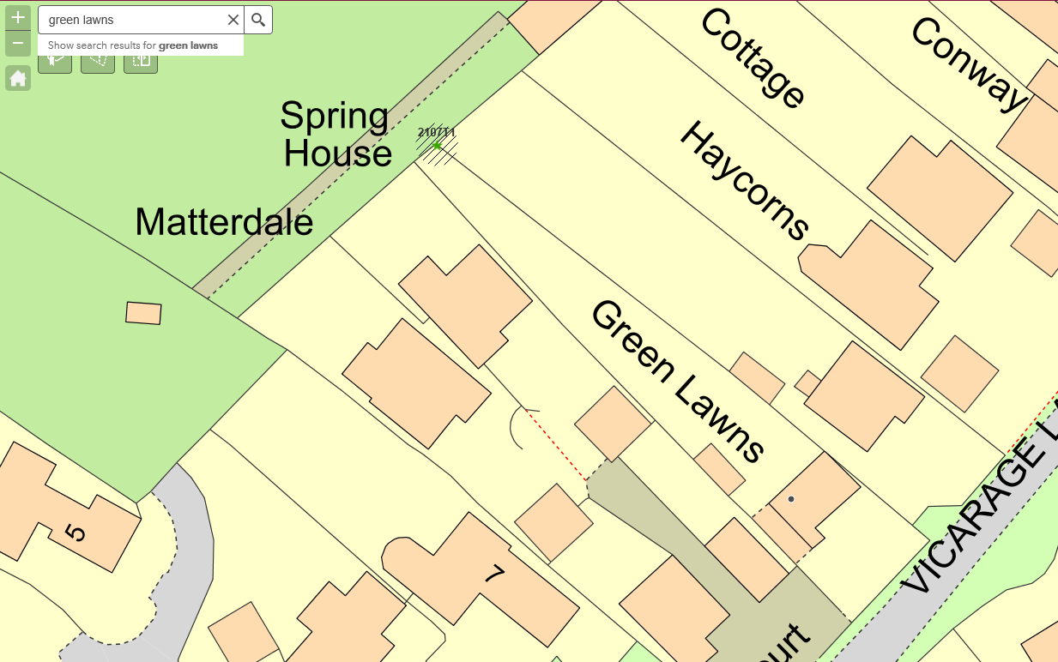

2107T1

Shows approx. surface area of tree branches and the close - proximity to the corner of Spring House.