Blacknest Fields Wildlife Pond: Location and block plan
- Proposed location for the pond
The proposed site for Wildlife Pond is at Blacknest Fields in Blacknest, which lies within the Hampshire part of the South Downs National Park.
As shown in Figure A, Blacknest Fields is located three fields northwest from Blacknest’s ‘Jolly Farmer’ pub. It neighbours the Alice Holt Forest. W3Words at the site’s Blacknest Road entrance are: ‘pockets/sublime/cookie’. The W3Words for the location of the proposed pond itself are: ‘ignites/shunts/gems.’
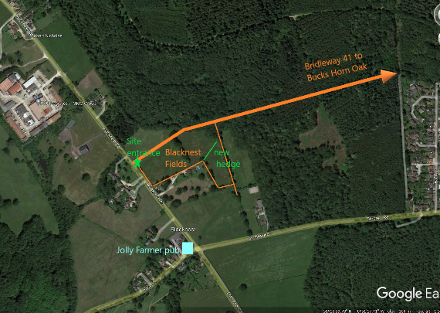 Figure A: Location Map
- Block Plan
The plan below (also attached as a pdf file) shows the location for the proposed pond within the Blacknest Fields site.
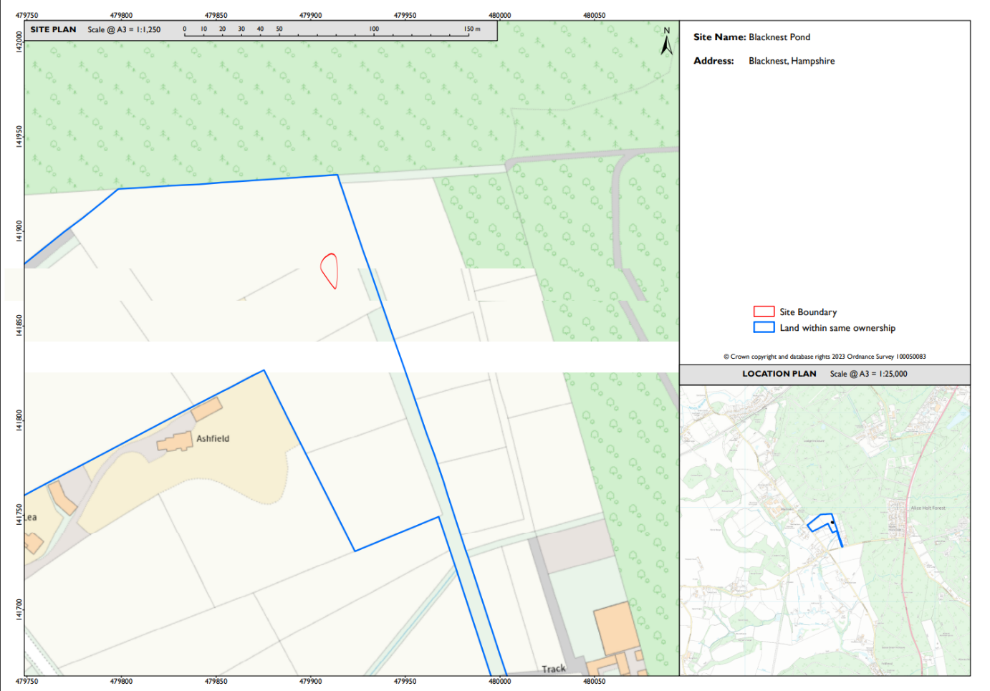

- Proposed pond dimensions and profile
The drawings below (also attached as a pdf file) show the dimensions and profile of the proposed pond at the Blacknest Fields site.

