Internal Alterations to The Ancient Unicorn Hotel, Bowes,
Barnard Castle.

Revised Internal Layout – Removal of Bedrooms.

LISTED BUILDING/ BOWES CONSERVATION AREA

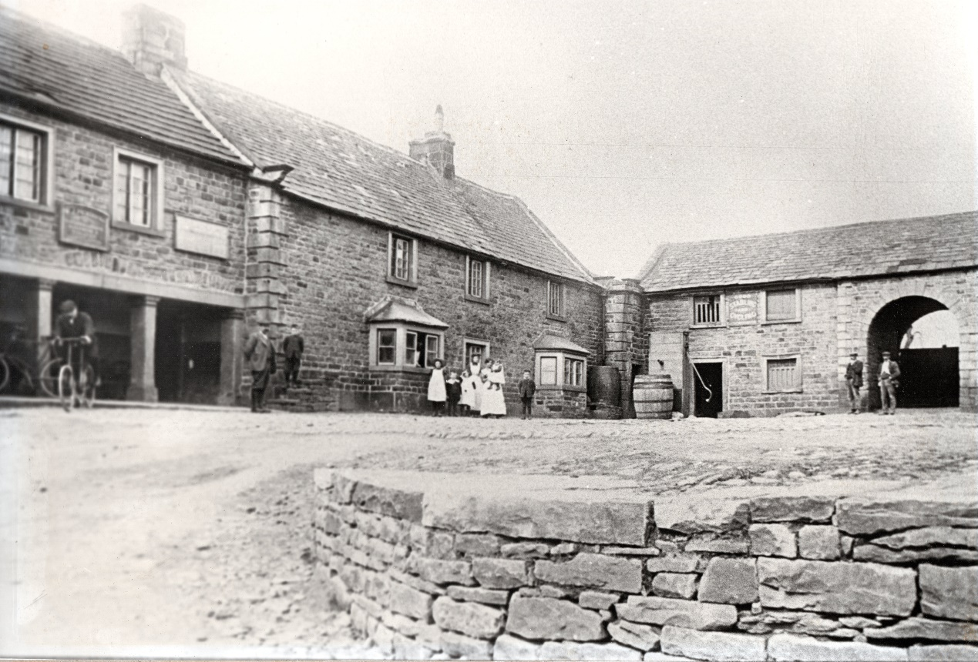

Heritage Statement.

The Heritage Statement.
- This statement is prepared in support of an application for the removal of the recently installed divisions which created three bedrooms in the area formerly used as the main lounge bar area of The Ancient Unicorn Hotel, Bowes. Consent was granted for an original scheme of works in 2017 (application number DM/17/03284/LB) and further revisions were approved in 2020 (application number DM/20/00086/LB) to accord with the requirements of Building Control notably to ensure that safe and secure fire escapes are provided to each habitable bedroom space. These schemes provided three en-suite bedroom facilities. Following a change in ownership of the Hotel the decision has been made to return the former bar area to its previous form and the current application is to remove the recent bedroom layout and late 20th century partition wall to create a large open bar lounge area. The proposal lies within the grade II listed building known as The Ancient Unicorn which lies in the Bowes Village Conservation Area. A heritage statement is therefore required. The report is prepared in line with the Durham County Council guidance on Heritage Statements of May 2014.

The Application Site – Location And Description.
- The proposal relates to the internal layout of The Ancient Unicorn Hotel in Bowes village, notably to the existing public bar and lounge areas in the rear wing of the property which fronts onto the courtyard permission for the alteration of which was given in 2017 (application number DM/17/03284/LB) and subsequently amended in 2020 (application number DM/20/00086/LB).

- The Ancient Unicorn Hotel has developed to its present form over the last 350 years and comprises three main elements linked together and with later additions and alterations. The main building of the Ancient Unicorn which includes the present application site is listed grade II whilst opposite the Hotel and slightly to the east lie the listed buildings of Croft House and Sunny Croft with the Listed Arch House (Bowes Club) beyond that. Other listed buildings within the village are further away. The site and its setting lies wholly within the Bowes Village Conservation Area.

- The part of the hotel which is the focus of the proposed work lies in the earlier building which fronts onto the cobbled courtyard and is a two storey structure with two ground floor bay windows. This building is considered the oldest part of the complex although the precise details of the front wall are thought to have changed substantially on several occasions. Previous work has shown the outer stone face of the wall is backed by a modern block-work leaf in some areas forming the inner lining to the building. Until recently the ground floor currently comprised a single open space with a central dividing wall running along the length of the building and access to the rest of the hotel via the link building at the south end of the room adjacent to the main fireplace. The two approved schemes of internal alterations have been implemented to form three bedrooms all with en-suite facilities At the northwest corner of this space is an access to the previous general use toilets housed in a small modern extension dating from the 1960’s or early 70’s and now converted to form the en-suites to two of the bedrooms.

- The upper floor of this building provides staff accommodation and is not affected by the proposal. The main frontage block to Front Street comprises visitor rooms to the first and second floors and a public dining room to the ground floor. This is not affected by the physical works proposed. The linking building connects the two main structures and this will remain physically unaltered, although the main public bar has now been relocated into the central lounge area. The proposed work will only affect the modern inserted stud partition walls and bedroom layouts.

The Heritage Asset.
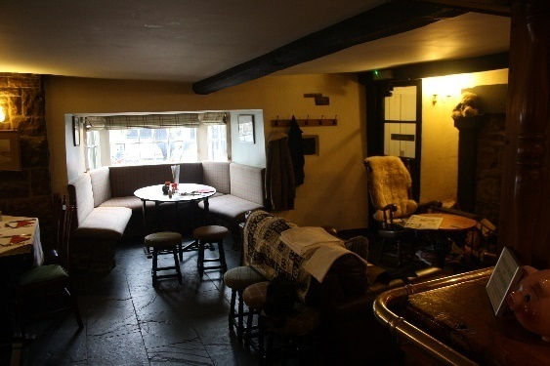
- The area of the Hotel subject to the proposal is a relatively small part of the whole designated site however prior to the works in 2020 it was possibly the most well-known part and certainly one of the more heavily used spaces of the building. It previously comprised a single open plan space some 12.5m long by 9m wide with the bar, main fireplace and entrance at the southern end and access to the toilets and a further later fireplace at the northwestern corner. To the east elevation the space was defined by two substantial vernacular bay windows which open out onto the courtyard with a single fixed window placed centrally between them. To the west there is a single late Victorian sliding sash window and a door which gives access to the small beer garden to the rear. The large room was divided by a modern stud wall which runs down the centre of the space effectively creating two rooms from a single area. The 2020 works subdivided this room to create a single suite to the rear and two accessible rooms to the east facing frontage of the building whilst retaining a small area as a small public lounge.

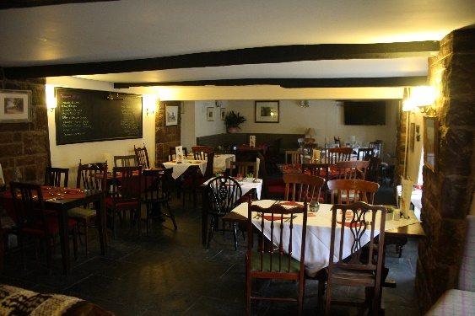
- This part of the building has been subject to very substantial and significant changes since it was first constructed. The original building was only half the depth of the present room section finishing somewhere close to the central dividing wall. Behind this later extensions have been added and the original rear wall has been removed and is supported on the two large pillars which stand within the centre of the room. The dividing wall between these is a later insertion to recreate something of the earlier form of the building and divide up the lounge space. This can be ascertained by the thickness of the wall at first floor level and the presence of a mullion casement window in the attic space above the rear extensions. The frontage building served as the main public house element of the Hotel however it was divided into at least two and possibly three sections with a central door where the fixed window now is and a corridor separating the two rooms to give a store room in the northern end of the building. This has at some point been served by two doors in the position of the present bay window as shown in the historic photo dating from the early 20th century.

- The internal cross walls included a fireplace to the northernmost room and a thick wall to carry the first floor fireplace above. This wall and remains of the fireplace remains in place at first floor level and the thickness of the wall can be seen in the supporting beams to the ground floor which are present as plaster features in the ceiling. This early internal arrangement lasted until the early 1970’s when the whole of the interior was stripped out to produce a single space since which time various arrangements of timber dividers and positions of the bar have been present. The result of the years of alteration and reconfiguration had left the interior of the public bar as a single space with a modern dividing wall which bears no resemblance to the original layout or to typical layouts of traditional dales pubs. The final alteration was the subdivision of the space in 2020 which this application is seeking to reverse.

The Building in a Statutory Heritage Context.

Bowes Village Conservation Area
- The Ancient Unicorn lies within the boundary of the identified Bowes Village Conservation Area, a designation made by Teesdale District Council in the 1980’s which has not been revised since the initial designation. To date there is has been no conservation area appraisal undertaken. The conservation area boundary is tightly drawn to the built up area of Bowes village and includes all buildings and their curtilages except for the modest close of Local Authority housing constructed in the 1950’s to the southeast end of the settlement. The boundary extends almost up to the by-pass, leaving only the road junction out of the protected area south of the trunk road. It includes Dotheboys Hall and the barns of West End Farm at its western extremity and Bowes Hall and the 1980’s development of Low Road at the east. The Ancient Unicorn is positioned slightly east of centre within the conservation area and both the hotel and its entire curtilage and surroundings are within the designated heritage site.

- The conservation area boundary map is attached at Appendix 1.

Listed Building Statutory Designation.

- The Ancient Unicorn Hotel is listed (Grade II) and was added to the list of Buildings of Special Architectural or Historic Importance on 17th June 1986. It lies within the identified Bowes Village Conservation Area and the full Listed Building entry appears at Appendix 2.

Extent of the Asset.
- The Ancient Unicorn Hotel covers an area of approximately 350m² in total however this application relates only to the changes to the ground floor public bar which is around 112m². The physical changes will be concentrated in the single ground floor area and the attached modern toilet block however operational changes will occur to other parts of the ground floor to bring these into a better more productive use.

Statement of Significance.
- The Ancient Unicorn is a significant historic structure in the village and an example of one of the coaching inns on the important Trans–Pennine route. The works proposed are limited to the public bar which has substantially changed in form, scale and character over the last 50 years from a traditional multi–roomed dales pub with small intimate spaces to a stripped out single space more typical of 1970’s and 80’s urban centre pubs. Since the 1990’s attempts have been made to reverse some of the 1970’s alterations and the repositioning of the bar, dividing up the room with the spine wall and creating different seating areas have re-established some of the individual spaces however the building can still lack an intimate atmosphere associated with historic pubs.

- The historic significance of the ground floor space is much diminished by the works of the 1970’s and most features of historic interest in this area have been lost or covered over. The main surviving features in this ground floor room are the large fireplace to the south end wall and the safe/candle-box set in the southeast corner, both of which will be safeguarded in the works. The current proposals will not affect any historic fabric but will alter the internal layout of the building and its character.

The Proposed Works.
- The existing layout is a recent creation developed by the previous owner to maximise the residential stays and make the business more of a holiday accommodation establishment, moving away from the previous village pub character. Following a change of owner the previous focus of the building as a village pub for events and food is being re-established and this requires a larger open space. The proposal is to remove the recently created bedrooms and open the main bar area back up in the form it was prior to 2020. This will involve only the removal of modern partition walls. No new openings in historic fabric are to be formed and any reworking of plasterwork to internal walls will be restricted to minor patching of modern plaster surfaces.

Analysis – The Impact on the Asset
- There are no external works proposed to the building, only the single internal space being affected by the proposal. The internal works will have no impact on the external character or appearance of the listed building or on the wider conservation area. Internally the area subject to the proposal has been thoroughly modernised and refurbished on several occasions since the 1970’s work removed the earlier internal arrangement and this has been recognised by the previous granting of approvals for the subdivision of the space. There is not considered to be any significant historic fabric within the area of the works, the nearest significant features being the large fireplace and candle box at the south end of the room both of which are away from the areas of proposed alteration. The remodelling of the toilet areas will only take place within the rear outbuilding which is all of modern construction and contains no features of historic interest. It is considered that the proposed internal works will have no significant impact on the historic fabric of the building.

Conclusion.
- The change in ownership of the hotel and pub has resulted in changed aims and priorities for the business and a consequential need to alter the building to accommodate the new business model. The previously approved works to the Ancient Unicorn Hotel were considered to have an acceptable level of impact on the way in which the building is used and on the heritage asset. The proposed new layout will reverse these changes and reinstate a previous floor plan with no impact on historic fabric internally. The external appearance of the building will remain completely unchanged retaining its character and the manner in which it addresses its setting within the village conservation area. The physical impact on the building will be negligible and will impact only on modern finishes and materials used for alterations over the last 30 years.

Appendices.

Appendix 1 Bowes Conservation Area Map.

Location of site shown in red circle.
Map extract from Durham County Council website.
Map not to scale.

Appendix 2 Listed Building designation (Summary).

THE ANCIENT UNICORN HOTEL AND ATTACHED REAR WING
This building is listed under the Planning (Listed Buildings and Conservation Areas) Act 1990 as amended for its special architectural or historic interest.
List entry Number: 1323027
District: County Durham
District Type: Unitary Authority
Parish: Bowes
Grade: II
Date first listed: 17-Jun-1986

Details
BOWES THE STREET NY 9913 (North side) 33/16 The Ancient Unicorn Hotel and attached rear wing (shown on OS map as Unicorn House) II Hotel. Mid C18 front block with altered and refronted C17 rear wing of 2 builds. Front block: dressed sandstone with squared rubble returns; graduated green slate roof; stone chimney stacks. Rear wing: squared rubble; left section has stone-flagged roof, right section has green slate roof; stone chimney stacks.
Front block: 3 storeys plus basement; 3 bays. Raised-and-chamfered quoins. Basement has central boarded door flanked by blocked windows. Replaced casements in moulded surrounds above basement string course. Stone eaves cornice. Roof with coped gables and shaped kneelers. Corniced end stacks.
Rear wing: set-back 2-storey, 2-bay left section facing courtyard has a Tuscan screen, now glazed, and 3 segmental relieving arches above. 2 replaced casements in moulded surrounds on first floor. Passage behind screen has two 16-pane sashes in moulded surrounds. Refronted 2-storey, irregular 3-bay right section has raised-and-chamfered quoins to left; 2 late C19 stone canted bay windows and 3 horizontal sliding sashes above. Mounting block to left. Left end and ridge stacks. Short 2-storey, gabled stair wing to rear, flanked by one-storey outshuts. 2-light chamfered-mullioned, first-floor window concealed by left outshut.
Interior: front block has cut-string, dogleg staircase of 3 flights plus landing rail, with 2 turned balusters per tread and a ramped moulded handrail.
C20 additions to left return of front block and at right end of rear wing,andattached farmbuildings to rear, are not of special interest.
Listing NGR: NY9949513540
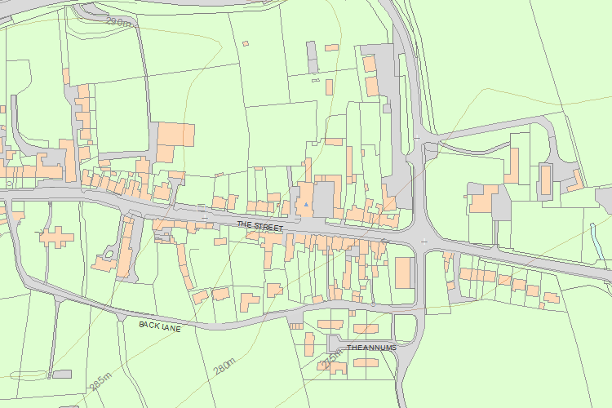© Crown Copyright and database right 2017. All rights reserved. Ordnance Survey Licence number 100024900.
© British Crown and SeaZone Solutions Limited 2017. All rights reserved. Licence number 102006.006.

NOTE: The Listed Building Description mentions only the main frontage Hotel building and the Rear Wing and specifically excludes the attached buildings to the west and the east of the rear wing.

Appendix 3 Other Listed Buildings in Bowes Village Conservation Area

Building | Address | Grade
Bowes Hall | The Street, Bowes | II
Garden Walls Gate Piers and Gates to Bowes Hall | The Street, Bowes | II
Numbers 1 and 2 | The Street, Bowes | II
Bowes and District Working Men’s Club | The Street, Bowes | II
Croft House, Sunny Croft and attached extension. | The Street, Bowes | II
The Grove | The Street, Bowes | II
Forecourt Wall and Gatepiers in Front of The Grove | The Street, Bowes | II
Church of St Giles | Back Lane, Bowes | II
Tomb of William Thompson | St Giles Churchyard, Back Lane, Bowes | II
Headstone to Thomas Hanby | St Giles Churchyard, Back Lane, Bowes | II
Headstone to William Shaw | St Giles Churchyard, Back Lane, Bowes | II
Table Tomb to Henry Bincks | St Giles Churchyard, Back Lane, Bowes | II
Bowes Castle | Back Lane, Bowes | I
Castle Terrace | The Street, Bowes | II
Annums Farmhouse | The Street, Bowes | II
Cross House and Church View | The Street, Bowes | II
Base and Cross Shaft Fragment in the Garden of Cross House | The Street, Bowes | II
Prospect House and Archway to Right | The Street, Bowes | II
Dotheboys Hall and former Coach House | The Street, Bowes | II
West End Farm Barn and Attached Range of Byres | The Street, Bowes | II

