Vellanuson Farm House, showing the adjoining redundant Apple Store to the right

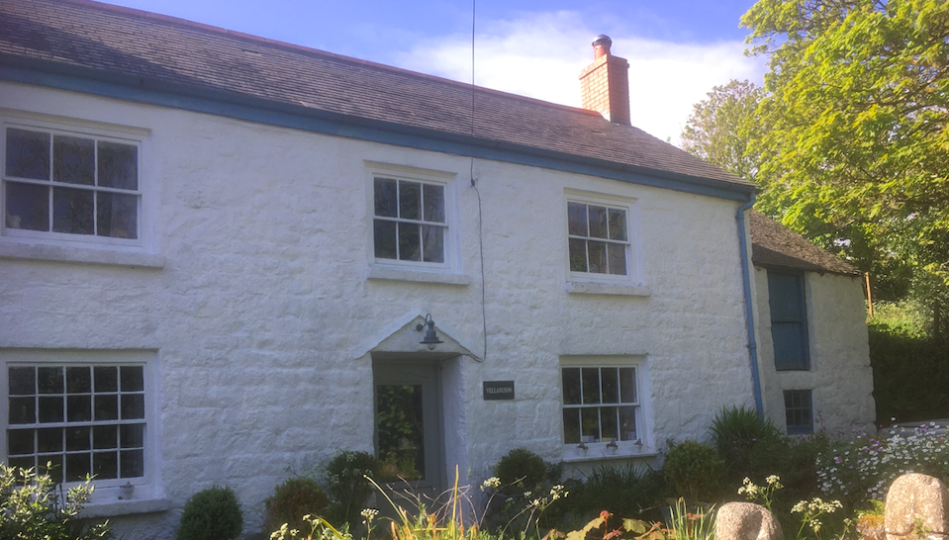

Vellanuson Mill House, located to the left of the Farm House (from the road)

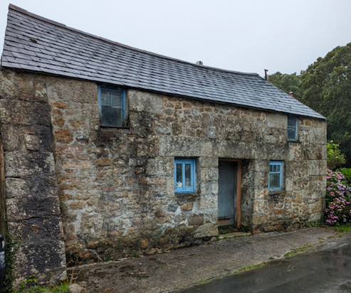

The rear entrance /view of the Apple Store. The roof has deteriorated far more than when this photo was taken 6 months ago

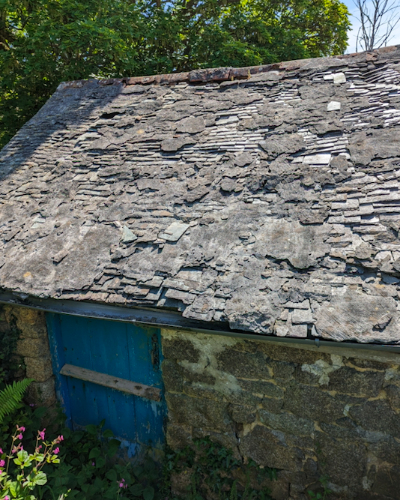

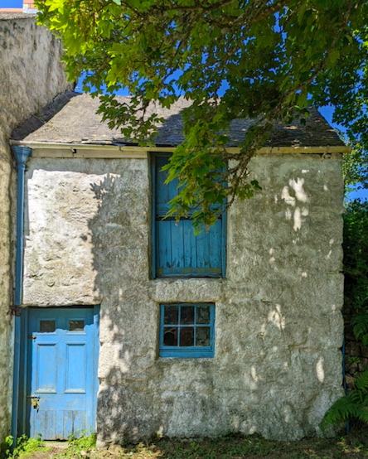

The front view of the Apple Store

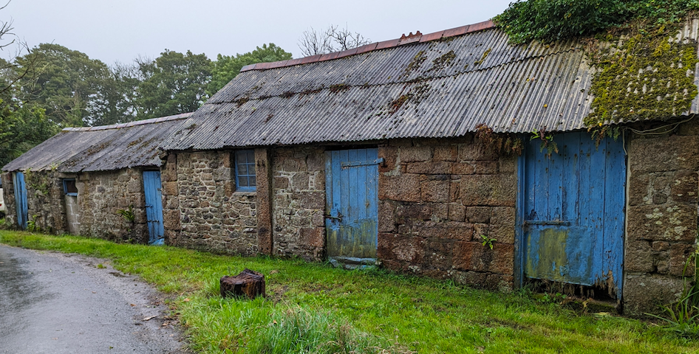

The outbuildings opposite the Mill House

